**MINISTRY OF EDUCATION AND TRAINING**

**FPT UNIVERSITY**

Capstone Project Document

**In-store Customer Heatmap System**

|  |  |
| --- | --- |
| **Group 07** | |
| **Group members** | Vũ Tấn Huy – SE62172  Đỗ Quốc Cường – SE62573  Nguyễn Quang Tuyến – SE62069  Đinh Hoàng Phúc – SE61768 |
| **Supervisor** | Lâm Hữu Khánh Phương |
| **Ext. Supervisor** | N/A |
| **Capstone Project code** | ICHS |

Ho Chi Minh City, 3th May 2019

**Contents**

**List of Figures** 6

**List of Tables** 8

**A.** **Introduction** 11

**1.** **Project Information** 11

**2.** **Introduction** 12

**3.** **Current Situation** 12

**4.** **Problem Definition** 12

**5.** **Proposed Solution** 12

**5.1. Feature functions** 12

**5.2. Advantages and disadvantages** 13

**6.** **Functional Requirement** 13

**7.** **Role and Responsibilities** 13

**B.** **Software Project Management Plan** 13

**1.** **Problem Definition** 13

1.1. Name of This Capstone Project 13

1.2. Problem Abstract 14

1.3. Project Overview 15

**2.** **Project Organization** 17

2.1. Software Process Model 17

2.2. Roles and Responsibilities 17

2.3. Tools and Techniques 18

**3.** **Project Management Plan** 19

3.1. Software Development Life Cycle 19

3.2. Phase Detail 20

3.3. All Meeting Minutes 21

**4.** **Coding Convention** 21

**C.** **Software Requirement Specification** 22

**1.User Requirement Specification** 22

**1.1 Unauthorized User Requirement** 22

**1.2 Authorized User Requirement** 22

**1.3 User Requirement** 22

**1.4 Admin Requirement** 23

**1.5 Server Requirement** 23

**2.System Requirement Specification** 24

2.1 External Interface Requirement 24

2.2 System Overview Use Case 24

2.3 List of Use Case 26

**3.Software System Attribute** 85

3.1 Usability 85

3.2 Reliability 85

3.3 Security 85

3.4 Maintainability 85

3.5 Portability 85

3.6 Performance 85

**4** **Conceptual Diagram** 86

**D.** **Software Design Description** 86

**1.** **Design Overview** 86

**2. System Architecture Design** 87

**2.1** **Overview** 87

**2.2** **Server Architecture Design** 88

**2.3** **Server Architecture Description** 88

**2.4** **Web Application Architecture Design** 89

**2.5** **Web Application Architecture Description** 89

**3** **Component Diagram** 90

**4** **Detailed Description** 91

4.1 Class Diagram 91

4.2 Class Diagram Explanation 92

4.3 Interaction Diagram 95

**5** **User Interface Design** 100

5.1 User 100

**6** **Database Design** 108

6.1 Entity Relationship Diagram 108

6.2 Entity Dictionary 108

**7** **Algorithms** 108

**7.1** **Faster RCNN** 108

**7.2** **Draw Heatmap** 110

**7.3** **Face Detection** 111

**E.** **System Implementation & Test** 112

**1.** **Introduction** 112

1.1. Overview 112

1.2. Test Approach 112

**2.** **Database Relationship Diagram** 113

2.1. Physical Diagram 113

2.2. Data Dictionary 114

**3.** **Test Plan** 117

3.1. Features to be Tested 117

3.2. Features not to be Tested 117

**4.** **Testing Test Case** 117

4.1 Test Case 117

4.1.1 <User> Edit Profile 117

4.1.2 <User> Change Password 118

4.1.3 <User> View number of People in store 118

4.1.4 <User> View number of People in Zone 119

4.1.5 <User> View number of People in camera 120

4.1.6 <Admin> Add Company 121

4.1.7 <Admin> Edit Company 123

4.1.8 <Admin> Deactivate Company 124

4.1.9 <Admin> Add Account 125

4.1.10 <Admin> Edit Account 128

4.1.11 <Admin> Delete Account 130

4.1.12 <Admin> Add Store 131

4.1.13 <Admin> Search Store 133

4.1.14 <Admin> Add Zone 134

4.1.15 <Admin> Add Camera 135

4.2 テストケース 136

4.2.1 ＜ユーザー＞プロファイルの編集 136

4.2.2 ＜ユーザー＞パスワードの変更 137

4.2.3 ＜ユーザー＞１店舗の人数を表示 138

4.2.4 ＜ユーザー＞１エリアの人数を表示 139

4.2.5 ＜ユーザー＞１台のカメラの人数を表示 141

4.2.6 <管理者>会社の追加 144

4.2.7 <管理者>会社の編集 146

4.2.8 <管理者>会社の無効化 148

4.2.9 <管理者>アカウントを追加 149

4.2.10 <管理者>アカウントの編集 155

4.2.11 <管理者>アカウントの削除 157

4.2.12 <管理者>ストアの追加 157

4.2.13 <管理者>検索ストア 161

4.2.14 <管理者>エリアを追加 162

4.2.15 <管理者>カメラの追加 165

**F.** **Software User’s Manual** 167

**1.** **Installation Guide** 167

1.1. Hardware Requirement 167

1.2. Software Requirement 167

**2.** **User Guide** 168

2.1 Login 168

2.2 Edit Profile 168

2.3 Change Password 169

2.4 View Store 170

2.5 View Zone 171

2.6 View Camera 172

2.7 View Stream Heatmap 174

2.8 View People Detection and Counting People 174

2.9 Preview Heatmap in Time 175

2.10 Log Out 177

2.11 View statistic store following month, date and time of date. 177

2.12 View statistic Zone following month, date and time of date. 181

2.13 View statistic camera following month, date and time of date. 184

**F1.ソフトウェアユーザーマニュアル** 187

**1.** **インストールガイド** 187

1.1. ハードウェア要件 187

1.2. ソフトウェア要件 187

**2.** **ユーザーガイド** 188

2.1 ログイン 188

2.2 プロファイルの編集 188

2.3 パスワードの変更 189

2.4 ビューストア 190

2.5 ビューエリア 191

2.6 ビューカメラ 192

2.7 ストリームヒートマップの表示 194

2.8 人物検出の表示と人物のカウント 194

2.9 時間内のヒートマップのプレビュー 195

2.10 ログアウト 197

2.11 月、日付、時刻の統計ストアを表示します。 197

2.12 月、日付、日付の次の統計領域を表示します。 201

2.13 月、日付、日付の次の統計カメラを表示します。 204

**G.** **Appendix** 207

**1.** **StarUML Documentation For Activity Diagram** 207

**2.** **UML For Drawing Diagram (2.0 Standard)** 207

# **List of Figures**

Figure 1 : Waterfall model 17

Figure 2 : System Overview Use Case Diagram 25

Figure 3 : <Unauthorized User> Overview Use Case 26

Figure 4 : <Unauthorized User> Login 26

Figure 5 : <Authorized User> Overview Use Case 28

Figure 6 : <Authorized User> Logout 28

Figure 7 : <Authorized User> Change Password 30

Figure 8 : <Authorized User> View Profile 32

Figure 9 : <Authorized User> Update Profile 33

Figure 10 : <Admin>Overview Use Case Diagram 35

Figure 11 : <Admin> Add Company 36

Figure 12 : <Admin> Edit Company 37

Figure 13 : <Admin> Search Company 39

Figure 14 : <Admin> Deactivate Company 40

Figure 15 : <Admin> Add Account 42

Figure 16 : <Admin> Edit Account 44

Figure 17 : <Admin> Search Account 46

Figure 18 : <Admin> Delete Account 47

Figure 19 : <Admin> Add Store 49

Figure 20 : <Admin> Edit Store 51

Figure 21 : <Admin> Search Store 53

Figure 22 : <Admin> Deactivate Store 54

Figure 23 : <Admin> Add Zone 56

Figure 24 : <Admin> Edit Zone 57

Figure 25 : <Admin> Search Zone 59

Figure 26 : <Admin> Deactivate Zone 60

Figure 27 : <Admin> Add Camera 62

Figure 28 : <Admin> Edit Camera 64

Figure 29 : <Admin> Search Camera 65

Figure 30 : <Admin> Delete Camera 67

Figure 31 : <User> Overview Use Case Diagram 69

Figure 32 : <User> View Store 69

Figure 33 : <User> View Zone 71

Figure 34 : - <User> View Camera 72

Figure 35 : <User> View Streaming Camera 74

Figure 36 : <User> See Object Detection 75

Figure 37 : <User> See Count People 77

Figure 38 : <User> See Face Detection 78

Figure 39 : <User> View Stream Heatmap 80

Figure 40 : <User> View Report 82

Figure 41 : <User> View Heatmap 83

Figure 42 : Conceptual Diagram 86

Figure 43 : System Architecture Design Overview 87

Figure 44 : Server Architecture Design 88

Figure 45 : Web Application Architecture Design 89

Figure 46 : Component Diagram 90

Figure 47 : Class Diagram 91

Figure 48 : Sequence Diagram <Login> 95

Figure 49 : Sequence Diagram <Create Company> 96

Figure 50 : Sequence Diagram <Update Company> 96

Figure 51 : Sequence Diagram <Activate Company> 97

Figure 52 : Sequence Diagram <Deactivate Company> 97

Figure 53 : Sequence Diagram <Search Company> 98

Figure 54 : Sequence Diagram <Get report camera by time> 98

Figure 55 : Sequence Diagram <Get report Zone by time> 99

Figure 56 : Sequence Diagram <Get report store by time> 99

Figure 57 : User Interface <Login> 100

Figure 58 : User Interface <Menu Bar> 101

Figure 59 : User Interface <Edit Profile> 102

Figure 60 : User Interface <Change Password> 102

Figure 61 : User Interface <View List Store> 103

Figure 62 : User Interface <View List Zone> 103

Figure 63 : User Interface <View List Camera> 104

Figure 64 : User Interface <Streaming Camera> 104

Figure 65 : User Interface <Preview Camera> 105

Figure 66 : User Interface <Statistic Store> 106

Figure 67 : User Interface <Statistic Zone> 106

Figure 68 : User Interface <Statistic Camera> 107

Figure 69 : Entity Relationship Diagram 108

Figure 70 : Faster RCNN 1 109

Figure 71 : Faster RCNN 2 110

Figure 72 : Draw Heatmap <Dot Image> 110

Figure 73 : Draw Heatmap <Color Range> 111

Figure 74 : Draw Heatmap <Heatmap Color Image> 111

Figure 75 : Face Detection 111

Figure 76 : Face Detection <Haar-Like> 1 111

Figure 77 : Face Detection <Haar-Like> 2 112

Figure 78 : Physical Diagram 113

Figure 79 : User Guide <Login> 168

Figure 80 : User Guide <Edit Profile> 168

Figure 81 : User Guide <Change Password> 170

Figure 82 : User Guide <View Store> 170

Figure 83 : User Guide <View Zone> 171

Figure 84 : User Guide <View Camera> 173

Figure 85 : User Guide <View Heatmap> 174

Figure 86 : User Guide <View People Detection and Counting People> 174

Figure 87 : User Guide <Preview Heatmap in Time> 176

Figure 88 : User Guide <LogOut> 177

Figure 89 : User Guide <View statistic store following month, date and time of date> 180

Figure 90 : User Guide <View statistic Zone following month, date and time of date> 183

Figure 91 : User Guide <View statistic camera following month, date and time of date> 186

Figure 92 : ユーザーガイド<ログイン> 188

Figure 93 : ユーザーガイド<プロファイルの編集> 188

Figure 94 : ユーザーガイド<パスワードの変更> 190

Figure 95 : ユーザーガイド<ストアの表示> 190

Figure 96 : ユーザーガイド<表示エリア> 191

Figure 97 : ユーザーガイド<カメラの表示> 193

Figure 98 : ユーザーガイド<ヒートマップの表示> 194

Figure 99 : ユーザーガイド<人の検出の表示と人のカウント> 194

Figure 100 : ユーザーガイド<時間内のヒートマップのプレビュー> 196

Figure 101 : ユーザーガイド<ログアウト> 197

Figure 102 : ユーザーガイド <月、日付、時刻の統計ストアを表示します> 200

Figure 103 : ユーザーガイド <月、日付、日付の次の統計領域を表示します> 203

Figure 104 : ユーザーガイド <月、日付、日付の次の統計カメラを表示します> 206

# **List of Tables**

Table 1: Roles and Responsibilities 13

Table 2: Hardware Requirement for Server 16

Table 3 : Hardware Requirement for Camera 16

Table 4 : Roles and responsibilities 18

Table 5 : Tools List 18

Table 6 : Technique List 19

Table 7 : Software Development Life Cycle Detail 20

Table 8 : Requirement Definition 20

Table 9 : System and Software design 20

Table 10 : Implementation and Unit testing 21

Table 11 : System Testing and Setup Camera 21

Table 12 : Operation and Maintenance 21

Table 13 : <Unauthorized User> Login 28

Table 14 : <Authorized User> Logout 29

Table 15 : <Authorized User> Change Password 31

Table 16 : <Authorized User> View Profile 33

Table 17 : <Authorized User> Update Profile 35

Table 18: <Admin> Add Company 37

Table 19 : <Admin> Edit Company 39

Table 20 : <Admin> Search Company 40

Table 21 : <Admin> Deactivate Company 42

Table 22 : <Admin> Add Account 44

Table 23 : <Admin> Edit Account 46

Table 24 : <Admin> Search Account 47

Table 25 : <Admin> Delete Account 48

Table 26: <Admin> Add Store 50

Table 27 : <Admin> Edit Store 52

Table 28: <Admin> Search Store 54

Table 29 : <Admin> Deactivate Store 55

Table 30 : <Admin> Add Zone 57

Table 31: <Admin> Edit Zone 59

Table 32 : <Admin> Search Zone 60

Table 33 : <Admin> Deactivate Zone 62

Table 34: <Admin> Add Camera 63

Table 35 : <Admin> Edit Camera 65

Table 36 : <Admin> Search Camera 66

Table 37 : <Admin> Delete Camera 68

Table 38 : <User> View Store 70

Table 39 : <User> View Zone 72

Table 40 : <User> View Camera 73

Table 41 : <User> View Streaming Camera 75

Table 42 : <User> See Object Detection 76

Table 43 : <User> See count people 78

Table 44 : <User> See Face Detection 80

Table 45 : <User> View Stream Heatmap 81

Table 46 : <User> View Report 83

Table 47: <User> Preview heatmap in Time 84

Table 48 : Conceptual Diagram Dictionary 86

Table 49: Component Dictionary 90

Table 50 : Class Diagram Dictionary 92

Table 51 : Class Diagram Explanation <Account> 92

Table 52 : Class Diagram Explanation <Company> 93

Table 53 : Class Diagram Explanation <Store> 93

Table 54 : Class Diagram Explanation <Zone> 94

Table 55 : Class Diagram Explanation <Camera> 94

Table 56: Class Diagram Explanation <Report> 94

Table 57: Class Diagram Explanation<Traffic> 95

Table 58 : Login <Field> 100

Table 59: Login < Buttons/Hyperlinks> 100

Table 60 : Menu Bar < Buttons/Hyperlinks> 101

Table 61 : Edit Profile < Fields > 102

Table 62 : Edit Profile < Buttons/Hyperlinks> 102

Table 63 : Change Password < Fields > 103

Table 64 : Change Password < Buttons/Hyperlinks> 103

Table 65 : View List Store < Buttons/Hyperlinks> 103

Table 66 : View List Zone < Buttons/Hyperlinks> 104

Table 67 : View List Camera < Buttons/Hyperlinks> 104

Table 68 : Streaming Camera < Buttons/Hyperlinks> 105

Table 69 : Preview Camera < Fields> 105

Table 70 : Preview Camera < Buttons/Hyperlinks> 105

Table 71 : Statistic Store < Fields> 106

Table 72 : Statistic Store < Buttons/Hyperlinks> 106

Table 73 : Statistic Zone < Fields > 107

Table 74 : Statistic Zone < Buttons/Hyperlinks> 107

Table 75 : Statistic Camera < Fields> 107

Table 76 : Statistic Camera < Buttons/Hyperlinks> 108

Table 77 : Entity Relationship Diagram Dictionary 108

Table 78: Physical Diagram Dictionary 114

Table 79 : Physical Diagram Detail Dictionary 116

Table 80 : Test Case <Edit Profile> 117

Table 81 : Test Case <Change Password> 118

Table 82 : Test Case <View number of People in store> 119

Table 83 : Test Case <View number of People in Zone> 120

Table 84 : Test Case <View number of People in camera> 121

Table 85 : Test Case <Add Company> 123

Table 86 : Test Case <Edit Company> 124

Table 87 : Test Case <Deactivate Company> 125

Table 88 : Test Case <Add Account> 128

Table 89 : Test Case <Edit Account> 130

Table 90 : Test Case <Delete Account> 131

Table 91 : Test Case <Add Store> 133

Table 92 : Test Case <Search Store> 133

Table 93 : Test Case <Add Zone> 135

Table 94 : Test Case <Add Camera> 136

Table 95 : テストケース <プロファイルの編集> 137

Table 96 : テストケース <パスワードの変更> 137

Table 97 : テストケース <１店舗の人数を表示> 139

Table 98 : テストケース <１エリアの人数を表示> 140

Table 99 : テストケース <１台のカメラの人数を表示> 144

Table 100 : テストケース <会社の追加> 146

Table 101 : テストケース <会社の編集> 148

Table 102 : テストケース <会社の無効化> 149

Table 103 : テストケース <アカウントを追加> 154

Table 104 : テストケース <アカウントの編集 156

Table 105 : テストケース <アカウントの削除> 157

Table 106 : テストケース <ストアの追加> 160

Table 107 : テストケース <検索ストア> 162

Table 108 : テストケース <エリアを追加> 165

Table 109 : テストケース <カメラの追加> 167

Table 110 : Hardware Requirement 167

Table 111 : Software Requirement 167

Table 112 : User Guide <Login > 168

Table 113 : User Guide <Edit Profile> 169

Table 114 : User Guide <Change Password> 170

Table 115 : User Guide <View Store> 171

Table 116 : User Guide <View Zone> 171

Table 117 : User Guide <View Camera> 173

Table 118 : User Guide <View Heatmap> 174

Table 119 : User Guide < View People Detection and Counting People > 174

Table 120 : User Guide <Preview Heatmap in Time> 176

Table 121 : User Guide <LogOut> 177

Table 122 : User Guide <View statistic store following month, date and time of date> 180

Table 123 : User Guide <View statistic Zone following month, date and time of date> 184

Table 124 : User Guide <View statistic camera following month, date and time of date> 187

Table 125 : ハードウェア要件 187

Table 126 : ソフトウェア要件 187

Table 127 : ユーザーガイド<ログイン> 188

Table 128 : ユーザーガイド<プロファイルの編集> 189

Table 129 : ユーザーガイド<パスワードの変更> 190

Table 130 : ユーザーガイド<ストアの表示> 191

Table 131 : ユーザーガイド<表示エリア> 191

Table 132 : ユーザーガイド<カメラの表示> 193

Table 133 : ユーザーガイド<ヒートマップの表示> 194

Table 134: ユーザーガイド<人の検出の表示と人のカウント> 195

Table 135 : ユーザーガイド<時間内のヒートマップのプレビュー> 196

Table 136 : ユーザーガイド<ログアウト> 197

Table 137 : ユーザーガイド <月、日付、時刻の統計ストアを表示します> 200

Table 138 : ユーザーガイド <月、日付、日付の次の統計領域を表示します> 204

Table 139 : ユーザーガイド <月、日付、日付の次の統計カメラを表示します> 207

# **Introduction**

## **Project Information**

- Project name: **In-Store Customer Heatmap System**

- Project Code: **ICHS**

- Project Type: **Web Application**

- Start Date: 03/05/19

-End Date: 27/08/19

## **Introduction**

In this project, we will introduce a solution in store data analysis. In the current era, information or data is always very important and useful in many fields, especially in analysis.

Our web is using technologies to make data’s analysis easier for users to manage or analyze, in which the camera supports RTSP protocol that supports converting video to the heatmap form shown on screen.

Through this web, along with the features it offers, the team wants to help managers or shop owners have a view of customer’s behavior that they can change their store and make it better.

## **Current Situation**

Currently, the use of shop's security cameras is simply used for monitoring purposes and when problems arise, the videos will be extracted. This inadvertently wastes the amazing effects that the camera offers. What the current camera offers is just quite difficult to exploit all that data effectively.

Nowadays, when information technology is very popular, AI (Artificial Intelligence) is also one of the things that are very interested. So, combining cameras with an AI-based application that helps users to make the most of the benefits of the camera is really a good idea.

## **Problem Definition**

* Applications included with the camera are usually only used for streaming and video playback.
* Streaming is mainly used for monitoring purposes.
* The extracted videos do not bring much value for analysis.
* Do not bring the most of the benefits that the camera offers.

## **Proposed Solution**

Our Proposed Solution is to build a system named In-Store Customer Heatmap System (ICHS), a Web application where users can view stream videos in the heatmap mode and people detection mode, can know the density of Zones, count the number of people ... from there, based on reports, they Zoneble to make assessments or reasonable changes.

### **5.1. Feature functions**

- Web application: Help user view streaming camera and see customer’s behavior.

* Video streaming: watch real-time streaming camera in website.
* See Detect people on video: see how to detect people in real-time streaming camera.
* See people counting on video: see count the result of people detection.
* See heatmap: see heatmap in real-time streaming video.
* See people analysis: see face analysis in real-time streaming video.
* Preview heatmap in time: see heatmap in each hour.
* Get report: report how many people in each time and how long people stay in each place.
* Web admin: Help admin to manage system.
* Manage company, account, store, Zone, camera.

- RTSP server: Get video steaming in camera and analyze it.

* Get camera streaming: use RTSP to take camera view.
* Detect people: detect people and where people are.
* Draw heatmap: base on result of detection and draw heatmap.
* Detect Face: detect face people and get their information.

### **5.2. Advantages and disadvantages**

Advantages

* System allows user see streaming camera in website.
* System can detect people and behavior to make a report for user.
* System allows user to see store/shop heatmap that can change product or style.

Disadvantages

* Don’t have many people know about heatmap

## **Functional Requirement**

Function requirements of the system are listed as below:

- User component:

* View Streaming camera.
* View result of detect, heatmap.
* Preview heatmap in time.
* View report.
* Admin component:
* Manage company, store, Zone, camera.
* RTSP server component:
* Get streaming camera.
* Detect people.
* Draw heatmap.
* Analyze face.
* Save video.
* Upload video in cloud.

## **Role and Responsibilities**

|  |  |  |  |  |
| --- | --- | --- | --- | --- |
| No | Full Name | Role | Position | Contact |
| 1 | Mr. Lâm Hữu Khánh Phương | Project Manager | Supervisor | phuonglhk@fpt.edu.vn |
| 2 | Vũ Tấn Huy | Developer | Leader | huyvtse62176@fpt.edu.vn |
| 3 | Đỗ Quốc Cường | Developer | Member | cuongdqse62573@fpt.edu.vn |
| 4 | Nguyễn Quang Tuyến | Developer | Member | tuyennqse62069@fpt.edu.vn |
| 5 | Đinh Hoàng Phúc | Developer | Member | phucdhse61768@fpt.edu.vn |

Table 1: Roles and Responsibilities

# **Software Project Management Plan**

## **Problem Definition**

* 1. Name of This Capstone Project

**- Official name**: In-Store Customer Heatmap System

**- Vietnamese name**: Xây dựng biểu đồ nhiệt khách hàng trong cửa hàng

**- Abbreviation**: ICHS

* 1. Problem Abstract

Currently, the use of cameras in shops, stores, ... is extremely common and necessary. Cameras here are often used for observation, management or monitoring. But when technology is growing, we can fully utilize cameras to do more things. With that in mind, the develop team decided to develop a software to do it in the most optimal way.

Based on RTSP protocol, combined with camera and a stable internet connection. An web based application has been made, thanks to the combination of machine learning and algorithms, we can now count the number of people in the store through the video screen,measure store traffic in real time and show on heatmap, the owner/manager also can get some reports from the application ... thereby helping store management more proactive.

* 1. Project Overview

*1.3.1 Current Situation*

Problems encountered in this project:

* Face detection range is low.
* People detection is not 100% correct.
* Need a powerful server to load this system.
* Hard to test: base on time and brightness.

*1.3.2 The Proposed System*

We are focus to use camera as much as possible, make it have more benefit. User can access to view their camera every time everywhere and can see customer density.

For users:

* + - * Get store
      * Get Zone
      * Get camera
      * See streaming camera
      * See people detection
      * See people count
      * See face detection
      * See heatmap on camera
      * See heatmap in time
      * See report

For Admin:

* + - * Manage company
      * Manage account
      * Manage store
      * Manage Zone
      * Manage camera

For RTSP server:

* + - * Get streaming camera
      * Detect people
      * Count people
      * Detect face
      * Draw heatmap
      * Save video
      * Upload to cloud

*1.3.3 Future plans*

Divide face detection to one specific camera and use that camera to count people come in shop/store.

*1.3.4 Development Environment*

* **For server**

|  |  |  |
| --- | --- | --- |
| Windows | Minimum Requirements | Recommended |
| Internet Connection | Cable, Wi-Fi (8 Mbps) | Cable, Wi-Fi (16 Mbps) |
| Operating System | Window 7 | Window 10 |
| Computer Processor | Intel® Core i7 1.8GHz | Intel® Core i7 2.50 GHz |
| Computer Memory | 4GB RAM | 8GB RAM |

Table 2: Hardware Requirement for Server

* For camera

|  |  |
| --- | --- |
| **Requirements** | |
| Lens | 2.8 mm @F2.0, horizontal field of view 105.8° |
| Lens Mount | M12 |
| Day& Night | IR cut filter with auto switch |
| Digital noise reduction | 3D DNR |
| IR Range | 30m |
| **Image** | |
| Max. Resolution | 1280 × 720 |
| Day/Night Switch | Support auto, scheduled |
| **Network** | |
| Network Storage | NAS (NFS, SMB/CIFS) |
| Protocol | RTSP |
| Alarm | Video tampering, network disconnected, IP address conflicted |
| Detections | Motion Detection |
| General Function | Anti-flicker, heartbeat, mirror, password protection, privacy mask, watermark, IP address filter |
| Communication Interface | 1 RJ45 10M/100M self-adaptive Ethernet port |

Table 3 : Hardware Requirement for Camera

## **Project Organization**

* 1. Software Process Model

The software process model used in developing is based on the Waterfall model.

Reasons we choose this:

* RTSP server architecture need to be designed to make it fast as much as possible.
* The requirements are not often change.



Figure 1 : Waterfall model

* 1. Roles and Responsibilities

|  |  |  |  |
| --- | --- | --- | --- |
| No | Full name | Role in Group | Responsibilities |
| 1 | Lâm Hữu Khánh Phương | Supervisor, Project Manager | * Specify user requirements * Control the development process * Give out technique and business analysis support |
| 2 | Vũ Tấn Huy | Team leader, B.A, Developer, Tester | * Managing process * Designing database * Clarifying requirements * Design architecture * GUI design * Create test plan * Coding * Testing |
| 3 | Đỗ Quốc Cường | Team member,  B.A, Developer,  Tester | * Clarifying requirements * Prepare documents * GUI design * Coding * Testing |
| 4 | Nguyễn Quang Tuyến | Team member,  B.A, Developer,  Tester | * Clarifying requirements * Prepare documents * GUI design * Coding * Testing |
| 5 | Đinh Hoàng Phúc | Team member,  B.A, Developer,  Tester | * Clarifying requirements * Prepare documents * GUI design * Coding * Testing |

Table 4 : Roles and responsibilities

* 1. Tools and Techniques

|  |  |
| --- | --- |
| **Tool** | **Name / Version** |
| Web server | Apache Tomcat 9.0.19 |
| Development tool | IntelliJ, IDEA, Visual Code |
| DBMS | MySQL |
| Source control | GitHub |
| Modeling tool | Star UML, Draw.io |
| Document tool | Microsoft Word 2016 |

Table 5 : Tools List

|  |  |
| --- | --- |
| **Technique** | **Name / version** |
| Frontend | HTML5, CSS, TypeScript, Angular |
| Backend | Java, Spring Boot, Python 3.6.8, Flask-SocketIO, OpenCV, Redis |

Table 6 : Technique List

## **Project Management Plan**

* 1. Software Development Life Cycle

|  |  |  |  |  |  |
| --- | --- | --- | --- | --- | --- |
| Phase | Description | Deliverables | Resource  needed | Dependencies  Constrains | Risks |
| Requirements Definition | Collect and analyze requirements | SRS | 14 man-days | N/A | Unclear requirements  Lack of experience |
| System and Software design | Design system structure | System architecture | 7 man-days | Depend on SRS and feature in it. | Can’t calculate how fast it can be. |
| Implementation and Unit Testing | Implement the system | Runnable system | 49 man-days | Requirement and system design | Always update system design to improve performance  At first, just use webcam to demo |
| System Testing  And Setup Camera | Test and fix bug  Setup real camera on real store | Test case  Safe system | 14 man-days | Runnable system | Hard to setup a place to set camera |
| Operation and Maintenance | Maintain system | The installation, migration, support and maintenance of complete system | 14 man-days | Camera with dynamic port |  |

Table 7 : Software Development Life Cycle Detail

* 1. Phase Detail

*3.2.1 Requirement Definition*

|  |  |  |
| --- | --- | --- |
| Task | Description | Author |
| 1.Collect requirements | Find techniques and software which have similar feature | HuyVT,  CuongDQ,  TuyenNQ,  PhucDH |
| 2.Identify and clarify main functions | Define core main function and how to implement | HuyVT,  CuongDQ,  TuyenNQ,  PhucDH |
| 3.Requirements specification | Breakdown requirements in detail. | HuyVT,  CuongDQ,  TuyenNQ,  PhucDH |
| 4.Requirements validation | Validate requirement | HuyVT,  CuongDQ,  TuyenNQ,  PhucDH |

Table 8 : Requirement Definition

*3.2.2 System and Software design*

|  |  |  |
| --- | --- | --- |
| Task | Description | Author |
| 1.Server Architecture Design | Design how server get camera and stream it into website | HuyVT |
| 2.Website Architecture Design | Design how API and website connect and technologies | CuongDQ,  TuyenNQ,  PhucDH |
| 3.Interface Design | Design UX, UI for website | HuyVT,  CuongDQ,  TuyenNQ,  PhucDH |
| 4.Database Design | Design system data structure and represent it in a database | HuyVT,  CuongDQ,  TuyenNQ,  PhucDH |

Table 9 : System and Software design

*3.2.3 Implementation and Unit testing*

|  |  |  |
| --- | --- | --- |
| Task | Description | Author |
| 1.Implement server | Create server for get data from camera and use it to detect people and save it in database | HuyVT,  TuyenNQ |
| 2.Implement web and API | Make connection between API and website to get data | CuongDQ,  TuyenNQ,  PhucDH |
| 3.Implememt connection between server and website | Make connection between server and web to get stream camera | HuyVT,  CuongDQ |
| 4.Unit testing | Test output of each function and each case meet its design | HuyVT,  CuongDQ,  TuyenNQ,  PhucDH |

Table 10 : Implementation and Unit testing

*3.2.4 System Testing and Setup Camera*

|  |  |  |
| --- | --- | --- |
| Task | Description | Author |
| 1.Integration Testing | Test combine all of unit | HuyVT,  CuongDQ,  TuyenNQ,  PhucDH |
| 2.System Testing | Test whole system with main flow and all feature | HuyVT,  CuongDQ,  TuyenNQ,  PhucDH |
| 3.Setup Camera | Set camera in real shop/store | HuyVT,  CuongDQ,  TuyenNQ,  PhucDH |
| 4.Beta Testing | Run system with camera in real shop | HuyVT,  CuongDQ,  TuyenNQ,  PhucDH |

Table 11 : System Testing and Setup Camera

*3.2.5 Operation and Maintenance*

|  |  |  |
| --- | --- | --- |
| Task | Description | Author |
| 1.Expanding system | Update new features | HuyVT,  TuyenNQ |
| 2.Maintain | Maintain system | HuyVT,  CuongDQ,  TuyenNQ,  PhucDH |

Table 12 : Operation and Maintenance

* 1. All Meeting Minutes

All Meeting minutes are contained in folder “Meeting Minutes”.

## **Coding Convention**

Python: Using to develop RTSP server

* Naming Conventions:
* Variable: using snake case, have meaningful and have separated by underscores.

Ex: current_time, id_camera

* Method: methods should be verb, name is using snake case, have meaningful and easily to understand.

Ex: get_all_camera

* Constants: constants should be uppercase all word and separated by underscores.

Ex: MODEL_NAME

* Using Python code convention from:

<https://www.python.org/dev/peps/pep-0008/>

Java: Using to develop RESTful API server

* Naming Convention:
* Variable names should be meaningful and short, easy to understand and should not start with underscore _ or dollar sign $ characters
* Methods should be verbs, in mixed case with the first letter lowercase, with the first letter of each internal word capitalized.

Ex: run(), login(), create()

* Indentation:
* On the same line cannot put different types, variables and functions cannot declared on the same line
* Declaration Convention:
* Using Java Code Convention from:

<http://www.oracle.com/technetwork/java/codeconvtoc-136057.html>

# **Software Requirement Specification**

## **1.User Requirement Specification**

**1.1 Unauthorized User Requirement**

Unauthorized user is a person who just can login to use system. They can’t do anything without login. If they want to have an account to login, they must contact admin to be provided. Function Unauthorized user can use:

* Login

**1.2 Authorized User Requirement**

Authorized user is a person who can view profile and update profile. They can change their password if they don’t like old password. Function authorized user can use:

* Logout
* Change Password
* View Profile
* Update Profile

**1.3 User Requirement**

User is a person who use this web to see streaming video camera and see how it detect people and count people. By result that is detected by server, user can see report. Function user can use:

* View store
* View Zone
* View Camera
* See People Detection
* View Streaming Camera
* See Face Detection
* See Count People
* View Stream Heatmap
* View Report
* Preview Heatmap in Time

**1.4 Admin Requirement**

Admin is a person who manage all data in database expect report from camera. Function admin can use:

* Manage Company
* Manage Account
* Manage Store
* Manage Zone
* Manage Camera

**1.5 Server Requirement**

Server is automatic handler that use frame to detect people, face, count, draw heatmap, save video and upload to cloud. Server will automatic upload to cloud video in 00:00. Function server can use:

* Get Streaming By RTSP
* Detect People
* Detect Face
* Draw Heatmap
* Count People
* Draw Heatmap in Time
* Upload Cloud
* Save Video

## **2.System Requirement Specification**

2.1 External Interface Requirement

*2.1.1 User Interface*

* + - Website GUI should be simple, clear and use primary language is English.
    - Color is easily to watch in night or day.

*2.1.2 Hardware Requirement*

* + - Camera must be IP Camera and has supports RTSP.

*2.1.3 Software Interface*

* + - Web application: Chromes, Firefox.

*2.1.1 Communication Protocol*

* + - Use RTSP (Real Time Streaming Protocol) for communication between camera and RTSP server.
    - Use socket-IO for communication between web and RTSP server.
    - Use HTTP for communication between web and API.

2.2 System Overview Use Case

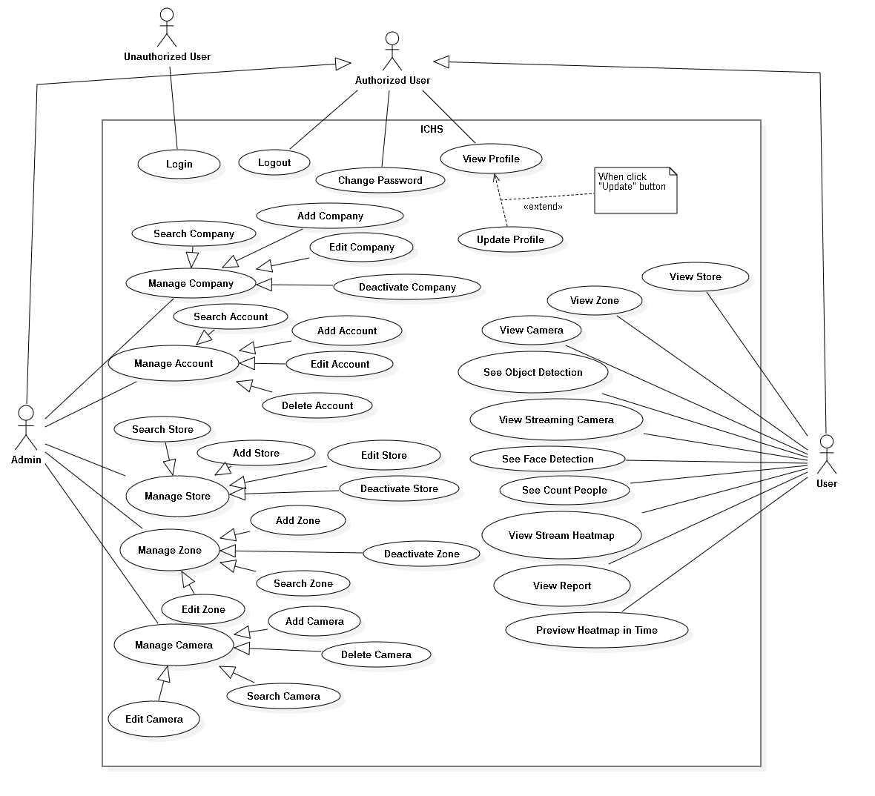

Figure 2 : System Overview Use Case Diagram

* 1. List of Use Case
     1. <Unauthorized User> Overview Use Case



Figure 3 : <Unauthorized User> Overview Use Case

##### <Unauthorized User> Login



Figure 4 : <Unauthorized User> Login

|  |  |  |  |
| --- | --- | --- | --- |
| **USE CASE – UC_01** | | | |
| **Use Case No.** | 01 | **Use Case Version** | 1.0 |
| **Use Case Name** | Login | | |
| **Author** | HuyVT | | |
| **Date** | 08/08/2018 | **Priority** | Normal |
| **Actor:**   * Unauthorized user   **Summary:**   * This use case allows the unauthorized log in the system.   **Goal:**   * Unauthorized logged in the system.   **Triggers:**   * Unauthorized clicks “Đăng nhập” button. * Unauthorized sends the login command.   **Preconditions:**   * Unauthorized at “Đăng nhập” page.   **Post Conditions:**   * **Success:** Unauthorized login the system. * **Fail:** System shows error message.   **Main Success Scenario:**   |  |  |  | | --- | --- | --- | | **Step** | **Actor Action** | **System Response** | | 1 | Unauthorized goes to Login page by clicking “Đăng nhập” button. | System requires information:   * Username: free text input. * Password: free text input. | | 2 | Unauthorized inputs information. |  | | 3 | Unauthorized clicks “Đăng nhập” button. | System validates the information and shows confirmation message.  [Exception 1,2,3] |   **Alternative:** N/A.  **Exceptions:**   |  |  |  | | --- | --- | --- | | **No** | **Cause** | **System Response** | | 1 | Network problem. | System shows “Đăng nhập không thành công!” message. | | 2 | Username is blank. | System shows “Tên tài khoản rỗng” message. | | 3 | Password is blank. | System shows “Mật khẩu rỗng” message. |   **Relationships:** N/A.  **Business Rules:**   * After logged in, system redirect to main page. * A notification pop-up when user login success. * System must ensure has no duplicate user. * Password must be greater than 6. | | | |

Table 13 : <Unauthorized User> Login

* + 1. <Authorized User> Overview Use Case

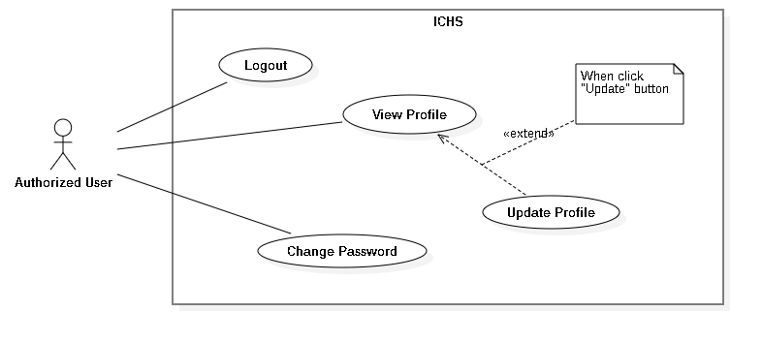

Figure 5 : <Authorized User> Overview Use Case

##### <Authorized User> Logout



Figure 6 : <Authorized User> Logout

|  |  |  |  |
| --- | --- | --- | --- |
| **USE CASE – UC_02** | | | |
| **Use Case No.** | 02 | **Use Case Version** | 1.0 |
| **Use Case Name** | User Logout | | |
| **Author** | HuyVT | | |
| **Date** | 08/08/2019 | **Priority** |  |
| **Actor:**   * User   **Summary:**   * This use case allows the authorized user logout from application.   **Goal:**   * Authorized user logout from the system.   **Triggers:**   * Authorized user clicks Settings button. * Authorized user clicks “Log Out” button. * Authorized user sends the logout command.   **Preconditions:**   * Authorized login success.   **Post Conditions:**   * **Success:** Authorized logout from system. * **Fail:** System shows error message.   **Main Success Scenario:**   |  |  |  | | --- | --- | --- | | **Step** | **Actor Action** | **System Response** | | 1 | User clicks “Log Out” button. | System displays dialog with “You want to log out?” message. | | 2 | User clicks “Yes” button. | User logout from the system. |   **Alternative:** N/A.  **Exception:**   |  |  |  | | --- | --- | --- | | **No** | **Actor Action** | **System Response** | | 1 | User clicks “Cancel” button. | Close the dialog. |   **Relationships:** N/A.  **Business Rules:**   * After logout from the system, system return Login page. * User can login with another account. | | | |

Table 14 : <Authorized User> Logout

##### <Authorized User> Change Password



Figure 7 : <Authorized User> Change Password

|  |  |  |  |
| --- | --- | --- | --- |
| **USE CASE – UC_03** | | | |
| **Use Case No.** | 03 | **Use Case Version** | 1.0 |
| **Use Case Name** | Change password | | |
| **Author** | HuyVT | | |
| **Date** | 08/08/2019 | **Priority** |  |
| **Actor:**   * User   **Summary:**   * This use case allows the authorized user logout from application.   **Goal:**   * Authorized user logout from the system.   **Triggers:**   * Authorized user clicks “Change password” button. * Authorized user sends the logout command.   **Preconditions:**   * Authorized login success.   **Post Conditions:**   * **Success:** Authorized logout from system. * **Fail:** System shows error message.   **Main Success Scenario:**   |  |  |  | | --- | --- | --- | | **Step** | **Actor Action** | **System Response** | | 1 | User clicks “Change password” button. | System shows change password page with request information in form:  + Old password: text input  + Password: text input  + Confirm password: text input | | 2 | User inputs password that need to change. |  | | 3 | User clicks “Change” button. | System validates the information and shows result in the main page.  [Exception 1, 2, 3, 4, 5] |   **Alternative:** N/A.  **Exception:**   |  |  |  | | --- | --- | --- | | **No** | **Actor Action** | **System Response** | | 1 | Network is problem. | System shows error message. | | 2 | Old password is blank | System shows “Old password is required!” message. | | 3 | Password is blank | System shows “Password is required!” message. | | 4 | Password length is not greater than 6 | System shows “Min length < 6” message. | | 5 | Confirm password are not equal with password | System shows “The passwords are not equal” message. |   **Relationships:** N/A.  **Business Rules:**   * New password must be greater than 6. * After change password, system shows “change password success” message and return dashboard page. * All field: old password, password, confirm password not blank. | | | |

Table 15 : <Authorized User> Change Password

##### <Authorized User> View Profile



Figure 8 : <Authorized User> View Profile

|  |  |  |  |
| --- | --- | --- | --- |
| **USE CASE – UC_04** | | | |
| **Use Case No.** | 04 | **Use Case Version** | 1.0 |
| **Use Case Name** | View Profile | | |
| **Author** | HuyVT | | |
| **Date** | 08/08/2019 | **Priority** |  |
| **Actor:**   * User   **Summary:**   * This use case allows the authorized user can view profile.   **Goal:**   * Authorized user check profile.   **Triggers:**   * Authorized user clicks “Edit profile” button. * Authorized user sends the logout command.   **Preconditions:**   * Authorized login success.   **Post Conditions:**   * **Success:** Authorized user can view profile. * **Fail:** System shows error message.   **Main Success Scenario:**   |  |  |  | | --- | --- | --- | | **Step** | **Actor Action** | **System Response** | | 1 | User clicks “Edit profile” button. | System displays profile page with request information in form:  + Username: text input (not edit)  + Fullname: text input  + Gender: male or female  + Email: text input  + Phone: text input  [Exception 1] |   **Alternative:** N/A.  **Exception:**   |  |  |  | | --- | --- | --- | | **No** | **Actor Action** | **System Response** | | 1 | Network has problem | System shows error message. |   **Relationships:** N/A.  **Business Rules: N/A.** | | | |

Table 16 : <Authorized User> View Profile

##### <Authorized User> Update Profile



Figure 9 : <Authorized User> Update Profile

|  |  |  |  |
| --- | --- | --- | --- |
| **USE CASE – UC_05** | | | |
| **Use Case No.** | 05 | **Use Case Version** | 1.0 |
| **Use Case Name** | Update Profile | | |
| **Author** | HuyVT | | |
| **Date** | 08/08/2019 | **Priority** |  |
| **Actor:**   * User   **Summary:**   * This use case allows the authorized user can update information of the profile.   **Goal:**   * Authorized user update profile.   **Triggers:**   * Authorized user clicks “Edit profile” button. * Authorized user clicks “Update” button. * Authorized user sends the logout command.   **Preconditions:**   * Authorized login success.   **Post Conditions:**   * **Success:** Authorized user update profile success. * **Fail:** System shows error message.   **Main Success Scenario:**   |  |  |  | | --- | --- | --- | | **Step** | **Actor Action** | **System Response** | | 1 | User clicks “Edit profile” button. | System displays profile page with request information in form:  + Username: text input (not edit)  + Fullname: text input  + Gender: male or female  + Email: text input  + Phone: text input | | 2 | User inputs information that need to update. |  | | 3 | User clicks “Update” button. | System validates the information and shows confirmation message.  [Exception 1, 2, 3, 4] |   **Alternative:** N/A.  **Exception:**   |  |  |  | | --- | --- | --- | | **No** | **Actor Action** | **System Response** | | 1 | Network has problem | System shows error message. | | 2 | Fullname is blank | System shows “Fullname is required!” message. | | 3 | Email is blank | System shows “Email is required!” message. | | 4 | Phone is blank | System shows “Phone is required!” message. |   **Relationships:** Extend from “View profile” use case.  **Business Rules: N/A.**   * After update, system return the dashboard page. * Phone must be 11 number. * Username not edit by user, only edit when admin ‘s role. | | | |

Table 17 : <Authorized User> Update Profile

* + 1. <Admin> Overview Use Case

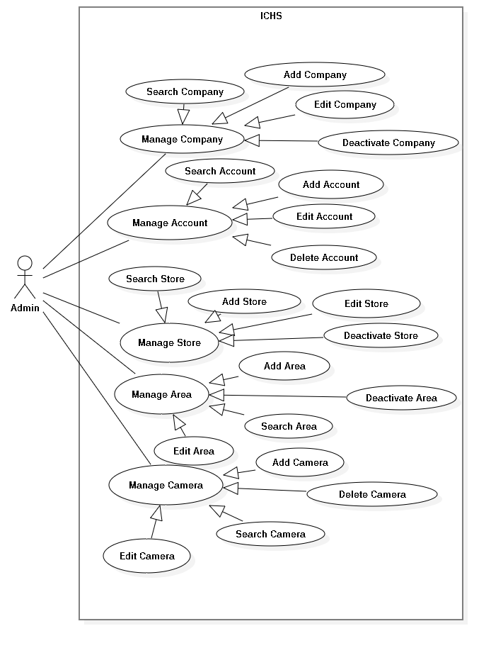

Figure 10 : <Admin>Overview Use Case Diagram

##### <Admin> Add Company



Figure 11 : <Admin> Add Company

|  |  |  |  |
| --- | --- | --- | --- |
| **USE CASE – UC_06** | | | |
| **Use Case No.** | 06 | **Use Case Version** | 1.0 |
| **Use Case Name** | Add Company | | |
| **Author** | CuongDQ | | |
| **Date** | 16/08/2019 | **Priority** |  |
| **Actor:**   * Admin   **Summary:**   * This use case allows the admin to add company.   **Goal:**   * Admin add new company.   **Triggers:**   * Admin clicks “Add Company” button. * Admin sends add company command.   **Preconditions:**   * Admin login success. * Admin is at “Company” page.   **Post Conditions:**   * **Success:** Admin add company successfully. * **Fail:** System displays error message.   **Main Success Scenario:**   |  |  |  | | --- | --- | --- | | **Step** | **Actor Action** | **System Response** | | 1 | Admin clicks “Add Company” button. | System displays “Add Company” page. Page contains 3 text fields and requires information:   * Name: text input * Address: text input | | 2 | Admin inputs information and clicks “Add” button | System displays message “Create Company Successfully !” |   **Alternative:** N/A.  **Exception:**   |  |  |  | | --- | --- | --- | | **No** | **Actor Action** | **System Response** | | 1 | Admin clicks “Back” button. | Back to Company page. | | 2 | Company Name is blank. | System displays “Name is required !” message. | | 3 | Company Address is blank. | System displays “Address is required !” message. |   **Relationships: Generalization** from “Manage Company” use case.  **Business Rules:**   * After add new company to the system, admin return to Company page. | | | |

Table 18: <Admin> Add Company

##### <Admin> Edit Company



Figure 12 : <Admin> Edit Company

|  |  |  |  |
| --- | --- | --- | --- |
| **USE CASE – UC_07** | | | |
| **Use Case No.** | 07 | **Use Case Version** | 1.0 |
| **Use Case Name** | Edit Company | | |
| **Author** | CuongDQ | | |
| **Date** | 16/08/2019 | **Priority** |  |
| **Actor:**   * Admin   **Summary:**   * This use case allows the admin to edit company.   **Goal:**   * Admin edit existing company.   **Triggers:**   * Admin clicks “Edit Company” button. * Admin sends edit company command.   **Preconditions:**   * Admin login success. * Admin is at “Company” page.   **Post Conditions:**   * **Success:** Admin edit company successfully. * **Fail:** System displays error message.   **Main Success Scenario:**   |  |  |  | | --- | --- | --- | | **Step** | **Actor Action** | **System Response** | | 1 | Admin clicks “Edit Company” button. | System displays “Add Company” page. Page contains 3 text fields and requires information:   * Name: text input * Address: text input | | 2 | Admin inputs information and clicks “Update” button | System displays message “Update Company Successfully !” |   **Alternative:** N/A.  **Exception:**   |  |  |  | | --- | --- | --- | | **No** | **Actor Action** | **System Response** | | 1 | Admin clicks “Back” button. | Back to Company page. | | 2 | Company Name is blank. | System displays “Name is required !” message. | | 3 | Company Address is blank. | System displays “Address is required !” message. |   **Relationships:** **Generalization** from “Manage Company” use case.  **Business Rules:**   * After edit company, admin return to Company page. | | | |

Table 19 : <Admin> Edit Company

##### <Admin> Search Company



Figure 13 : <Admin> Search Company

|  |  |  |  |
| --- | --- | --- | --- |
| **USE CASE – UC_08** | | | |
| **Use Case No.** | 08 | **Use Case Version** | 1.0 |
| **Use Case Name** | Search Company | | |
| **Author** | CuongDQ | | |
| **Date** | 16/08/2019 | **Priority** |  |
| **Actor:**   * Admin   **Summary:**   * This use case allows the admin to search Company.   **Goal:**   * Admin searches company in the system.   **Triggers:**   * Admin clicks “Search” button. * Admin sends search company command.   **Preconditions:**   * Admin login success. * Admin is in “Company” page.   **Post Conditions:**   * **Success:** Admin search company in system. * **Fail:** System displays error message.   **Main Success Scenario:**   |  |  |  | | --- | --- | --- | | **Step** | **Actor Action** | **System Response** | | 1 | Admin inputs keywords and clicks “Search” button in Company page. | System displays the “Company” page and shows all companies which name has keyword that admin input. |   **Alternative:** N/A.  **Exception:** N/A.  **Relationships:** **Generalization** from “Manage Company” use case.  **Business Rules:** N/A. | | | |

Table 20 : <Admin> Search Company

##### <Admin> Deactivate Company



Figure 14 : <Admin> Deactivate Company

|  |  |  |  |
| --- | --- | --- | --- |
| **USE CASE – UC_09** | | | |
| **Use Case No.** | 09 | **Use Case Version** | 1.0 |
| **Use Case Name** | Deactivate Company | | |
| **Author** | PhucDH | | |
| **Date** | 08/06/2019 | **Priority** |  |
| **Actor:**   * Admin   **Summary:**   * This use case allows the admin to deactivate company.   **Goal:**   * Admin deactivate existing company.   **Triggers:**   * Admin clicks “Inactive Company” button. * Admin sends deactivate company command.   **Preconditions:**   * Admin login success. * Admin is at “Company” page.   **Post Conditions:**   * **Success:** Admin deactivate company successfully. * **Fail:** System displays error message.   **Main Success Scenario:**   |  |  |  | | --- | --- | --- | | **Step** | **Actor Action** | **System Response** | | 1 | Admin clicks “Detail Company” button. | System displays Detail Company page. | | 2 | Admin clicks “Inactive” button. | Systems shows “Do you want to inactive ?”message. | |  | Admin clicks “Ok” button | System shows “Inactive Company successfully !”message. |   **Alternative:** N/A.  **Exception:**   |  |  |  | | --- | --- | --- | | **No** | **Actor Action** | **System Response** | | 1 | Admin clicks “Cancel” button. | Back to Company Detail page. |   **Relationships:** **Generalization** from “Manage Company” use case.  **Business Rules:**   * After deactivate company, admin return to Company page. * Inactive Company can’t view store or account. * Can’t edit inactive Company. | | | |

Table 21 : <Admin> Deactivate Company

##### <Admin> Add Account



Figure 15 : <Admin> Add Account

|  |  |  |  |
| --- | --- | --- | --- |
| **USE CASE – UC_10** | | | |
| **Use Case No.** | 10 | **Use Case Version** | 1.0 |
| **Use Case Name** | Add Account | | |
| **Author** | CuongDQ | | |
| **Date** | 08/06/2019 | **Priority** |  |
| **Actor:**   * Admin   **Summary:**   * This use case allows the admin to add new account to company.   **Goal:**   * Admin add new account.   **Triggers:**   * Admin clicks “Add Account” button. * Admin sends add account command.   **Preconditions:**   * Admin login success. * Admin is at “Account” page.   **Post Conditions:**   * **Success:** Admin add account successfully. * **Fail:** System displays error message.   **Main Success Scenario:**   |  |  |  | | --- | --- | --- | | **Step** | **Actor Action** | **System Response** | | 1 | Admin clicks “Add Account” button. | System displays “Add Account” page. Page contains 5 text fields, 2 checkboxes and requires information:   * Username: text input * Password: text input * Full Name: text input * Email: text input * Phone Number: text input * Gender: checkbox * Role: checkbox | | 2 | Admin inputs information and clicks “Add” button | System displays message “Add Account Successfully !” |   **Alternative:** N/A.  **Exception:**   |  |  |  | | --- | --- | --- | | **No** | **Actor Action** | **System Response** | | 1 | Admin clicks “Cancel” button. | Back to Account page. | | 2 | Username is blank. | System displays “Username is required !” message. | | 3 | Password is blank. | System displays “Min length < 6” message. | | 4 | Fullname is blank. | System displays “Fullname is required !” message. | | 5 | Email is blank. | System displays “Email must be right format” message. | | 7 | Username has been used. | System displays “This username is existed !” message. |   **Relationships: Generalization** from “Manage Account” use case.  **Business Rules:**   * After add new account to the company, admin return to Account page. * Phone must be number and with format (0xxxxxxxxx) or (84-xxxxxxxxx) | | | |

Table 22 : <Admin> Add Account

##### <Admin> Edit Account



Figure 16 : <Admin> Edit Account

|  |  |  |  |
| --- | --- | --- | --- |
| **USE CASE – UC_11** | | | |
| **Use Case No.** | 11 | **Use Case Version** | 1.0 |
| **Use Case Name** | Edit Account | | |
| **Author** | CuongDQ | | |
| **Date** | 08/06/2019 | **Priority** |  |
| **Actor:**   * Admin   **Summary:**   * This use case allows the admin to edit account.   **Goal:**   * Admin edit existing account.   **Triggers:**   * Admin clicks “Edit Account” button. * Admin sends edit account command.   **Preconditions:**   * Admin login success. * Admin is at “Account” page.   **Post Conditions:**   * **Success:** Admin edit account successfully. * **Fail:** System displays error message.   **Main Success Scenario:**   |  |  |  | | --- | --- | --- | | **Step** | **Actor Action** | **System Response** | | 1 | Admin clicks “Edit Account” button. | System displays “Edit Account” page. Page contains 5 text fields, 2 checkboxes and requires information:   * User Name: text input * Password: text input * Full Name: text input * Phone Number: text input * Email: text input * Gender: checkbox * Role: checkbox | | 2 | Admin inputs information and clicks “Update” button | System displays message “Update Account Successfully !” |   **Alternative:** N/A.  **Exception:**   |  |  |  | | --- | --- | --- | | **No** | **Actor Action** | **System Response** | | 1 | Admin clicks “Back” button. | Back to Account page. | | 2 | Username is blank. | System displays “Username is required !” message. | | 3 | Password is blank. | System displays “Min length < 6” message. | | 4 | Fullname is blank. | System displays “Fullname is required !” message. | | 5 | Email is blank. | System displays “Email must be right format” message. | | 7 | Username has been used. | System displays “This username is existed !” message. |   **Relationships: Generalization** from “Manage Account” use case.  **Business Rules:**   * After edit account, admin return to Account page. * Phone must be number and with format (0xxxxxxxxx) or (84-xxxxxxxxx) | | | |

Table 23 : <Admin> Edit Account

##### <Admin> Search Account



Figure 17 : <Admin> Search Account

|  |  |  |  |
| --- | --- | --- | --- |
| **USE CASE – UC_12** | | | |
| **Use Case No.** | 12 | **Use Case Version** | 1.0 |
| **Use Case Name** | Search Account | | |
| **Author** | CuongDQ | | |
| **Date** | 16/08/2019 | **Priority** |  |
| **Actor:**   * Admin   **Summary:**   * This use case allows the admin to search Account.   **Goal:**   * Admin searches account of the company.   **Triggers:**   * Admin clicks “Search” button. * Admin sends search account command.   **Preconditions:**   * Admin login success. * Admin is in “Account” page.   **Post Conditions:**   * **Success:** Admin search account in system. * **Fail:** System displays error message.   **Main Success Scenario:**   |  |  |  | | --- | --- | --- | | **Step** | **Actor Action** | **System Response** | | 1 | Admin inputs keywords and clicks “Search” button in Account page. | System displays the “Account” page and shows all Accounts which name has keyword that admin input. |   **Alternative:** N/A.  **Exception:** N/A.  **Relationships:** **Generalization** from “Manage Account” use case.  **Business Rules:** N/A. | | | |

Table 24 : <Admin> Search Account

##### <Admin> Delete Account



Figure 18 : <Admin> Delete Account

|  |  |  |  |
| --- | --- | --- | --- |
| **USE CASE – UC_13** | | | |
| **Use Case No.** | 13 | **Use Case Version** | 1.0 |
| **Use Case Name** | Delete Account | | |
| **Author** | CuongDQ | | |
| **Date** | 08/06/2019 | **Priority** |  |
| **Actor:**   * Admin   **Summary:**   * This use case allows the admin to delete account.   **Goal:**   * Admin delete existing account.   **Triggers:**   * Admin clicks “Delete Account” button. * Admin sends delete account command.   **Preconditions:**   * Admin login success. * Admin is at “Detail Account” page.   **Post Conditions:**   * **Success:** Admin delete account successfully. * **Fail:** System displays error message.   **Main Success Scenario:**   |  |  |  | | --- | --- | --- | | **Step** | **Actor Action** | **System Response** | | 1 | Admin clicks “Delete” button. | System displays “Do you want to delete account in this store ?” message. | | 2 | Admin clicks “Ok” button | System shows “Delete Account in this store successfully!”. |   **Alternative:** N/A.  **Exception:**   |  |  |  | | --- | --- | --- | | **No** | **Actor Action** | **System Response** | | 1 | Admin clicks “Cancel” button. | Back to Detail Account page. |   **Relationships:** **Generalization** from “Manage Account” use case.  **Business Rules:**   * After delete account, admin return to Account page. | | | |

Table 25 : <Admin> Delete Account

##### <Admin> Add Store



Figure 19 : <Admin> Add Store

|  |  |  |  |
| --- | --- | --- | --- |
| **USE CASE – UC_14** | | | |
| **Use Case No.** | 14 | **Use Case Version** | 1.0 |
| **Use Case Name** | Add Store | | |
| **Author** | PhucDH | | |
| **Date** | 08/06/2019 | **Priority** |  |
| **Actor:**   * Admin   **Summary:**   * This use case allows the admin to add store.   **Goal:**   * Admin add new store.   **Triggers:**   * Admin clicks “Add Store” button. * Admin sends add store command.   **Preconditions:**   * Admin login success. * Admin is at “Store” page.   **Post Conditions:**   * **Success:** Admin add store successfully. * **Fail:** System displays error message.   **Main Success Scenario:**   |  |  |  | | --- | --- | --- | | **Step** | **Actor Action** | **System Response** | | 1 | Admin clicks “Add Store” button. | System displays “Add Store” page. Page contains 3 text fields and requires information:   * Name: text input * Address: text input * Phone Number: text input | | 2 | Admin inputs information and clicks “Add” button | System displays message “Add Store Successfully !” |   **Alternative:** N/A.  **Exception:**   |  |  |  | | --- | --- | --- | | **No** | **Actor Action** | **System Response** | | 1 | Admin clicks “Back” button. | Back to Store page. | | 2 | Store Name is blank. | System displays “Name is required !” message. | | 3 | Store Address is blank. | System displays “Address is required !” message. | | 4 | Store Name has been used. | System displays “This store is existed !” message. |   **Relationships: Generalization** from “Manage Store” use case.  **Business Rules:**   * After add new store, admin return to Store page. * Phone must be number and with format (0xxxxxxxxx) or (84-xxxxxxxxx) | | | |

Table 26: <Admin> Add Store

##### <Admin> Edit Store



Figure 20 : <Admin> Edit Store

|  |  |  |  |
| --- | --- | --- | --- |
| **USE CASE – UC_15** | | | |
| **Use Case No.** | 15 | **Use Case Version** | 1.0 |
| **Use Case Name** | Edit Store | | |
| **Author** | PhucDH | | |
| **Date** | 08/06/2019 | **Priority** |  |
| **Actor:**   * Admin   **Summary:**   * This use case allows the admin to edit store.   **Goal:**   * Admin edit existing store.   **Triggers:**   * Admin clicks “Edit Store” button. * Admin sends edit store command.   **Preconditions:**   * Admin login success. * Admin is at “Store” page.   **Post Conditions:**   * **Success:** Admin edit store successfully. * **Fail:** System displays error message.   **Main Success Scenario:**   |  |  |  | | --- | --- | --- | | **Step** | **Actor Action** | **System Response** | | 1 | Admin clicks “Edit Store” button. | System displays “Edit Store” page. Page contains 3 text fields and requires information:   * Store Name: text input * Store Address: text input * Store Phone Number: text input | | 2 | Admin inputs information and clicks “Update” button | System displays message “Update Store Successfully !” |   **Alternative:** N/A.  **Exception:**   |  |  |  | | --- | --- | --- | | **No** | **Actor Action** | **System Response** | | 1 | Admin clicks “Back” button. | Back to Store page. | | 2 | Store Name is blank. | System displays “Name is required !” message. | | 3 | Store Address is blank. | System displays “Address is required !” message. | | 4 | Store Name has been used. | System displays “This store is existed !” message. |   **Relationships: Generalization** from “Manage Store” use case.  **Business Rules:**   * After edit store, admin return to Store page. * Phone must be number and with format (0xxxxxxxxx) or (84-xxxxxxxxx) | | | |

Table 27 : <Admin> Edit Store

##### <Admin> Search Store



Figure 21 : <Admin> Search Store

|  |  |  |  |
| --- | --- | --- | --- |
| **USE CASE – UC_16** | | | |
| **Use Case No.** | 16 | **Use Case Version** | 1.0 |
| **Use Case Name** | Search Store | | |
| **Author** | PhucDH | | |
| **Date** | 16/08/2019 | **Priority** |  |
| **Actor:**   * Admin   **Summary:**   * This use case allows the admin to search Store.   **Goal:**   * Admin searchs store of the company.   **Triggers:**   * Admin clicks “Search” button. * Admin sends search store command.   **Preconditions:**   * Admin login success. * Admin is in “Store” page.   **Post Conditions:**   * **Success:** Admin search store in system. * **Fail:** System displays error message.   **Main Success Scenario:**   |  |  |  | | --- | --- | --- | | **Step** | **Actor Action** | **System Response** | | 1 | Admin inputs keywords and clicks “Search” button in Store page. | System displays the “Store” page and shows all Store which name has keyword that admin input. |   **Alternative:** N/A.  **Exception:** N/A.  **Relationships:** **Generalization** from “Manage Store” use case.  **Business Rules:** N/A. | | | |

Table 28: <Admin> Search Store

##### <Admin> Deactivate Store



Figure 22 : <Admin> Deactivate Store

|  |  |  |  |
| --- | --- | --- | --- |
| **USE CASE – UC_17** | | | |
| **Use Case No.** | 17 | **Use Case Version** | 1.0 |
| **Use Case Name** | Deactivate Store | | |
| **Author** | PhucDH | | |
| **Date** | 08/06/2019 | **Priority** |  |
| **Actor:**   * Admin   **Summary:**   * This use case allows the admin to deactivate store.   **Goal:**   * Admin deactivate existing store.   **Triggers:**   * Admin clicks “Inactive Store” button. * Admin sends deactivate store command.   **Preconditions:**   * Admin login success. * Admin is at “Store” page.   **Post Conditions:**   * **Success:** Admin deactivate store successfully. * **Fail:** System displays error message.   **Main Success Scenario:**   |  |  |  | | --- | --- | --- | | **Step** | **Actor Action** | **System Response** | | 1 | Admin clicks “Detail Store” button. | System displays Detail Store page. | | 2 | Admin clicks “Inactive” button. | Systems shows “Do you want to inactive ?”message. | |  | Admin clicks “Ok” button | System shows “Inactive Store successfully !”message. |   **Alternative:** N/A.  **Exception:**   |  |  |  | | --- | --- | --- | | **No** | **Actor Action** | **System Response** | | 1 | Admin clicks “Cancel” button. | Back to Store Detail page. |   **Relationships:** **Generalization** from “Manage Store” use case.  **Business Rules:**   * After deactivate store, admin return to Store page. * Inactive Store can’t view Zone or account. * Can’t edit inactive store. | | | |

Table 29 : <Admin> Deactivate Store

##### <Admin> Add Zone

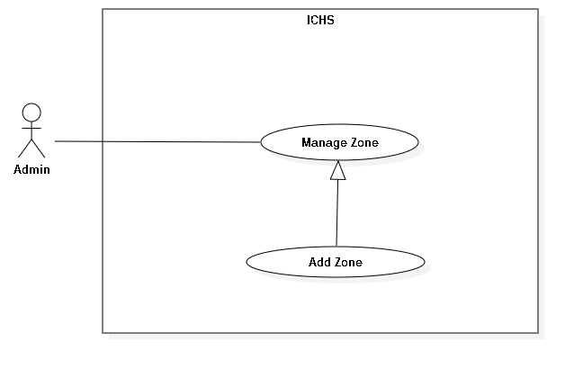

Figure 23 : <Admin> Add Zone

|  |  |  |  |
| --- | --- | --- | --- |
| **USE CASE – UC_18** | | | |
| **Use Case No.** | 18 | **Use Case Version** | 1.0 |
| **Use Case Name** | Add Zone | | |
| **Author** | PhucDH | | |
| **Date** | 08/06/2019 | **Priority** |  |
| **Actor:**   * Admin   **Summary:**   * This use case allows the admin to add Zone to store.   **Goal:**   * Admin add new Zone to store.   **Triggers:**   * Admin clicks “Add Zone” button. * Admin sends add Zone command.   **Preconditions:**   * Admin login success. * Admin is at “Zone” page.   **Post Conditions:**   * **Success:** Admin add Zone successfully. * **Fail:** System displays error message.   **Main Success Scenario:**   |  |  |  | | --- | --- | --- | | **Step** | **Actor Action** | **System Response** | | 1 | Admin clicks “Add Zone” button. | System displays “Add Zone” page. Page contains 2 text fields and requires information:   * Zone Floor: text input * Zone Name: text input | | 2 | Admin inputs information and clicks “Add” button | System displays message “Add Zone Successfully !” |   **Alternative:** N/A.  **Exception:**   |  |  |  | | --- | --- | --- | | **No** | **Actor Action** | **System Response** | | 1 | Admin clicks “Back” button. | Back to Zone page. | | 2 | Zone Floor is blank. | System displays “Floor is required !” message. | | 3 | Zone Name is blank. | System displays “Name is required !” message. |   **Relationships: Generalization** from “Manage Zone” use case.  **Business Rules:**   * After add new Zone, admin return to Zone page. | | | |

Table 30 : <Admin> Add Zone

##### <Admin> Edit Zone

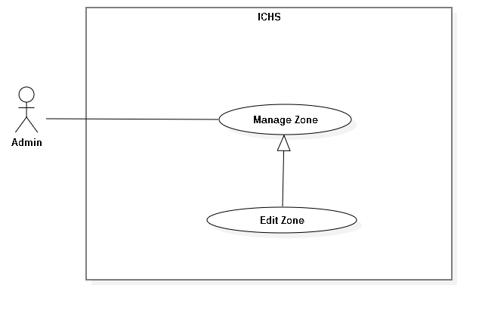

Figure 24 : <Admin> Edit Zone

|  |  |  |  |
| --- | --- | --- | --- |
| **USE CASE – UC_19** | | | |
| **Use Case No.** | 19 | **Use Case Version** | 1.0 |
| **Use Case Name** | Edit Zone | | |
| **Author** | PhucDH | | |
| **Date** | 08/06/2019 | **Priority** |  |
| **Actor:**   * Admin   **Summary:**   * This use case allows the admin to edit Zone.   **Goal:**   * Admin edit existing Zone.   **Triggers:**   * Admin clicks “Edit Zone” button. * Admin sends edit Zone command.   **Preconditions:**   * Admin login success. * Admin is at “Zone” page.   **Post Conditions:**   * **Success:** Admin edit Zone successfully. * **Fail:** System displays error message.   **Main Success Scenario:**   |  |  |  | | --- | --- | --- | | **Step** | **Actor Action** | **System Response** | | 1 | Admin clicks “Edit Zone” button. | System displays “Edit Zone” page. Page contains 2 text fields and requires information:   * Zone Floor: text input * Zone Name: text input | | 2 | Admin inputs information and clicks “Update” button | System displays message “Update Zone Successfully !” |   **Alternative:** N/A.  **Exception:**   |  |  |  | | --- | --- | --- | | **No** | **Actor Action** | **System Response** | | 1 | Admin clicks “Back” button. | Back to Zone page. | | 2 | Zone Floor is blank. | System displays “Floor is required !” message. | | 3 | Zone Name is blank. | System displays “Name is required !” message. |   **Relationships: Generalization** from “Manage Zone” use case.  **Business Rules:**   * After edit Zone, admin return to Zone page. | | | |

Table 31: <Admin> Edit Zone

##### <Admin> Search Zone

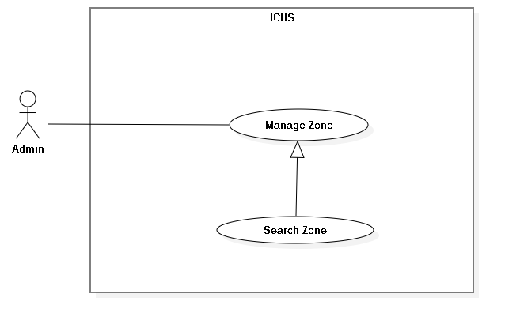

Figure 25 : <Admin> Search Zone

|  |  |  |  |
| --- | --- | --- | --- |
| **USE CASE – UC_20** | | | |
| **Use Case No.** | 20 | **Use Case Version** | 1.0 |
| **Use Case Name** | Search Zone | | |
| **Author** | PhucDH | | |
| **Date** | 16/08/2019 | **Priority** |  |
| **Actor:**   * Admin   **Summary:**   * This use case allows the admin to search Zone.   **Goal:**   * Admin searches Zone in the store.   **Triggers:**   * Admin clicks “Search” button. * Admin sends search Zone command.   **Preconditions:**   * Admin login success. * Admin is in “Zone” page.   **Post Conditions:**   * **Success:** Admin search store in system. * **Fail:** System displays error message.   **Main Success Scenario:**   |  |  |  | | --- | --- | --- | | **Step** | **Actor Action** | **System Response** | | 1 | Admin inputs keywords and clicks “Search” button in Zone page. | System displays the “Zone” page and shows all Zones which floor has keyword that admin input. |   **Alternative:** N/A.  **Exception:** N/A.  **Relationships:** **Generalization** from “Manage Zone” use case.  **Business Rules:** N/A. | | | |

Table 32 : <Admin> Search Zone

##### <Admin> Deactivate Zone

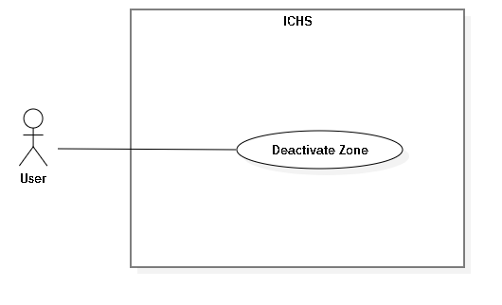

Figure 26 : <Admin> Deactivate Zone

|  |  |  |  |
| --- | --- | --- | --- |
| **USE CASE – UC_21** | | | |
| **Use Case No.** | 21 | **Use Case Version** | 1.0 |
| **Use Case Name** | Deactivate Zone | | |
| **Author** | PhucDH | | |
| **Date** | 08/06/2019 | **Priority** |  |
| **Actor:**   * Admin   **Summary:**   * This use case allows the admin to deactivate Zone.   **Goal:**   * Admin deactivate existing Zone.   **Triggers:**   * Admin clicks “Delete Zone” button. * Admin sends deactivate Zone command.   **Preconditions:**   * Admin login success. * Admin is at “Zone” page.   **Post Conditions:**   * **Success:** Admin deactivate Zone successfully. * **Fail:** System displays error message.   **Main Success Scenario:**   |  |  |  | | --- | --- | --- | | **Step** | **Actor Action** | **System Response** | | 1 | Admin clicks “Detail Zone” button. | System displays Detail Zone page. | | 2 | Admin clicks “Inactive” button. | Systems shows “Do you want to inactive ?”message. | |  | Admin clicks “Ok” button | System shows “Inactive Zone successfully !”message. |   **Alternative:** N/A.  **Exception:**   |  |  |  | | --- | --- | --- | | **No** | **Actor Action** | **System Response** | | 1 | Admin clicks “Cancel” button. | Back to Zone Detail page. |   **Relationships:** **Generalization** from “Manage Zone” use case.  **Business Rules:**   * After deactivate Zone, admin return to Zone page. * Inactive Zone can’t view camera. * Can’t edit inactive Zone. | | | |

Table 33 : <Admin> Deactivate Zone

##### <Admin> Add Camera



Figure 27 : <Admin> Add Camera

|  |  |  |  |
| --- | --- | --- | --- |
| **USE CASE – UC_22** | | | |
| **Use Case No.** | 22 | **Use Case Version** | 1.0 |
| **Use Case Name** | Add Camera | | |
| **Author** | PhucDH | | |
| **Date** | 08/06/2019 | **Priority** |  |
| **Actor:**   * Admin   **Summary:**   * This use case allows the admin to add camera to Zone.   **Goal:**   * Admin add new camera to Zone.   **Triggers:**   * Admin clicks “Add Camera” button. * Admin sends add camera command.   **Preconditions:**   * Admin login success. * Admin is at “Camera” page.   **Post Conditions:**   * **Success:** Admin add camera successfully. * **Fail:** System displays error message.   **Main Success Scenario:**   |  |  |  | | --- | --- | --- | | **Step** | **Actor Action** | **System Response** | | 1 | Admin clicks “Add Camera” button. | System displays “Add Camera” page. Page contains 1 text fields and 1 input file field requires information:   * Camera IP: text input | | 2 | Admin inputs information and clicks “Add” button | System displays message “Add Camera Successfully !” |   **Alternative:** N/A.  **Exception:**   |  |  |  | | --- | --- | --- | | **No** | **Actor Action** | **System Response** | | 1 | Admin clicks “Back” button. | Back to Camera page. | | 2 | Camera IP is blank. | System displays “IP must be number and with format (xxx.xxx.xxx.xxx: port)” message. |   **Relationships: Generalization** from “Manage Camera” use case.  **Business Rules:**   * After add new camera, admin return to camera page. | | | |

Table 34: <Admin> Add Camera

##### <Admin> Edit Camera



Figure 28 : <Admin> Edit Camera

|  |  |  |  |
| --- | --- | --- | --- |
| **USE CASE – UC_23** | | | |
| **Use Case No.** | 23 | **Use Case Version** | 1.0 |
| **Use Case Name** | Edit Camera | | |
| **Author** | PhucDH | | |
| **Date** | 08/06/2019 | **Priority** |  |
| **Actor:**   * Admin   **Summary:**   * This use case allows the admin to edit camera.   **Goal:**   * Admin edit existing camera.   **Triggers:**   * Admin clicks “Edit Camera” button. * Admin sends edit camera command.   **Preconditions:**   * Admin login success. * Admin is at “Camera” page.   **Post Conditions:**   * **Success:** Admin edit camera successfully. * **Fail:** System displays error message.   **Main Success Scenario:**   |  |  |  | | --- | --- | --- | | **Step** | **Actor Action** | **System Response** | | 1 | Admin clicks “Edit Camera” button. | System displays “Edit Camera” page. Page contains 1 text fields and 1 input file field requires information:   * Camera IP: text input | | 2 | Admin inputs information and clicks “Update” button | System displays message “Update Camera Successfully !” |   **Alternative:** N/A.  **Exception:**   |  |  |  | | --- | --- | --- | | **No** | **Actor Action** | **System Response** | | 1 | Admin clicks “Back” button. | Back to Camera page. | | 2 | Camera IP is blank. | System displays “IP must be number and with format (xxx.xxx.xxx.xxx)” message. |   **Relationships: Generalization** from “Manage Camera” use case.  **Business Rules:**   * After edit camera, admin return to Camera page. | | | |

Table 35 : <Admin> Edit Camera

##### <Admin>Search Camera



Figure 29 : <Admin> Search Camera

|  |  |  |  |
| --- | --- | --- | --- |
| **USE CASE – UC_24** | | | |
| **Use Case No.** | 24 | **Use Case Version** | 1.0 |
| **Use Case Name** | Search Camera | | |
| **Author** | PhucDH | | |
| **Date** | 16/08/2019 | **Priority** |  |
| **Actor:**   * Admin   **Summary:**   * This use case allows the admin to search Camera.   **Goal:**   * Admin searches camera in Zone.   **Triggers:**   * Admin clicks “Search” button. * Admin sends search camera command.   **Preconditions:**   * Admin login success. * Admin is in “Camera” page.   **Post Conditions:**   * **Success:** Admin search camera in system. * **Fail:** System displays error message.   **Main Success Scenario:**   |  |  |  | | --- | --- | --- | | **Step** | **Actor Action** | **System Response** | | 1 | Admin inputs keywords and clicks “Search” button in Camera page. | System displays the “Camera” page and shows all camera which IP has keyword that admin input. |   **Alternative:** N/A.  **Exception:** N/A.  **Relationships:** **Generalization** from “Manage Camera” use case.  **Business Rules:** N/A. | | | |

Table 36 : <Admin> Search Camera

##### <Admin> Delete Camera

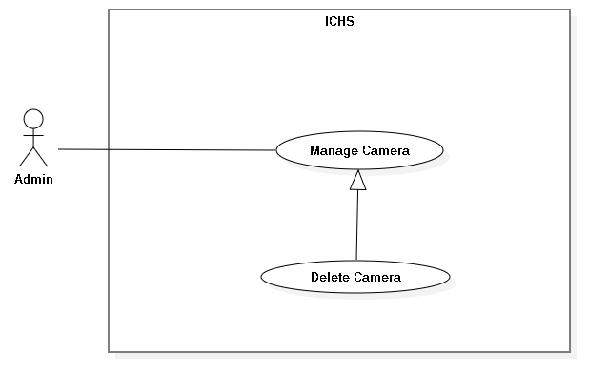

Figure 30 : <Admin> Delete Camera

|  |  |  |  |
| --- | --- | --- | --- |
| **USE CASE – UC_25** | | | |
| **Use Case No.** | 25 | **Use Case Version** | 1.0 |
| **Use Case Name** | Delete Camera | | |
| **Author** | PhucDH | | |
| **Date** | 08/06/2019 | **Priority** |  |
| **Actor:**   * Admin   **Summary:**   * This use case allows the admin to delete camera.   **Goal:**   * Admin delete existing camera.   **Triggers:**   * Admin clicks “Delete” button. * Admin sends deactivate camera command.   **Preconditions:**   * Admin login success. * Admin is at “Camera” page.   **Post Conditions:**   * **Success:** Admin delete camera successfully. * **Fail:** System displays error message.   **Main Success Scenario:**   |  |  |  | | --- | --- | --- | | **Step** | **Actor Action** | **System Response** | | 1 | Admin clicks “Detail Camera” button. | System displays Detail Camera page. | | 2 | Admin clicks “Delete” button. | Systems shows “Do you want to delete ?”message. | |  | Admin clicks “Ok” button | System shows “Delete Camera successfully !”message. |   **Alternative:** N/A.  **Exception:**   |  |  |  | | --- | --- | --- | | **No** | **Actor Action** | **System Response** | | 1 | Admin clicks “Cancel” button. | Back to Camera Detail page. |   **Relationships:** **Generalization** from “Manage Camera” use case.  **Business Rules:**   * After delete camera, admin return to Camera page. | | | |

Table 37 : <Admin> Delete Camera

* + 1. <User> Overview Use Case



Figure 31 : <User> Overview Use Case Diagram

##### <User> View Store



Figure 32 : <User> View Store

|  |  |  |  |
| --- | --- | --- | --- |
| **USE CASE – UC_26** | | | |
| **Use Case No.** | 26 | **Use Case Version** | 1.0 |
| **Use Case Name** | View Store | | |
| **Author** | HuyVT | | |
| **Date** | 08/08/2018 | **Priority** | Normal |
| **Actor:**   * User   **Summary:**   * This use case allows the user view store of company.   **Goal:**   * User view all stores within the limits allowed by the admin.   **Triggers:**   * User clicks “Store” button.   **Preconditions:**   * User login successful with account provided by the admin.   **Post Conditions:**   * **Success:** show all store with account user. * **Fail:** System shows error message.   **Main Success Scenario:**   |  |  |  | | --- | --- | --- | | **Step** | **Actor Action** | **System Response** | | 1 | User goes to dashboard page and click “store” button. | System show all store with account user.  [Exception 1] |   **Alternative:** N/A.  **Exceptions:**   |  |  |  | | --- | --- | --- | | **No** | **Cause** | **System Response** | | 1 | Network problem. | System shows error message. |   **Relationships:** N/A.  **Business Rules:** N/A. | | | |

Table 38 : <User> View Store

##### <User> View Zone

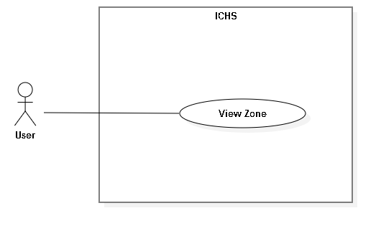

Figure 33 : <User> View Zone

|  |  |  |  |
| --- | --- | --- | --- |
| **USE CASE – UC_27** | | | |
| **Use Case No.** | 27 | **Use Case Version** | 1.0 |
| **Use Case Name** | View Zone | | |
| **Author** | TuyenNQ | | |
| **Date** | 08/08/2019 | **Priority** |  |
| **Actor:**   * User   **Summary:**   * This use case allows the user to view all Zones in one store.   **Goal:**   * User view all Zones in one store.   **Triggers:**   * User clicks “Store” button. * User clicks “View Zone” button. * User sends view Zone command.   **Preconditions:**   * User login successful with account provided by the admin. * User is at the chosen store page.   **Post Conditions:**   * **Success:** User view all Zones. * **Fail:** System shows error message.   **Main Success Scenario:**   |  |  |  | | --- | --- | --- | | **Step** | **Actor Action** | **System Response** | | 1 | User goes to dashboard page and click “store” button. | System show all store with account user. | | 2 | User clicks “Zone” button in Store page. | System displays the “Zone” page and shows Zones.  [Exception 1] |   **Alternative:** N/A.  **Exception:**   |  |  |  | | --- | --- | --- | | **No** | **Cause** | **System Response** | | 1 | Network problem. | System shows error message. |   **Relationships:** N/A.  **Business Rules:** N/A. | | | |

Table 39 : <User> View Zone

##### <User> View Camera



Figure 34 : - <User> View Camera

|  |  |  |  |
| --- | --- | --- | --- |
| **USE CASE – UC_28** | | | |
| **Use Case No.** | 28 | **Use Case Version** | 1.0 |
| **Use Case Name** | View Camera | | |
| **Author** | TuyenNQ | | |
| **Date** | 08/08/2019 | **Priority** |  |
| **Actor:**   * User   **Summary:**   * This use case allows the user to view all cameras in one Zone.   **Goal:**   * User view all cameras in one Zone that user choosen.   **Triggers:**   * User clicks “Store” button * User clicks “View Zone” button. * User clicks “Camera” button. * User sends view camera command.   **Preconditions:**   * User login success. * User is at the chosen Zone page.   **Post Conditions:**   * **Success:** User view all cameras. * **Fail:** System shows error message.   **Main Success Scenario:**   |  |  |  | | --- | --- | --- | | **Step** | **Actor Action** | **System Response** | | 1 | User goes to dashboard page and click “store” button. | System show all store with account user. | | 2 | User clicks “Zone” button in Store page. | System shows the “Zone” page and shows Zones. | | 3 | User clicks “Camera” button in Zone page. | System shows the “Camera” page and shows cameras.  [Exception 1] |   **Alternative:** N/A.  **Exception:**   |  |  |  | | --- | --- | --- | | **No** | **Cause** | **System Response** | | 1 | Network problem. | System shows error message. |   **Relationships:** N/A.  **Business Rules:** N/A. | | | |

Table 40 : <User> View Camera

##### <User> View Streaming Camera



Figure 35 : <User> View Streaming Camera

|  |  |  |  |
| --- | --- | --- | --- |
| **USE CASE – UC_29** | | | |
| **Use Case No.** | 29 | **Use Case Version** | 1.0 |
| **Use Case Name** | View Streaming Camera | | |
| **Author** | TuyenNQ | | |
| **Date** | 08/08/2019 | **Priority** |  |
| **Actor:**   * User   **Summary:**   * This use case allows the user to view the streaming video from the selected camera.   **Goal:**   * User view streaming video from camera.   **Triggers:**   * User clicks on “View Zone” button. * User clicks on “View camera” button. * User sends view streaming camera command.   **Preconditions:**   * User login success. * User is at “Camera” page.   **Post Conditions:**   * **Success:** User view streaming camera. * **Fail:** System displays error message.   **Main Success Scenario:**   |  |  |  | | --- | --- | --- | | **Step** | **Actor Action** | **System Response** | | 1 | User clicks on “View” button on store page. | System shows list all Zone in store. | | 2 | User clicks on “View” button on Zone page. | System shows list all camera in Zone. | | 3 | User click on “View” button on camera detail page. | System shows camera.  [Exception 1] |   **Alternative:** N/A.  **Exception:** N/A.   |  |  |  | | --- | --- | --- | | **No** | **Cause** | **System Response** | | 1 | Network problem. | System shows error message. |   **Relationships:** N/A.  **Business Rules:** N/A. | | | |

Table 41 : <User> View Streaming Camera

##### <User> See Object Detection



Figure 36 : <User> See Object Detection

|  |  |  |  |
| --- | --- | --- | --- |
| **USE CASE – UC_30** | | | |
| **Use Case No.** | 30 | **Use Case Version** | 1.0 |
| **Use Case Name** | See Object Detection | | |
| **Author** | TuyenNQ | | |
| **Date** | 08/08/2019 | **Priority** |  |
| **Actor:**   * User   **Summary:**   * This use case allows the user to see the object detection in streaming video from the selected camera.   **Goal:**   * User see object detection in streaming video.   **Triggers:**   * User clicks on “View Zone” button. * User clicks on “View camera” button. * User clicks the switch button in streaming video page. * User sends see object detection command.   **Preconditions:**   * User login success. * User is at “Camera Detail” page.   **Post Conditions:**   * **Success:** User see count people. * **Fail:** System shows error message.   **Main Success Scenario:**   |  |  |  | | --- | --- | --- | | **Step** | **Actor Action** | **System Response** | | 1 | User clicks on “View” button on store page. | System shows list all Zone in store. | | 2 | User clicks on “View” button on Zone page. | System shows list all camera in Zone. | | 3 | User click on “View” button on camera detail page. | System shows camera. | | 4 | User clicks “Object Detection” button. | System shows box in the video with count people.  [Exception 1] |   **Alternative:** N/A.  **Exception:**   |  |  |  | | --- | --- | --- | | **No** | **Cause** | **System Response** | | 1 | Network problem. | System shows error message. |   **Relationships:** N/A  **Business Rules:** N/A. | | | |

Table 42 : <User> See Object Detection

##### <User> See Count People



Figure 37 : <User> See Count People

|  |  |  |  |
| --- | --- | --- | --- |
| **USE CASE – UC_31** | | | |
| **Use Case No.** | 31 | **Use Case Version** | 1.0 |
| **Use Case Name** | See Count People | | |
| **Author** | TuyenNQ | | |
| **Date** | 08/08/2019 | **Priority** |  |
| **Actor:**   * User   **Summary:**   * This use case allows the user to see the people counting in streaming video from the selected camera.   **Goal:**   * User see count people in streaming video.   **Triggers:**   * User clicks on “View Zone” button. * User clicks on “View camera” button * User clicks the switch button in streaming video page. * User sends see count people command.   **Preconditions:**   * User login success. * User is at” Camera” page.   **Post Conditions:**   * **Success:** User view streaming camera. * **Fail:** System displays error message.   **Main Success Scenario:**   |  |  |  | | --- | --- | --- | | **Step** | **Actor Action** | **System Response** | | 1 | User clicks on “View” button on store page. | System shows list all Zone in store. | | 2 | User clicks on “View” button on Zone page. | System shows list all camera in Zone. | | 3 | User click on “View” button on camera detail page. | System shows camera. | | 4 | User clicks “Object Detection” in Camera Detail page. | System displays the video with count people. | | 5 |  | System shows box on streaming camera and detect person by box and count person.  [Exception 1] |   **Alternative:** N/A.  **Exception:**   |  |  |  | | --- | --- | --- | | **No** | **Cause** | **System Response** | | 1 | Network problem. | System shows error message. |   **Relationships:** N/A  **Business Rules:**   * System count people when people was detect. | | | |

Table 43 : <User> See count people

##### <User> See Face Detection



Figure 38 : <User> See Face Detection

|  |  |  |  |
| --- | --- | --- | --- |
| **USE CASE – UC_32** | | | |
| **Use Case No.** | 32 | **Use Case Version** | 1.0 |
| **Use Case Name** | See Face Detection | | |
| **Author** | TuyenNQ | | |
| **Date** | 08/08/2019 | **Priority** | Normal |
| **Actor:**   * User   **Summary:**   * This use case allows the user to see face detection in streaming video from the selected camera.   **Goal:**   * User see face detection in streaming video.   **Triggers:**   * User clicks on “View Zone” button. * User clicks on “View camera” button * User sends see count people command.   **Preconditions:**   * User login success. * User is at” Camera” page.   **Post Conditions:**   * **Success:** User view streaming camera. * **Fail:** System displays error message.   **Main Success Scenario:**   |  |  |  | | --- | --- | --- | | **Step** | **Actor Action** | **System Response** | | 1 | User clicks on “View” button on store page. | System shows list all Zone in store. | | 2 | User clicks on “View” button on Zone page. | System shows list all camera in Zone. | | 3 | User click on “View” button on camera detail page. | System shows camera. | | 4 |  | System shows box on streaming camera and detect face when face people near camera.  [Exception 1] |   **Alternative:** N/A.  **Exception:**   |  |  |  | | --- | --- | --- | | **No** | **Cause** | **System Response** | | 1 | Network problem. | System shows error message. |   **Relationships:** N/A  **Business Rules:**   * System face detection when face is near camera. * Face detection suggest age and gender for people. | | | |

Table 44 : <User> See Face Detection

##### <User> View Stream Heatmap



Figure 39 : <User> View Stream Heatmap

|  |  |  |  |
| --- | --- | --- | --- |
| **USE CASE – UC_33** | | | |
| **Use Case No.** | 33 | **Use Case Version** | 1.0 |
| **Use Case Name** | View Streaming Heatmap | | |
| **Author** | TuyenNQ | | |
| **Date** | 08/08/2019 | **Priority** |  |
| **Actor:**   * User   **Summary:**   * This use case allows the user to view the streaming heatmap from the selected camera.   **Goal:**   * User view streaming heatmap from camera.   **Triggers:**   * User clicks on “Store” button. * User clicks on “view Zone” button. * User clicks on “view camera” button. * User clicks on “heatmap” button of the camera. * User sends view streaming camera command.   **Preconditions:**   * User login success. * User is at “Camera” page.   **Post Conditions:**   * **Success:** User view streaming camera. * **Fail:** System displays error message.   **Main Success Scenario:**   |  |  |  | | --- | --- | --- | | **Step** | **Actor Action** | **System Response** | | 1 | User clicks on “store” button. | System shows list of store of user. | | 2 | User clicks on “View Zone” button. | System shows list of Zone in this store that user clicks on. | | 3 | User clicks on “view camera” button. | System shows that camera user clicks on. | | 4 | User clicks “heatmap” button. | System shows heatmap on this camera.  [Exception 1] |   **Alternative:** N/A.  **Exception:** N/A.   |  |  |  | | --- | --- | --- | | **No** | **Cause** | **System Response** | | 1 | Network problem. | System shows error message. |   **Relationships:** N/A.  **Business Rules:**   * Heatmap shows dots on streaming camera. | | | |

Table 45 : <User> View Stream Heatmap

##### <User> View Report



Figure 40 : <User> View Report

|  |  |  |  |
| --- | --- | --- | --- |
| **USE CASE – UC_34** | | | |
| **Use Case No.** | 34 | **Use Case Version** | 1.0 |
| **Use Case Name** | View Report | | |
| **Author** | TuyenNQ | | |
| **Date** | 08/08/2019 | **Priority** |  |
| **Actor:**   * User   **Summary:**   * This use case allows the user to view report from the selected camera.   **Goal:**   * User view streaming video from camera.   **Triggers:**   * User clicks the thumbnail of the camera. * User sends view streaming camera command.   **Preconditions:**   * User login success. * User is at” Camera” page.   **Post Conditions:**   * **Success:** User view streaming camera. * **Fail:** System displays error message.   **Main Success Scenario:**   |  |  |  | | --- | --- | --- | | **Step** | **Actor Action** | **System Response** | | 1 | User clicks thumbnail of the selected camera in Camera page. | System displays the selected camera page and shows streaming video.  [Exception 1] |   **Alternative:** N/A.  **Exception:**   |  |  |  | | --- | --- | --- | | **No** | **Cause** | **System Response** | | 1 | Network problem. | System shows error message. |   **Relationships:** N/A.  **Business Rules:**   * View report following store, Zone and camera. | | | |

Table 46 : <User> View Report

##### <User> Preview heatmap in time



Figure 41 : <User> View Heatmap

|  |  |  |  |
| --- | --- | --- | --- |
| **USE CASE – UC_35** | | | |
| **Use Case No.** | 35 | **Use Case Version** | 1.0 |
| **Use Case Name** | Preview Heatmap in Time | | |
| **Author** | TuyenNQ | | |
| **Date** | 08/08/2019 | **Priority** |  |
| **Actor:**   * User   **Summary:**   * This use case allows the user to view the streaming video from the selected camera and preview heatmap.   **Goal:**   * User view history heatmap.   **Triggers:**   * User clicks on “Store” button. * User clicks on “view Zone” button. * User clicks on “view camera” button. * User clicks on “preview heatmap” button. * User sends view streaming camera command.   **Preconditions:**   * User login success. * User is at “Camera” page.   **Post Conditions:**   * **Success:** User view streaming camera. * **Fail:** System displays error message.   **Main Success Scenario:**   |  |  |  | | --- | --- | --- | | **Step** | **Actor Action** | **System Response** | | 1 | User clicks on “store” button. | System shows list of store of user. | | 2 | User clicks on “View Zone” button. | System shows list of Zone in this store that user clicks on. | | 3 | User clicks on “view camera” button. | System shows that camera user clicks on. | | 4 | User clicks on “preview heatmap” button. | System shows heatmap in history.  [Exception 1] |   **Alternative:** N/A.  **Exception:**   |  |  |  | | --- | --- | --- | | **No** | **Cause** | **System Response** | | 1 | Network problem. | System shows error message. |   **Relationships:** N/A  **Business Rules:**   * System must be show heatmap on per time. * Heatmap update every 1 minute. | | | |

Table 47: <User> Preview heatmap in Time

## **3.Software System Attribute**

* 1. Usability

- User Interface is simple and easy to understand.

- Provide a convenient way to interact with system.

- Only takes about 1 hour to learn how to use.

- User only need to click without input anything else.

* 1. Reliability

- The accuracy of counting people is about 75%.

- The accuracy of heatmap is about 80%.

* 1. Security

- User connects to internet via browser to use the Web Application.

- Web Application uses the internet to push data to server and save on cloud.

- The system upload to cloud every day at 12:00 PM.

* 1. Maintainability

- The code is easy to manage, maintain or upgrade.

- The system will be maintained on the last day of each month.

- There will be immediate support when an incident occurs.

* 1. Portability

- The system is running on Windows 7 or above.

* 1. Performance
* Streaming camera ‘s FPS is about 10-15 so it is not too slow for watching camera.

## **Conceptual Diagram**

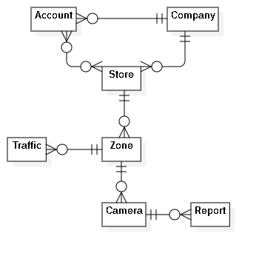

Figure 42 : Conceptual Diagram

|  |  |
| --- | --- |
| **Entity Data dictionary: describe all content of all entities** | |
| **Entity Name** | **Description** |
| Account | Contains the account information. |
| Company | Contains the company information. |
| Store | Contains the store information. |
| Zone | Contains the zone information. |
| Camera | Contains the camera information. |
| Report | Contains the report information. |
| Traffic | Contains the traffic information. |

Table 48 : Conceptual Diagram Dictionary

# **Software Design Description**

## **Design Overview**

* This document describes the technical and user interface design of ICHS system. It includes the architectural design, the detailed design of common functions and business functions and the design of database model.
* The architectural design describes the overall architecture of the system and the architecture of each main component and subsystem.
* The detailed design describes static and dynamic structure for each component and functions. It includes class diagrams, class explanations and sequence diagrams for each use cases.
* The database design describes the relationships between entities and details of each entity.
* Document overview:
* Section 2: gives an overall description of the system architecture design.
* Section 3: gives component diagrams that describe the connection and integration of the system.
* Section 4: gives the detail design description, which includes class diagram, class explanation, and sequence diagram to details the application functions.
* Section 5: describe a fully attributed Entity Relationship Diagram.

## **2. System Architecture Design**

### **Overview**



Figure 43 : System Architecture Design Overview

### **Server Architecture Design**



Figure 44 : Server Architecture Design

### **Server Architecture Description**

This Server is multi-thread server because Server always gets image from camera by RTSP, detect people and send it to web application when it receives request at the same time.

We split RTSP server into 3 group with separate features and we call it is Worker:

* CameraWorker: It is a group of features that interact with camera, it gets image from camera and check error when camera has incident.
* VideoWorker: It is a group of features that interact with video, it records video in local storage and upload it when new day is come.
* Worker: It if a group of features that use TensorFlow API to detect people, draw heatmap, detect face.

CameraWorker get image from camera and save it in redis by base64. When error is appeared, the latest image will save in error image in redis and check if current image is different with error image. If correct, it will set flag in redis and stop VideoWorker and Worker.

Worker will take image in redis and detect people in it and save detected image into redis. After 1 minute, it will call heatmap and face detection and send bounding boxes to draw get result face detection and save it in database.

VideoWorker get image from camera and record it to video and call upload video process at 00:00.

### **Web Application Architecture Design**



Figure 45 : Web Application Architecture Design

### **Web Application Architecture Description**

* API Web Server (Spring boot): the server handles all requests from front-end to query data from database and validate it then send http response to front-end.
* Database (MySQL Workbench 8.0 CE): this database store all data of system.
* Angular has component-based architecture that provides a higher quality of code. Encapsulation also ensures that new developers – who’ve been recently onboarded to a project – can read code better.

## **Component Diagram**



Figure 46 : Component Diagram

| **Components Dictionary: Describes components** | |
| --- | --- |
| Business Service | Component which handles business process for Web Sever. Include |
| Repository | Component which handles storing and retrieving data from database. |
| Controller | Component which handles request and response, accept input, convert it to commands for model and view. |
| Router | Handle request and response, accept input and convert it to commands for back-end |
| Admin Component | Handle admin’s activities in the system |
| Manager Component | Handle manager’s activities in the system |

Table 49: Component Dictionary

## **Detailed Description**

* 1. Class Diagram

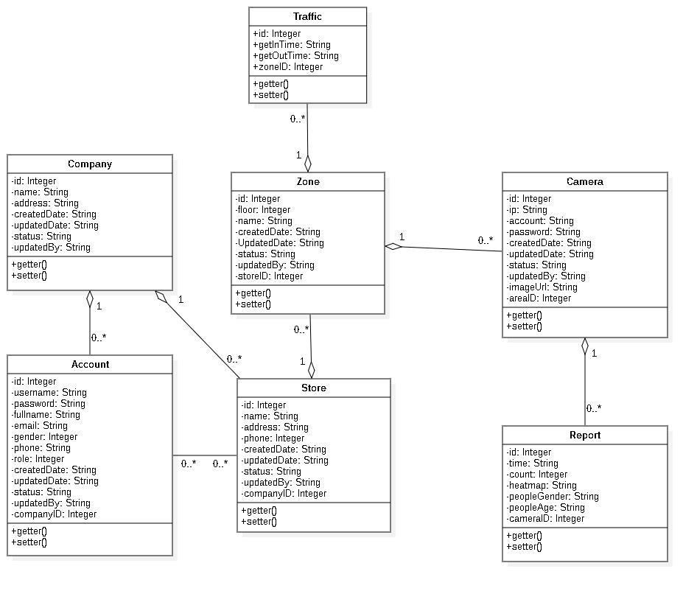

Figure 47 : Class Diagram

|  |  |  |
| --- | --- | --- |
| **CLASS DICTIONARY: DESCRIBE CLASS** | | |
| **Class Name** | **Mapping column with Conceptual diagram** | **Description** |
| **Company** | Company | Contains the information of Company |
| **Account** | Account | Contains the information of Account |
| **Store** | Store | Contains the information of Store |
| **Zone** | Zone | Contains the information of Zone |
| **Camera** | Camera | Contains the information of Camera |
| **Report** | Report | Contains the information of Report |
| **Traffic** | Traffic | Contains the information of Traffic |

Table 50 : Class Diagram Dictionary

* 1. Class Diagram Explanation
     1. Account

|  |  |  |  |
| --- | --- | --- | --- |
| Attribute | Type | Visibility | Description |
| Id | Integer | Private | Unique identifier of an account |
| Username | String | Private | Username of Account |
| Password | String | Private | Password of Account |
| Email | String | Private | Email of Account |
| Gender | Integer | Private | Gender of Account |
| Phone | Integer | Private | Phone number of Account |
| Role | Integer | Private | Role of Account |
| CreatedDate | String | Private | Date when account is created |
| UpdatedDate | String | Private | Date when account is updated |
| Status | String | Private | Status of account |
| UpdatedBy | String | Private | Which username updates account |
| CompanyID | Integer | Private | Contain information of the mentioned attribute |
| Method | **Return Type** | **Visibility** | **Description** |
| getter | DataType | Public | Get value for attribute |
| Setter | Void | Public | Set value for attribute |

Table 51 : Class Diagram Explanation <Account>

* + 1. Company

|  |  |  |  |
| --- | --- | --- | --- |
| Attribute | Type | Visibility | Description |
| Id | Integer | Private | Unique identifier of a company |
| Name | String | Private | Name of company |
| Address | String | Private | Address of company |
| CreatedDate | String | Private | Date when company is created |
| UpdatedDate | String | Private | Date when company is updated |
| Status | String | Private | Status of company |
| UpdatedBy | String | Private | Which username updates company |
| Method | **Return Type** | **Visibility** | **Description** |
| getter | DataType | Public | Get value for attribute |
| Setter | Void | Public | Set value for attribute |

Table 52 : Class Diagram Explanation <Company>

* + 1. Store

|  |  |  |  |
| --- | --- | --- | --- |
| Attribute | Type | Visibility | Description |
| Id | Integer | Private | Unique identifier of a store |
| Name | String | Private | Name of store |
| Address | String | Private | Address of store |
| Phone | Integer | Private | Phone of store |
| CreatedDate | String | Private | Date when store is created |
| UpdatedDate | String | Private | Date when store is updated |
| Status | String | Private | Status of store |
| UpdatedBy | String | Private | Which username updates store |
| CompanyID | Integer | Private | Contain information of the mentioned attribute |
| Method | **Return Type** | **Visibility** | **Description** |
| getter | DataType | Public | Get value for attribute |
| Setter | Void | Public | Set value for attribute |

Table 53 : Class Diagram Explanation <Store>

* + 1. Zone

|  |  |  |  |
| --- | --- | --- | --- |
| Attribute | Type | Visibility | Description |
| Id | Integer | Private | Unique identifier of an Zone |
| Floor | Integer | Private | Floor of Zone |
| Name | String | Private | Name of Zone |
| CreatedDate | String | Private | Date when Zone is created |
| UpdatedDate | String | Private | Date when Zone is updated |
| Status | String | Private | Status of Zone |
| UpdatedBy | String | Private | Which username updates Zone |
| StoreID | String | Private | Contain information of the mentioned attribute |
| Method | **Return Type** | **Visibility** | **Description** |
| getter | DataType | Public | Get value for attribute |
| setter | Void | Public | Set value for attribute |

Table 54 : Class Diagram Explanation <Zone>

* + 1. Camera

|  |  |  |  |
| --- | --- | --- | --- |
| Attribute | Type | Visibility | Description |
| Id | Integer | Private | Unique identifier of a camera |
| Ip | String | Private | Ip of camera |
| Account | String | Private | Account of camera |
| Passsword | String | Private | Password of camera |
| CreatedDate | String | Private | Date when camera is created |
| UpdatedDate | String | Private | Date when camera is updated |
| Status | String | Private | Status of camera |
| ImageUrl | String | Private | Image url of camera |
| UpdatedBy | String | Private | Which username updates camera |
| ZoneID | Integer | Private | Contain information of the mentioned attribute |
| Method | **Return Type** | **Visibility** | **Description** |
| getter | DataType | Public | Get value for attribute |
| Setter | Void | Public | Set value for attribute |

Table 55 : Class Diagram Explanation <Camera>

* + 1. Report

|  |  |  |  |
| --- | --- | --- | --- |
| Attribute | Type | Visibility | Description |
| Id | Integer | Private | Unique identifier of a report |
| Time | String | Private | Time of report |
| Count | String | Private | Number of counted people |
| Heatmap | String | Private | The matrix heatmap of people |
| PeopleGender | String | Private | Number gender of people |
| PeopleAge | String | Private | Number age of people |
| CameraID | Integer | Private | Contain information of the mentioned attribute |
| Method | **Return Type** | **Visibility** | **Description** |
| getter | DataType | Public | Get value for attribute |
| Setter | Void | Public | Set value for attribute |

Table 56: Class Diagram Explanation <Report>

* + 1. Traffic

|  |  |  |  |
| --- | --- | --- | --- |
| Attribute | Type | Visibility | Description |
| Id | Integer | Private | Unique identifier of traffic |
| GetInTime | String | Private | Time when get in |
| GetOutTime | String | Private | Time when get out |
| ZoneID | Integer | Private | Contain information of the mentioned attribute |
| Method | **Return Type** | **Visibility** | **Description** |
| getter | DataType | Public | Get value for attribute |
| Setter | Void | Public | Set value for attribute |

Table 57: Class Diagram Explanation<Traffic>

* 1. Interaction Diagram
     1. Login

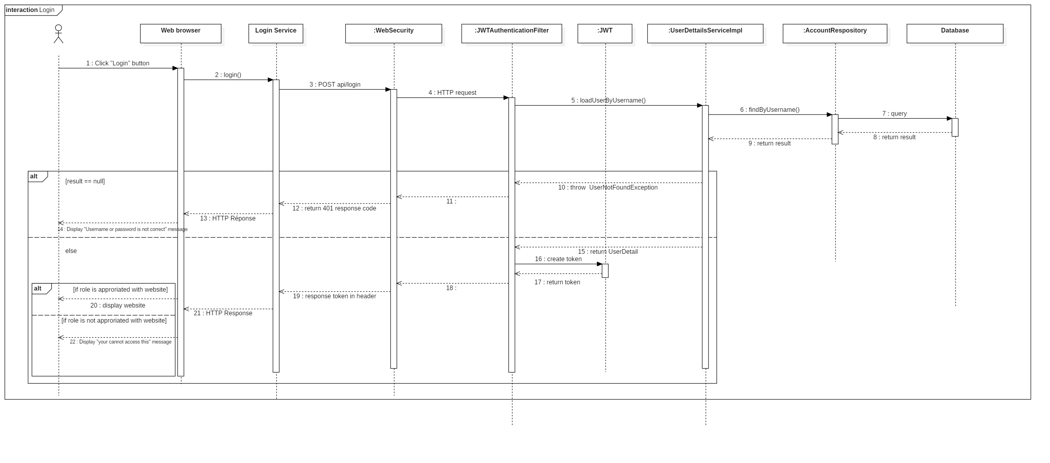

Figure 48 : Sequence Diagram <Login>

* + 1. Create Company

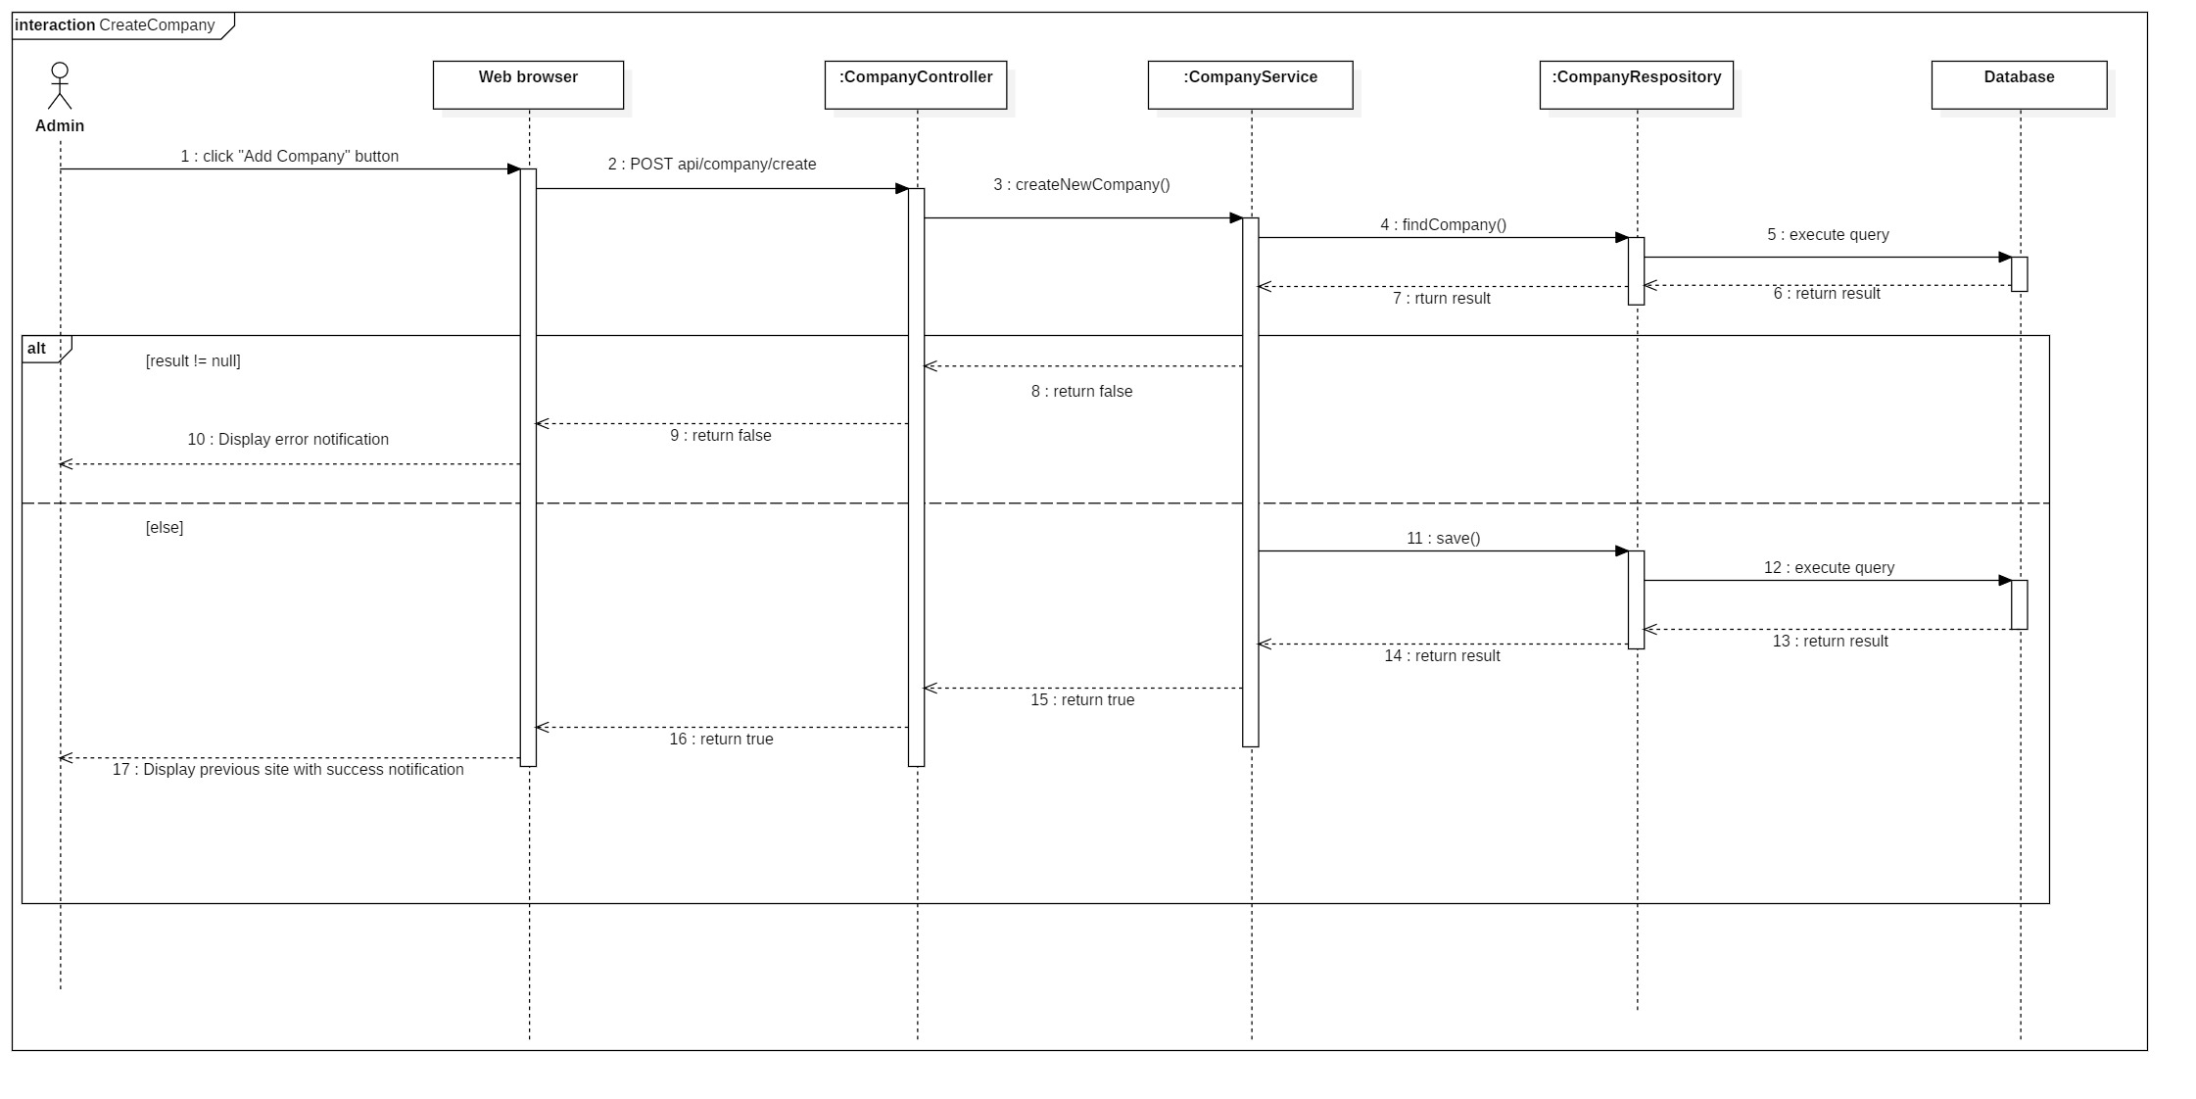

Figure 49 : Sequence Diagram <Create Company>

* + 1. Update Company

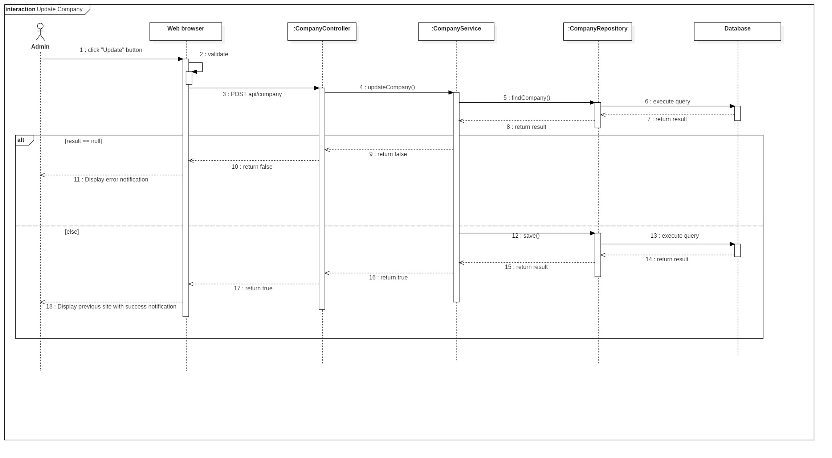

Figure 50 : Sequence Diagram <Update Company>

* + 1. Activate Company

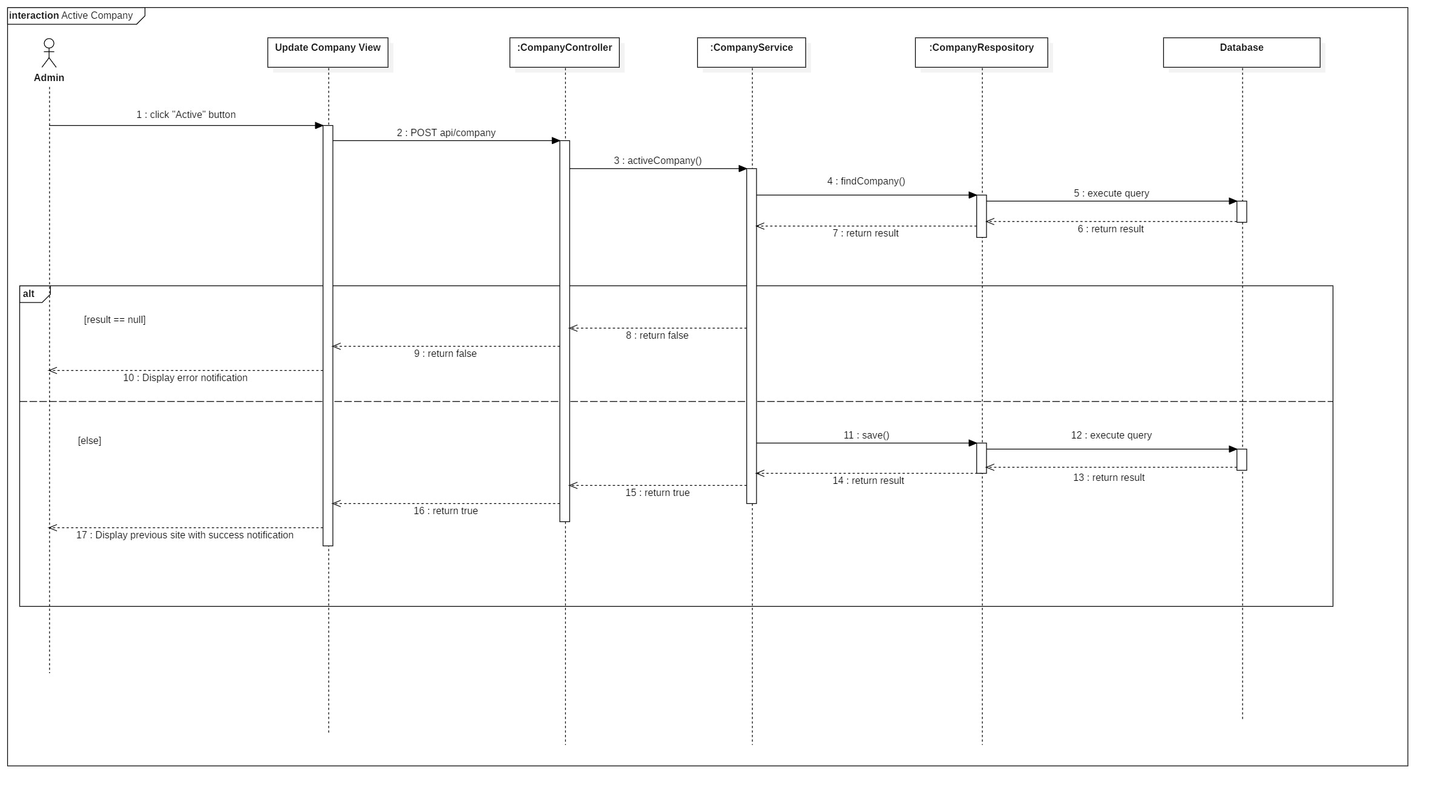

Figure 51 : Sequence Diagram <Activate Company>

* + 1. Deactivate Company

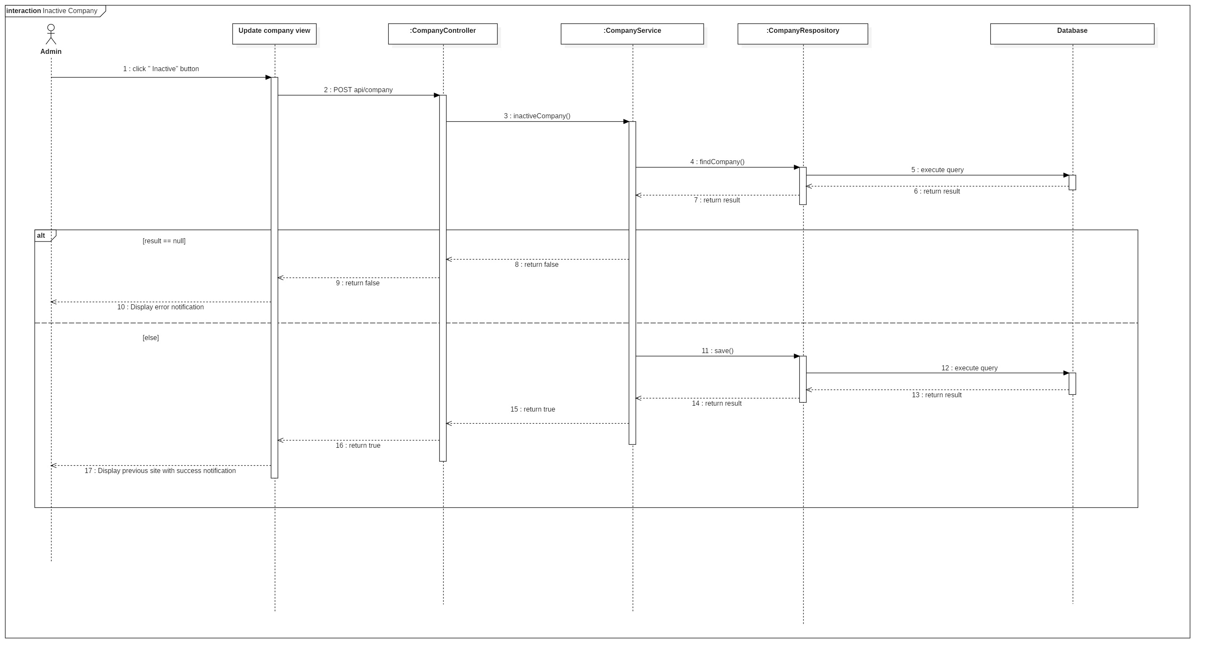

Figure 52 : Sequence Diagram <Deactivate Company>

* + 1. Search Company

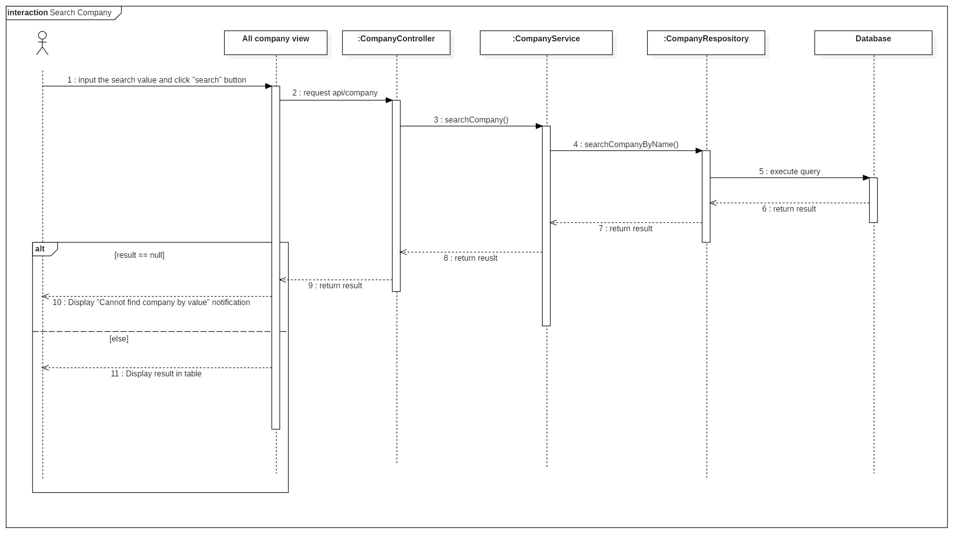

Figure 53 : Sequence Diagram <Search Company>

* + 1. Get report camera by time

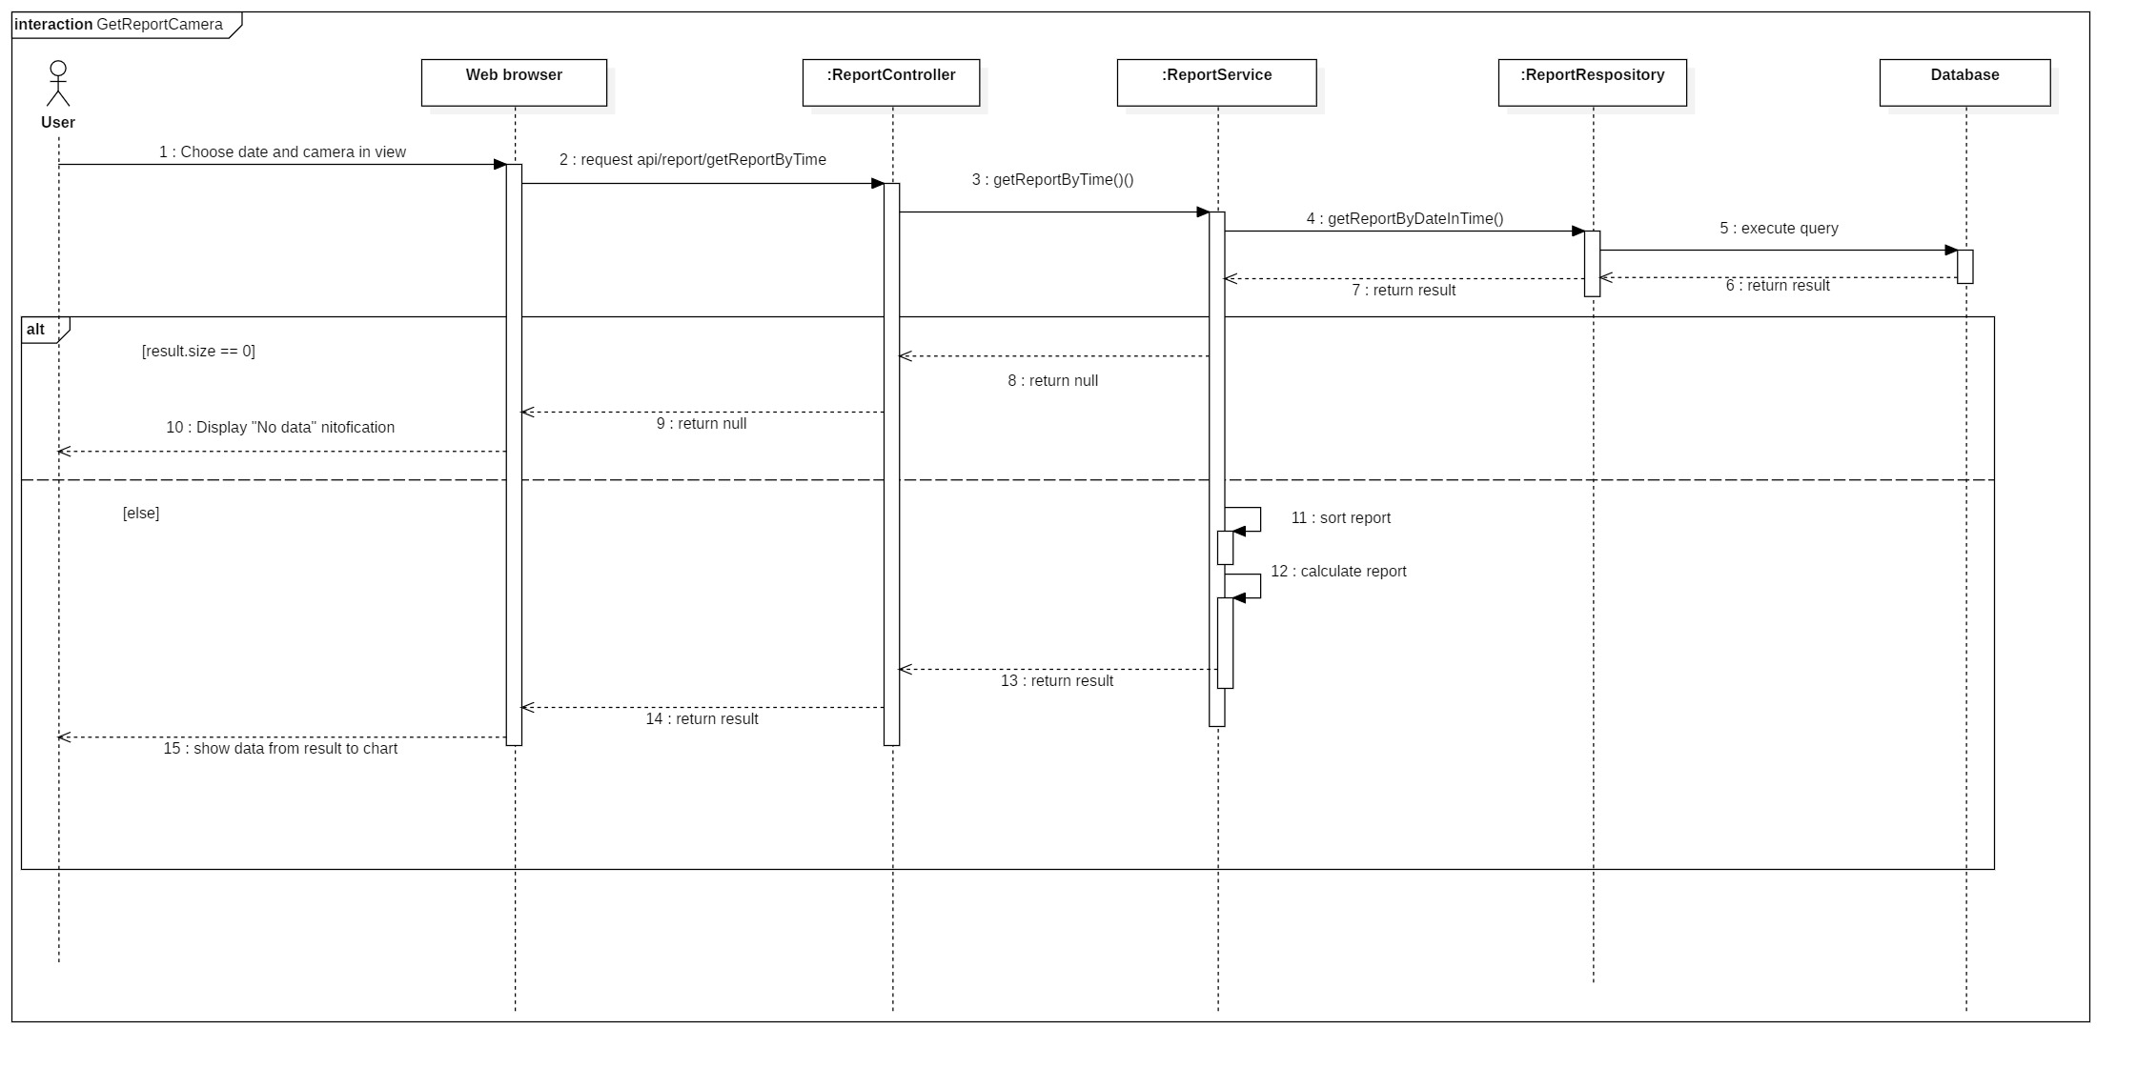

Figure 54 : Sequence Diagram <Get report camera by time>

* + 1. Get report Zone by time

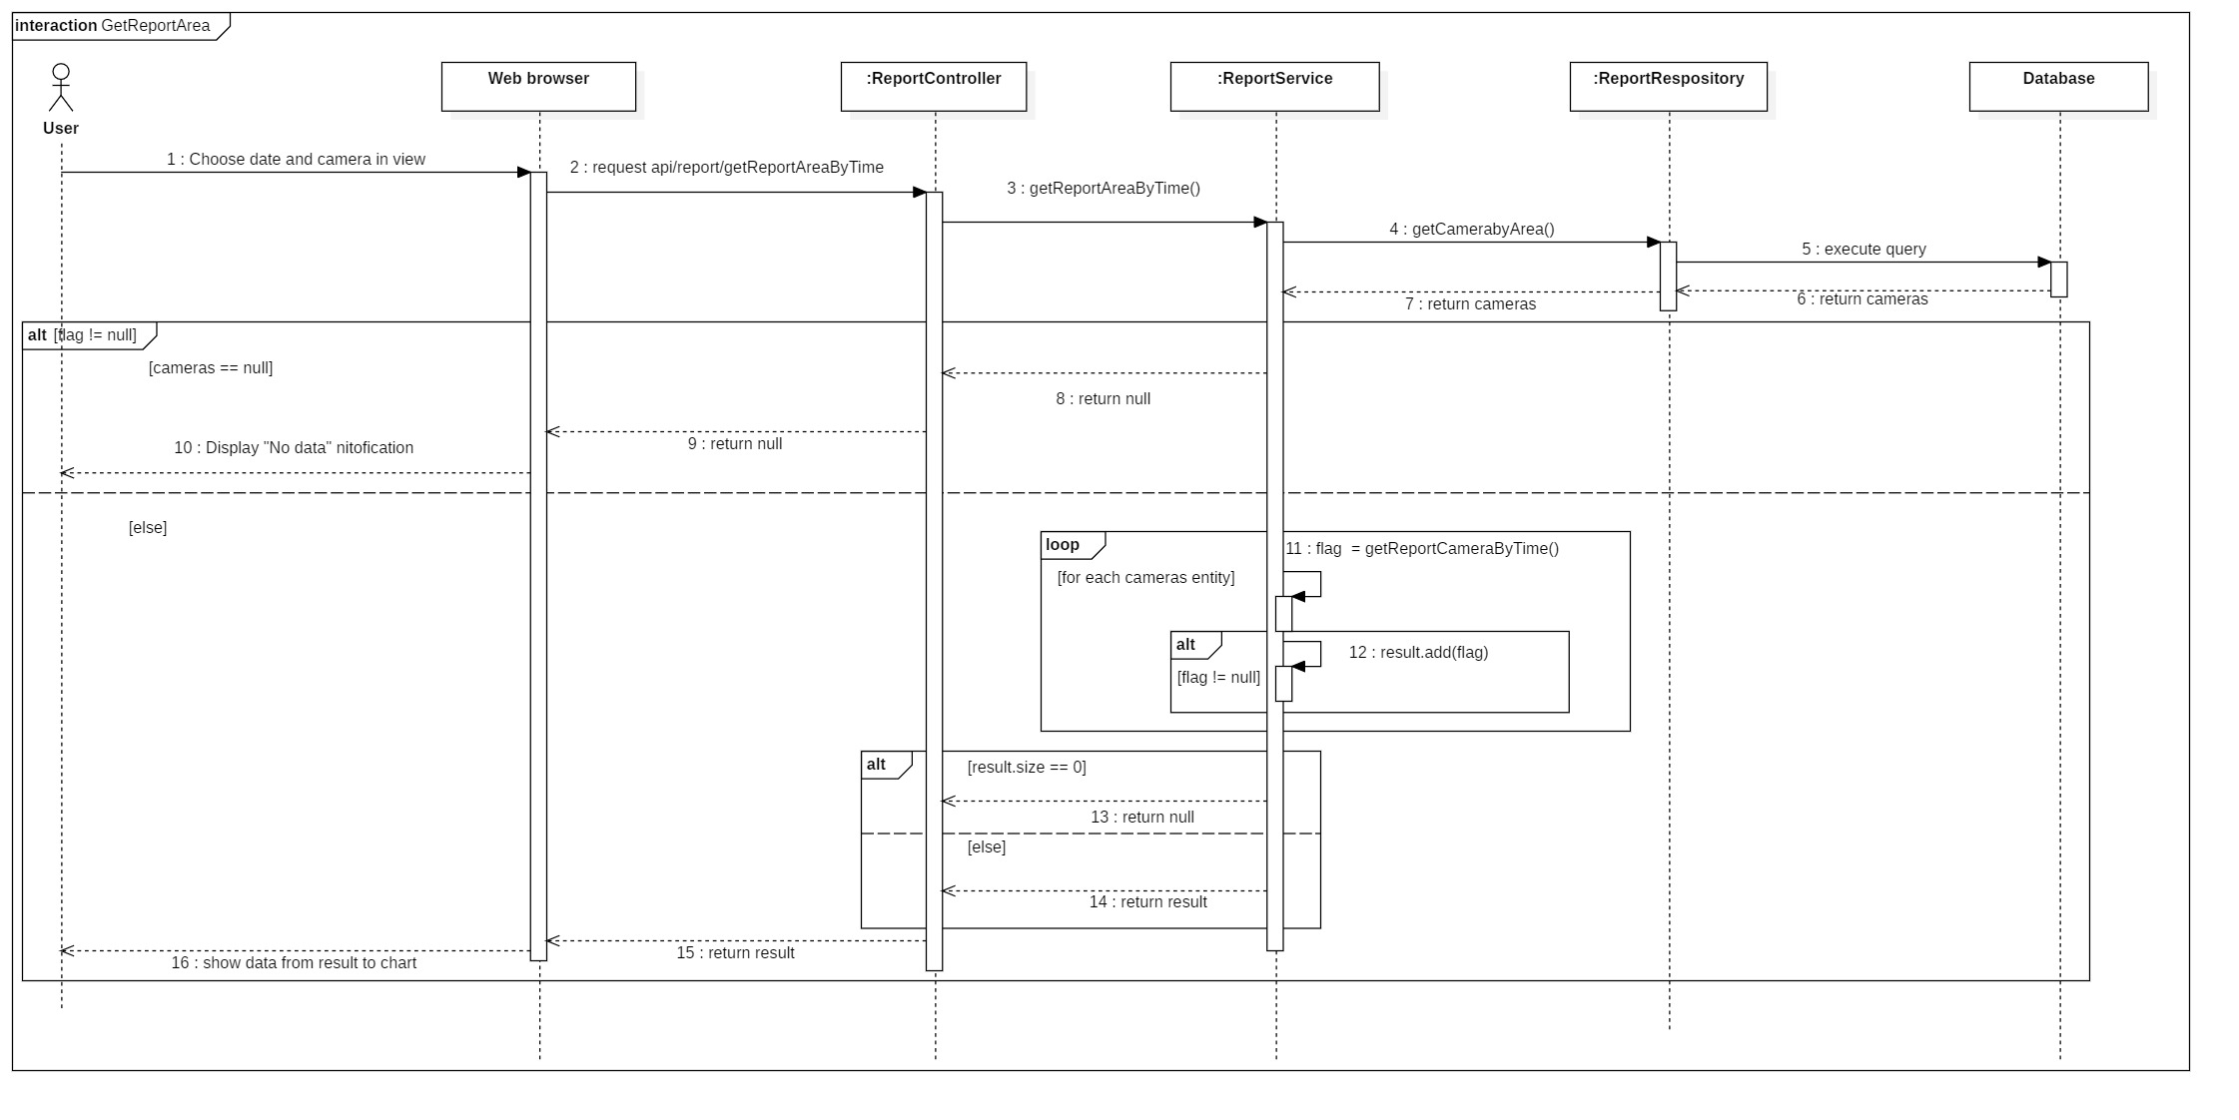

Figure 55 : Sequence Diagram <Get report Zone by time>

* + 1. Get report store by time

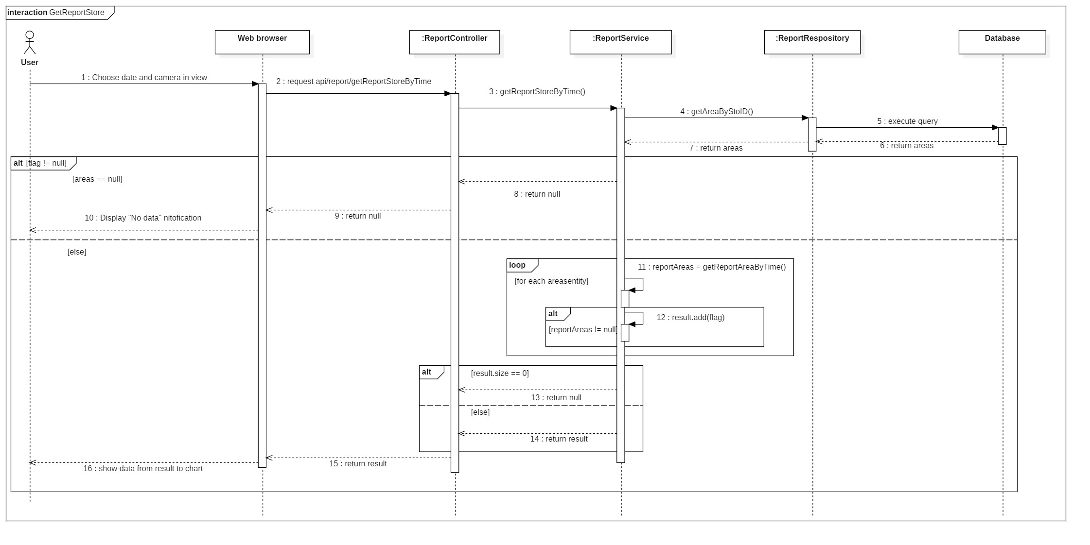

Figure 56 : Sequence Diagram <Get report store by time>

## **User Interface Design**

* 1. User
     1. Login



Figure 57 : User Interface <Login>

**Fields**

|  |  |  |  |  |  |  |
| --- | --- | --- | --- | --- | --- | --- |
| **No** | **Field Name** | **Description** | **Read only** | **Mandatory** | **Control Type** | **Data Type** |
| 1 | Username | Username of account to login | No | Yes | TextBox | String |
| 2 | Password | Password to login | No | Yes | Textbox | String |

Table 58 : Login <Field>

**Buttons/Hyperlinks**

|  |  |  |  |  |
| --- | --- | --- | --- | --- |
| **No** | **Function** | **Description** | **Validation** | **Outcome** |
| 3 | Login | Login to access the system | Require |  |

Table 59: Login < Buttons/Hyperlinks>

* + 1. Menu bar



Figure 58 : User Interface <Menu Bar>

**Buttons/Hyperlinks**

|  |  |  |  |  |
| --- | --- | --- | --- | --- |
| **No** | **Function** | **Description** | **Validation** | **Outcome** |
| 1 | Edit Profile | Edit detail of account | N/A | Transfer to detail account page |
| 2 | Change password | Change password of account | N/A | Transfer to change password page |
| 3 | Store | View list store of account | N/A | Transfer to view of stores |
| 4 | Statistic store | View statistic of store | N/A | Transfer to view of statistic store |
| 5 | Statistic Zone | View statistic of Zone | N/A | Transfer to view of statistic Zone |
| 6 | Statistic camera | View statistic of camera | N/A | Transfer to view of statistic camera |
| 7 | Logout | Logout | N/A | Transfer to login page |

Table 60 : Menu Bar < Buttons/Hyperlinks>

* + 1. Edit Profile



Figure 59 : User Interface <Edit Profile>

**Fields**

|  |  |  |  |  |  |  |
| --- | --- | --- | --- | --- | --- | --- |
| **No** | **Field Name** | **Description** | **Read only** | **Mandatory** | **Control Type** | **Data Type** |
| 1 | Fullname | Full name of account | No | Yes | TextBox | String |
| 2 | Gender | Gender of account | No | Yes | Radio | Integer |
| 3 | Email | Email of account | No | Yes | Textbox | String |
| 4 | Phone | Phone of account | No | Yes | Textbox | String |

Table 61 : Edit Profile < Fields >

**Buttons/Hyperlinks**

|  |  |  |  |  |
| --- | --- | --- | --- | --- |
| **No** | **Function** | **Description** | **Validation** | **Outcome** |
| 5 | Update | Update profile of account | N/A | Transfer to store view |

Table 62 : Edit Profile < Buttons/Hyperlinks>

* + 1. Change Password



Figure 60 : User Interface <Change Password>

**Fields**

|  |  |  |  |  |  |  |
| --- | --- | --- | --- | --- | --- | --- |
| **No** | **Field Name** | **Description** | **Read only** | **Mandatory** | **Control Type** | **Data Type** |
| 1 | Old password | Old password of account | No | Yes | TextBox | String |
| 2 | New Password | New password of account | No | Yes | TextBox | Strinf |
| 3 | Confirm password | Confirm new password | No | Yes | Textbox | String |

Table 63 : Change Password < Fields >

**Buttons/Hyperlinks**

|  |  |  |  |  |
| --- | --- | --- | --- | --- |
| **No** | **Function** | **Description** | **Validation** | **Outcome** |
| 4 | Update | Update password of account | N/A | Transfer to store view |

Table 64 : Change Password < Buttons/Hyperlinks>

* + 1. View list store



Figure 61 : User Interface <View List Store>

**Buttons/Hyperlinks**

|  |  |  |  |  |
| --- | --- | --- | --- | --- |
| **No** | **Function** | **Description** | **Validation** | **Outcome** |
| 1 | View | View all Zone of store | N/A | Transfer to Zone view |

Table 65 : View List Store < Buttons/Hyperlinks>

* + 1. View list Zone



Figure 62 : User Interface <View List Zone>

**Buttons/Hyperlinks**

|  |  |  |  |  |
| --- | --- | --- | --- | --- |
| **No** | **Function** | **Description** | **Validation** | **Outcome** |
| 1 | View | View all camera of Zone | N/A | Transfer to camera view |

Table 66 : View List Zone < Buttons/Hyperlinks>

* + 1. View list camera



Figure 63 : User Interface <View List Camera>

**Buttons/Hyperlinks**

|  |  |  |  |  |
| --- | --- | --- | --- | --- |
| **No** | **Function** | **Description** | **Validation** | **Outcome** |
| 1 | Live preview | Live and preview | N/A | Transfer to streaming camera page |

Table 67 : View List Camera < Buttons/Hyperlinks>

* + 1. Streaming Camera



Figure 64 : User Interface <Streaming Camera>

**Buttons/Hyperlinks**

|  |  |  |  |  |
| --- | --- | --- | --- | --- |
| **No** | **Function** | **Description** | **Validation** | **Outcome** |
| 1 | Show heatmap | Show heatmap in real-time | N/A | Image of heatmap is shown |
| 3 | Detect people and count | Detect all people in real-time and count. | N/A | Show all detected people |
| 4 | View of streaming | View of streaming camera | N/A |  |

Table 68 : Streaming Camera < Buttons/Hyperlinks>

* + 1. Preview Camera



Figure 65 : User Interface <Preview Camera>

**Fields**

|  |  |  |  |  |  |  |
| --- | --- | --- | --- | --- | --- | --- |
| **No** | **Field Name** | **Description** | **Read only** | **Mandatory** | **Control Type** | **Data Type** |
| 2 | Date picker | Choose date when user want to preview heatmap | No | Yes | Datetime picker | String |

Table 69 : Preview Camera < Fields>

**Buttons/Hyperlinks**

|  |  |  |  |  |
| --- | --- | --- | --- | --- |
| **No** | **Function** | **Description** | **Validation** | **Outcome** |
| 1 | View show heatmap on view of camera | Show heatmap | No |  |
| 3 | Time in one day | Choose time to know specific heatmap in time | N/A | Show heatmap preview in that time |
| 4 | Play | Show heatmap from time start to time end in one day | N/A | Show heatmap time-by-time |

Table 70 : Preview Camera < Buttons/Hyperlinks>

* + 1. Statistic Store



Figure 66 : User Interface <Statistic Store>

**Fields**

|  |  |  |  |  |  |  |
| --- | --- | --- | --- | --- | --- | --- |
| **No** | **Field Name** | **Description** | **Read only** | **Mandatory** | **Control Type** | **Data Type** |
| 3 | Month year picker | Choose month year when user wants to statistic | No | Yes | Datetime picker | String |

Table 71 : Statistic Store < Fields>

**Buttons/Hyperlinks**

|  |  |  |  |  |
| --- | --- | --- | --- | --- |
| **No** | **Function** | **Description** | **Validation** | **Outcome** |
| 1 | Show to chart number of counted people | Show chart | N/A |  |
| 2 | Choose specific type of statistic | Choose type of statistic such as month day, from time to time | Require |  |
| 4 | Choose which store want to statistic | Choose store of account which the user wants to statistic | Require | Show detail of store |

Table 72 : Statistic Store < Buttons/Hyperlinks>

* + 1. Statistic Zone



Figure 67 : User Interface <Statistic Zone>

**Fields**

|  |  |  |  |  |  |  |
| --- | --- | --- | --- | --- | --- | --- |
| **No** | **Field Name** | **Description** | **Read only** | **Mandatory** | **Control Type** | **Data Type** |
| 3 | Date picker | Choose date when user wants to statistic | No | Yes | Datetime picker | String |

Table 73 : Statistic Zone < Fields >

**Buttons/Hyperlinks**

|  |  |  |  |  |
| --- | --- | --- | --- | --- |
| **No** | **Function** | **Description** | **Validation** | **Outcome** |
| 1 | Show to chart number of counted people | Show chart | N/A |  |
| 2 | Choose specific type of statistic | Choose type of statistic such as month day, from time to time | Require |  |
| 4 | Choose which Zone want to statistic | Choose Zone of account which the user wants to statistic | Require | Show detail of Zone |

Table 74 : Statistic Zone < Buttons/Hyperlinks>

* + 1. Statistic Camera



Figure 68 : User Interface <Statistic Camera>

**Fields**

|  |  |  |  |  |  |  |
| --- | --- | --- | --- | --- | --- | --- |
| **No** | **Field Name** | **Description** | **Read only** | **Mandatory** | **Control Type** | **Data Type** |
| 3 | Time start and time end | Choose specific time start and time end of statistic | No | Yes | Dropdown box | String |

Table 75 : Statistic Camera < Fields>

**Buttons/Hyperlinks**

|  |  |  |  |  |
| --- | --- | --- | --- | --- |
| **No** | **Function** | **Description** | **Validation** | **Outcome** |
| 1 | Show to chart number of counted people | Show chart | N/A |  |
| 2 | Choose specific type of statistic | Choose type of statistic such as month day, from time to time | Require |  |
| 4 | Choose which camera want to statistic | Choose camera of account which the user wants to statistic | Require | Show detail of camera |

Table 76 : Statistic Camera < Buttons/Hyperlinks>

## **Database Design**

* 1. Entity Relationship Diagram

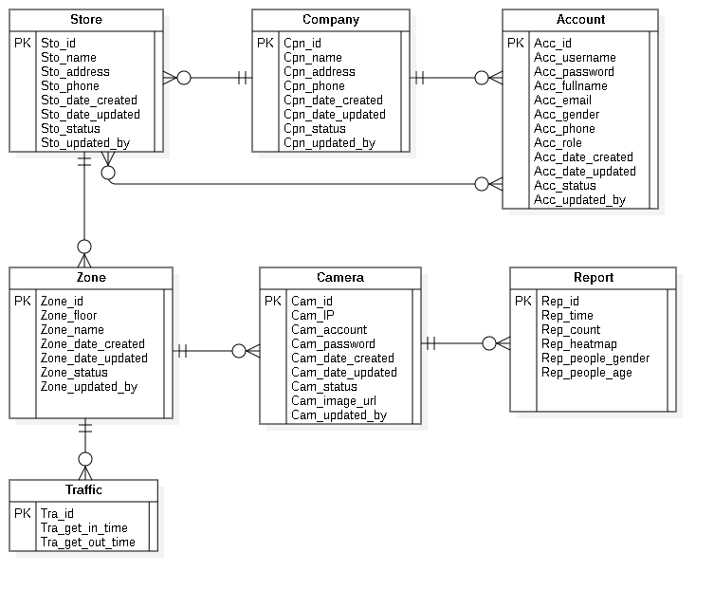

Figure 69 : Entity Relationship Diagram

6.2 Entity Dictionary

|  |  |  |
| --- | --- | --- |
| **Entity dictionary** | | |
| **Entity Name** | **Mapping column with Conceptual diagram** | **Description** |
| **Account** | Account | Contain the account information. |
| **Company** | Company | Contain the company information. |
| **Store** | Store | Contain the store information |
| **Zone** | Zone | Contain the Zone information. |
| **Camera** | Camera | Contain the camera information. |
| **Report** | Report | Contain the report information. |
| **Traffic** | Traffic | Contain the traffic information. |

Table 77 : Entity Relationship Diagram Dictionary

## **Algorithms**

### **Faster RCNN**

* + 1. ***Definition***

Faster RCNN is one of the most well-known objects detection networks which have 3 neural networks (Feature Network, Region Proposal Network, Detection Network). It is very useful for detecting object.

* + 1. ***Define problems***

We don’t have experience of training AI for detecting people. Because people is object that needed detect so It need a big data set to train for many posture. So we decide to use TensorFlow API that use this algorithms.

* + 1. ***Solution***

we decide to use TensorFlow API that use this algorithm.

Faster RCNN is Algorithms that TensorFlow API is using for detect object in image.





Figure 70 : Faster RCNN 1

Steps:

1. Take image to Region Proposal Network (RPN) to get Region Proposal which has ability that contain object.
2. By RPN, we can define which box have object and by ROI Pooling to convert image to fixed size image.
3. After get fixed image, classify object in image and return 2 result: class which is type of object and bounding boxes.

* **Region Proposal Network**

Input is image and output are Region Proposal which is rectangle. Instead of using (x center, y center, width, height), RPN detect Region Proposal by using Anchor and create anchor box with 4 parameters (x min, y min, x max, y max)





Figure 71 : Faster RCNN 2

### **Draw Heatmap**

* + 1. ***Definition***

Using LinearSegmentedColormap to create color map and use it to define what color based on grayscale image.

* + 1. ***Define problem***

Color must be changed based on long people stay in camera

* + 1. ***Solution***

Use dot image to draw on grayscale image.



Figure 72 : Draw Heatmap <Dot Image>

And create a heatmap color image in local storage.



Figure 73 : Draw Heatmap <Color Range>

We will set list of dots in a white image that it will become grayscale image and change its color based on how black it is.

 

Figure 74 : Draw Heatmap <Heatmap Color Image>

### **Face Detection**

* + 1. *Definition*

The Haar-like algorithm is also used for feature selection or feature extraction for an object in an image, with the help of edge detection, line detection, centre detection for detecting eyes, nose, mouth, etc. in the picture.

* + 1. *Define problem*

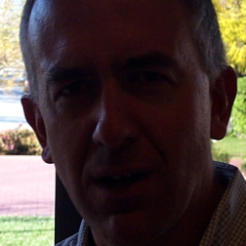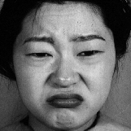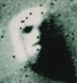

Figure 75 : Face Detection

Light, masked, special emotion, looks like face ...

* + 1. *Solution*

Featured of Haar-like

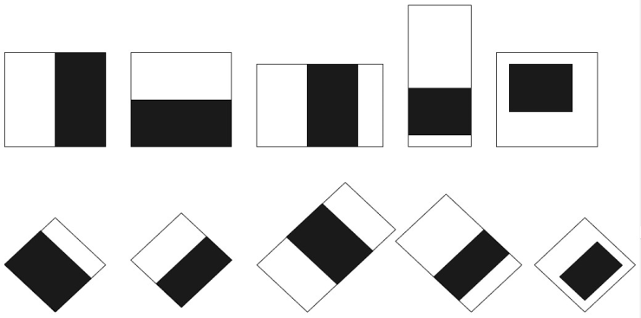

Figure 76 : Face Detection <Haar-Like> 1

Haar-like algorithm give the coordinates of x, y, w, h which makes a rectangle box in the picture to show the location of the face or we can say that to show the region of interest in the image. After this, it can make a rectangle box in the area of interest where it detects the face.

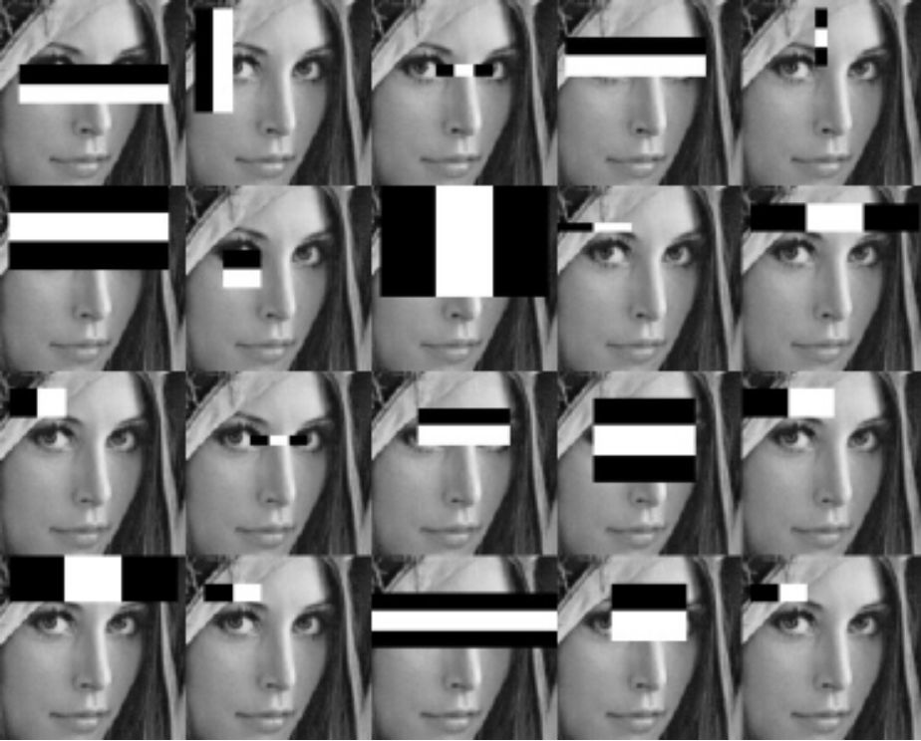

Figure 77 : Face Detection <Haar-Like> 2

# **System Implementation & Test**

## **Introduction**

* 1. Overview

This section describes the approach and methodologies used by group to plan, organize and manage the testing of ICHS. It provides in detail all necessary information about the implementation and testing procedure of the system included test plans, test cases, test result, test environments, pass/fail criteria and risks estimations as well as a checklist to cover all possible cases.

* 1. Test Approach
* **Goal**: Test all features in the whole VHT application based on the core flow.
* **Method**: Black-box testing.
* **Technique**: Check list.

The testing for this project consists of Integration System test level. Testing the program which was integrated and as a complete system to ensure that the software requirements have been met.

* Integration testing is performed by all member of team and approved by team leader.
* System testing is focused on assessing the system’s reliability. This process is concerned with finding errors that result from unanticipated interactions between components and component interface problems.

## **Database Relationship Diagram**

* 1. Physical Diagram

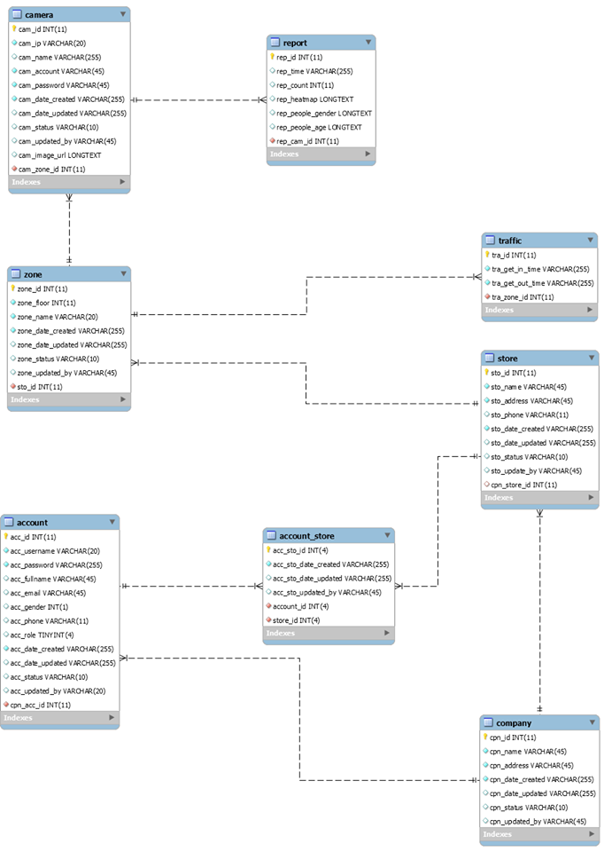

Figure 78 : Physical Diagram

* 1. Data Dictionary

|  |  |
| --- | --- |
| DATA DICTIONARY: DESCRIBE CONTENT OF ALL TABLES | |
| Table name | **Description** |
| Company | Contains the company information. |
| Account | Contains the account information. |
| Store | Contains the store information. |
| Zone | Contains the Zone information. |
| Camera | Contains the camera information. |
| Report | Contains the report information. |
| Account_Store | Contains relationship of account and store. |
| Traffic | Contains the traffic information. |

Table 78: Physical Diagram Dictionary

|  |  |  |  |  |
| --- | --- | --- | --- | --- |
| Table Name | Attributes | Description | Domain | Nulls |
| Account | acc_id | ID of account | int(11) | No |
| acc_username | Username of account | varchar(20) | No |
| acc_password | Password of account | varchar(255) | No |
| acc_fullname | Fullname of account | varchar(45) | Yes |
| acc_email | Email of account | varchar(45) | Yes |
| acc_gender | Gender of account | int(1) | Yes |
| acc_phone | Phone of account | varchar(11) | Yes |
| acc_role | real name of user | tinyint(4) | Yes |
| acc_date_created | Date when account is created | varchar(255) | No |
| acc_date_updated | Date when account is updated | varchar(255) | Yes |
| acc_status | Status of account | varchar(10) | Yes |
| acc_updated_by | Username updated account | varchar(20) | Yes |
| cpn_acc_id | ID of company | int(11) | No |
| Company | cpn_id | ID of admin | int(11) | No |
| cpn_name | Name of company | varchar(45) | No |
| cpn_address | Address of company | varchar(45) | No |
| cpn_date_created | Date when company is created | varchar(255) | No |
| cpn_date_updated | Date when company is updated | varchar(255) | Yes |
| cpn_status | Status of company | varchar(10) | Yes |
| cpn_updated_by | Username updated company | varchar(20) | Yes |
| Store | sto_id | ID of store | int(11) | No |
| sto_name | Name of store | varchar(45) | No |
| sto_address | Address of store | varchar(45) | No |
| sto_phone | Phone of store | varchar(11) | Yes |
| sto_date_created | Date when store is created | varchar(255) | No |
| Sto_date_updated | Date when store is updated | varchar(255) | Yes |
| sto_status | Status of store | varchar(10) | Yes |
| sto_updated_by | Username updated store | varchar(20) | Yes |
| cpn_store_id | ID of store | int(11) | Yes |
| Zone | Zone_id | ID of Zone | int(11) | No |
| Zone_floor | Floor of Zone | int(3) | No |
| Zone_name | Name of Zone | varchar(36) | No |
| Zone_date_created | Date when Zone is created | varchar(255) | No |
| Zone_date_updated | Date when Zone is created | varchar(255) | Yes |
| Zone_status | Status of Zone | varchar(10) | Yes |
| Zone_updated_by | Username updated Zone | varchar(20) | Yes |
| sto_id | ID of store | int(11) | No |
| Camera | cam_id | ID of camera | int(11) | No |
| cam_ip | Ip of camera | varchar(20) | No |
| cam_account | Account of camera | varchar(45) | No |
| cam_password | Password of camera | varchar(45) | No |
| cam_date_created | Date when camera is created | varchar(255) | No |
| cam_date_updated | Date when camera is updated | varchar(255) | Yes |
| cam_status | Status of camera | varchar(10) | Yes |
| cam_updated_by | Username updated camera | varchar(20) | Yes |
| cam_image_url | Image URL of camera | text | Yes |
| cam_Zone_id | ID of Zone | int(11) | No |
| Report | rep_id | ID of report | int(11) | No |
| rep_time | Time of report | varchar(255) | No |
| rep_count | Count number of report | int(11) | Yes |
| rep_heatmap | Heatmap matrix of report | varchar(255) | Yes |
| rep_people_gender | Gender of people of report | varchar(255) | Yes |
| rep_people_age | Age of people of report | varchar(255) | Yes |
| rep_cam_id | ID of camera | int(11) | No |
| Account_Store | acc_sto_id | ID of account_store | int(11) | No |
| acc_sto_date_created | Date when the account_store is created | varchar(255) | No |
| acc_sto_date_updated | Date when the account_store is updated | varchar(255) | Yes |
| acc_sto_updated_by | Username updated account_store | varchar(20) | Yes |
| account_id | ID of account | int(11) | No |
| store_id | ID of store | int(11) | No |
| Traffic | tra_id | ID of traffic | int(11) | No |
| tra_get_in_time | Time when get in | varchar(255) | Yes |
| tra_get_out_time | Time when get out | varchar(255) | Yes |
| tra_zone_id | ID of zone | int(11) | No |

Table 79 : Physical Diagram Detail Dictionary

## **Test Plan**

* 1. Features to be Tested
* User: edit profile, change password, view number of people in store, view number of people in Zone, view number of people in camera.
* User: add company, edit company, deactivate company, add account, edit account, delete account, add store, search store, add Zone, add camera.
  1. Features not to be Tested
* Login, logout, view store, view Zone, view camera, view report, view stream heatmap, view streaming camera,....

## **Testing Test Case**

* 1. Test Case
     1. <User> Edit Profile

|  |  |  |  |  |  |  |
| --- | --- | --- | --- | --- | --- | --- |
| **ID** | **Test Case Description** | **Pre-condition** | **Test case procedure** | **Expected output** | **Result** | **Test Date** |
| AL_1 | Test user update phone number over length 11 number. | - Guest must have an account. | 1. User clicks into “Edit Profile”.  2. User enters “091366474221” into “Phone” required field.  3. User clicks “Update” button. | System shows “Max length < 11, Phone must be number and with format (09xxxxxxxx) or (84-9xxxxxxxx)”. | Pass | 16/08/2019 |
| AL_2 | Test user have all blank field. | - Guest must have an account. | 1. Guest inputs a blank in all field.  2. User clicks “Update” button. | System shows error message “Form is not valid!”. | Pass | 16/08/2019 |
| AL_3 | Test user have “Full name” blank filed. | - Guest must have an account. | 1. Guest inputs a blank in “Full name” field.  2. User clicks “Update” button. | System shows error message “Fullname is required!”. | Pass | 16/08/2019 |
| AL_4 | Test user have “Email” blank field. | - Guest must have an account. | 1. Guest inputs a blank in “Email” field.  2. User clicks “Update” button. | System shows error message “Email is required!”. | Pass | 16/08/2019 |

Table 80 : Test Case <Edit Profile>

* + 1. <User> Change Password

|  |  |  |  |  |  |  |
| --- | --- | --- | --- | --- | --- | --- |
| **ID** | **Test Case Description** | **Pre-condition** | **Test case procedure** | **Expected output** | **Result** | **Test Date** |
| AL_1 | Test user change password not equal. | - Guest must have an account. | 1. User clicks into “Change Password”.  2. User enters “123456” into “Old password” required field.  3. User enters “1234567” into “Password” required field.  4. User enters “12345678” into “Confirm Password” required field. | System shows “The password is not equal”. | Pass | 16/08/2019 |

Table 81 : Test Case <Change Password>

* + 1. <User> View number of People in store

|  |  |  |  |  |  |  |
| --- | --- | --- | --- | --- | --- | --- |
| **ID** | **Test Case Description** | **Pre-condition** | **Test case procedure** | **Expected output** | **Result** | **Test Date** |
| AL_1 | Test user view number of people in one store by month. | - Guest must have an account. | 1. User clicks into “Store”.  2. User choose “Bình Thạnh” store.  3. User clicks “Month” button and choice 08/2019. | System displays number of people in this month following Zone in store. | Pass | 16/08/2019 |
| AL_2 | Test user view number of people in one store by day. | - Guest must have an account. | 1. User clicks into “Store”.  2. User choose “Bình Thạnh” store.  3. User clicks “Day” button and choice 21/07/2019. | System displays number of people in this day following Zone in store. | Pass | 16/08/2019 |
| AL_3 | Test user view number of people in one store by time (time in day). | - Guest must have an account. | 1. User clicks into “Store”.  2. User choose “Bình Thạnh” store.  3. User clicks “Day” button and choice 21/07/2019.  4. User choices “14:00” and “20:00” in 21/07/2019. | System displays number of people in this time from 14:00 to 20:00 following Zone in store. | Pass | 16/08/2019 |
| AL_4 | Test user view number of people in one store by time, day, month with no data. | - Guest must have an account. | 1. User clicks into “Store”.  2. User choose “Bình Thạnh” store.  3. User choices 10/2019 or 21/10/2019. | System shows notification “No data”. | Pass | 16/08/2019 |

Table 82 : Test Case <View number of People in store>

* + 1. <User> View number of People in Zone

|  |  |  |  |  |  |  |
| --- | --- | --- | --- | --- | --- | --- |
| **ID** | **Test Case Description** | **Pre-condition** | **Test case procedure** | **Expected output** | **Result** | **Test Date** |
| AL_1 | Test user view number of people in one Zone by month. | - Guest must have an account. | 1. User clicks into “Zone”.  2. User select “Bàn tròn tầng 1” in required field.  3. User clicks “Month” button and choice 08/2019. | System displays number of people in this month following “Bàn tròn tầng 1” Zone. | Pass | 16/08/2019 |
| AL_2 | Test user view number of people in one Zone by day. | - Guest must have an account. | 1. User clicks into “Store”.  2. User select “Bàn tròn tầng 1” in required field.  3. User clicks “Day” button and choice 21/07/2019. | System displays number of people in this day following “Bàn tròn tầng 1” Zone. | Pass | 16/08/2019 |
| AL_3 | Test user view number of people in one Zone by time (time in day). | - Guest must have an account. | 1. User clicks into “Store”.  2. User select “Bàn tròn tầng 1” in required field.  3. User clicks “Day” button and choice 21/07/2019.  4. User choices “8:00” and “10:00” in 21/07/2019. | System displays number of people in this time from 8:00 to 10:00 following “Bàn tròn tầng 1” Zone. | Pass | 16/08/2019 |
| AL_4 | Test user view number of people in one Zone by time, day, month with no data. | - Guest must have an account. | 1. User clicks into “Zone”.  2. User select “Bàn tròn tầng 1” in required field.  3. User choices 10/2019 or 21/10/2019. | System shows notification “No data”. | Pass | 16/08/2019 |

Table 83 : Test Case <View number of People in Zone>

* + 1. <User> View number of People in camera

|  |  |  |  |  |  |  |
| --- | --- | --- | --- | --- | --- | --- |
| **ID** | **Test Case Description** | **Pre-condition** | **Test case procedure** | **Expected output** | **Result** | **Test Date** |
| AL_1 | Test user view number of people in one camera by month. | - Guest must have an account.  - Must be an ip camera. | 1. User clicks into “camera”.  2. User select “123.20.250.6:554” in camera ip required field.  3. User clicks “Month” button and choice 08/2019. | System displays number of people in this camera ip “123.20.250.6:554” on 08/2019. | Pass | 16/08/2019 |
| AL_2 | Test user view number of people in one camera by day. | - Guest must have an account.  - Must be an ip camera. | 1. User clicks into “camera”.  2. User select “123.20.250.6:554” in camera ip required field.  3. User clicks “Day” button and choice 21/07/2019. | System displays number of people in this camera ip “123.20.250.6:554” on 21/07/0219. | Pass | 16/08/2019 |
| AL_3 | Test user view number of people in one camera by time (time in day) | - Guest must have an account.  - Must be an ip camera. | 1. User clicks into “camera”.  2. User select “123.20.250.6:554” in camera ip required field.  3. User clicks “Day” button and choice 21/07/2019. Time between 8:00 – 12:00 | System displays number of people in this camera ip “123.20.250.6:554” on 21/07/0219 at 8:00 – 12:00. | Pass | 16/08/2019 |
| AL_4 | Test user view number of people in a camera by month with no data. | - Guest must have an account.  - Must be an ip camera. | 1. User clicks into “camera”.  2. User select “123.20.250.6:554” in camera ip required field.  3. User clicks “Month” button and choice 09/2019. | System shows notification “No data”. | Pass | 16/08/2019 |
| AL_5 | Test user view number of people in a camera by day with no data. | - Guest must have an account.  - Must be an ip camera. | 1. User clicks into “camera”.  2. User select “123.20.250.6:554” in camera ip required field.  3. User clicks “Month” button and choice 01/09/2019. | System shows notification “No data”. | Pass | 16/08/2019 |
| AL_6 | Test user view number of people in a camera by time with no data. | - Guest must have an account.  - Must be an ip camera. | 1. User clicks into “camera”.  2. User select “123.20.250.6:554” in camera ip required field.  3. User clicks “Day” button and choice 01/09/2019. Time between 8:00 – 12:00 | System shows notification “No data”. | Pass | 16/08/2019 |

Table 84 : Test Case <View number of People in camera>

* + 1. <Admin> Add Company

|  |  |  |  |  |  |  |
| --- | --- | --- | --- | --- | --- | --- |
| **ID** | **Test Case Description** | **Pre-condition** | **Test case procedure** | **Expected output** | **Result** | **Test Date** |
| AL_1 | Test admin adds a company successfully. | 1. Unauthorized user logins at admin role. | 1. Admin clicks "Add Company" button. | System shows "Success Create Gongcha successfully !" with new Company in "Company" screen. | Pass | 16/08/2019 |
| 2.Admin is at “Company” screen. | 2. Admin inputs "Gongcha" into "Name” required field. |
|  | 3. Admin inputs "204B6 Nguyen Van Huong Quan 2" into "Address” required field. |
|  | 4. Admin clicks "Add" button. |
| AL_2 | Test admin add with a blank “Company” field. | 1.Unauthorized user logins at admin role. | 1. Admin inputs a blank in field “Name” | System shows “Name is required !” message. | Pass | 16/08/2019 |
| 2.Admin is at “Add” screen. | 2. Admin clicks “Add” button. |
| AL_3 | Test admin add with a blank “Address” field. | 1.Unauthorized user logins at admin role. | 1. Admin inputs a blank in field “Address” | System shows “Address is required !” message. | Pass | 16/08/2019 |
| 2.Admin is at “Add” screen. | 2. Admin clicks “Add” button. |
| AL_4 | Test admin inputs special characters. | 1.Unauthorized user logins at admin role. | 1.Admin inputs "+$^&%&*" into "Name" field. | System shows “The name of company cannot have special character !” message. | Pass | 16/08/2019 |
| 2.Admin is at “Add” screen. | 2. Admin clicks “Add” button. |
| AL_5 | Test admin add existed Company. | 1.Unauthorized user logins at admin role. | 1. Admin inputs "Gongcha" into "Name" required field. | System shows “This company is existed !” message. | Pass | 16/08/2019 |
| 2.Admin is at “Add” screen. | 2. Admin clicks "Add" button |

Table 85 : Test Case <Add Company>

* + 1. <Admin> Edit Company

|  |  |  |  |  |  |  |
| --- | --- | --- | --- | --- | --- | --- |
| **ID** | **Test Case Description** | **Pre-condition** | **Test case procedure** | **Expected output** | **Result** | **Test Date** |
| AL_1 | Test admin edits a company successfully. | 1. Unauthorized user logins at admin role. | 1. Admin clicks "Detail" button. | System shows “Company” screen with "Success Update Ongchan successfully !". | Pass | 16/08/2019 |
| 2. Admin inputs "Ongchan" into "Name" required field. |
| 2.Admin is at “Company” screen. | 3. Admin inputs "204B6 Nguyen Van Huong Quan Go Vap" into "Address" required field. |
| 4. Admin clicks "Update" button. |
| AL_2 | Test admin update with a blank “Name” field. | 1.Unauthorized user logins at admin role. | 1. Admin inputs a blank in field “Name” | System shows “Name is required !” message. | Pass | 16/08/2019 |
| 2.Admin is at “Detail” screen. | 2. Admin clicks “Update” button. |
| AL_3 | Test admin update with a blank “Address” field. | 1.Unauthorized user logins at admin role. | 1. Admin inputs a blank in field “Address” | System shows “Address is required !” message. | Pass | 16/08/2019 |
| 2.Admin is at “Detail” screen. | 2. Admin clicks “Update” button. |
| AL_4 | Test admin inputs special characters. | 1.Unauthorized user logins at admin role. | 1.Admin inputs "+$^&%&*" into "Name" field. | System shows “ The name of company cannot have special character !” message. | Pass | 16/08/2019 |
| 2.Admin is at “Detail” screen. |
|  |  | 2. Admin clicks “Update” button. |  |

Table 86 : Test Case <Edit Company>

* + 1. <Admin> Deactivate Company

|  |  |  |  |  |  |  |
| --- | --- | --- | --- | --- | --- | --- |
| **ID** | **Test Case Description** | **Pre-condition** | **Test case procedure** | **Expected output** | **Result** | **Test Date** |
| AL_1 | Test admin deactivate a company. | Admin is at "Company" screen. | Admin clicks “Detail Company” button of Company "Gongcha". | System displays Detail Company page. | Pass | 16/08/2019 |
| Admin clicks “Inactive” button. | Systems shows “Do you want to inactive ?”message. |
|  |  |  | Admin clicks “Ok” button | System shows “Inactive Gongcha successfully !”message. |

Table 87 : Test Case <Deactivate Company>

* + 1. <Admin> Add Account

|  |  |  |  |  |  |  |
| --- | --- | --- | --- | --- | --- | --- |
| **ID** | **Test Case Description** | **Pre-condition** | **Test case procedure** | **Expected output** | **Result** | **Test Date** |
| AL_1 | Test admin adds an account successfully. | 1. Unauthorized user logins at admin role. | 1. Admin clicks "View Account" button. | System shows “Add ronald Successfully!" | Pass | 16/08/2019 |
|  | 2. Admin clicks "Add" button. |
| 2.Admin is at “Company” screen. | 3. Admin inputs "ronaldo" into "Username" required field. |
|  | 4. Admin inputs "123456" into "Password" and "Confirm Password” required field. |
|  | 5. Admin inputs "Cristiano Ronaldo" in "Fullname" required field. |
|  | 6. Admin inputs "ronaldo@gmail.com" in "Email" required field. |
|  | 7. Admin inputs "0123456789" in "Phone" required field. |
|  | 8. Admin chooses "Male" in "Gender" checkbox. |
|  | 9. Admin chooses "Manager" in "Role" checkbox. |
|  | 10. Admin clicks "Add" button. |
| AL_2 | Test admin add with a blank “Username” field. | 1.Unauthorized user logins at admin role. | 1. Admin inputs a blank in field “Username” | System shows “Username is required !” message. | Pass | 16/08/2019 |
| 2.Admin is at “Add” screen. | 2. Admin clicks “Add” button. |
| AL_3 | Test admin add with a blank “Address” field. | 1.Unauthorized user logins at admin role. | 1. Admin inputs a blank in field “Address” | System shows “Address is required !” message. | Pass | 16/08/2019 |
| 2.Admin is at “Add” screen. |
|  |  | 2. Admin clicks “Add” button. |  |  |  |
| AL_4 | Test admin inputs wrong password format. | 1.Unauthorized user logins at admin role. | 1.Admin inputs "12345" in to "Password" field. | System shows “ Min length < 6” message. | Pass | 16/08/2019 |
| 2.Admin is at “Add” screen. |
| AL_5 | Test admin add existed Account. | 1.Unauthorized user logins at admin role. | 1. Admin inputs "Ronaldo" into "Username” required field. | System shows “This username is existed !” message. | Pass | 16/08/2019 |
| 2.Admin is at “Add” screen. | 2. Admin clicks "Password" required field. |
| AL_6 | Test admin inputs wrong email format. | 1.Unauthorized user logins at admin role. | 1.Admin inputs "12345" in to "Email" field. | System shows “Email must be right format” message. | Pass | 16/08/2019 |
| 2.Admin is at “Add” screen. |
| AL_7 | Test admin inputs wrong phone format. | 1.Unauthorized user logins at admin role. | 1.Admin inputs "12345" in to "Phone" field. | System shows “Phone must be number and with format (09xxxxxxxx) or (84-9xxxxxxxx)” message. | Pass | 16/08/2019 |
| 2.Admin is at “Add” screen. |

Table 88 : Test Case <Add Account>

* + 1. <Admin> Edit Account

|  |  |  |  |  |  |  |
| --- | --- | --- | --- | --- | --- | --- |
| **ID** | **Test Case Description** | **Pre-condition** | **Test case procedure** | **Expected output** | **Result** | **Test Date** |
| AL_1 | Test admin edits an account successfully. | 1. Unauthorized user logins at admin role. | 1. Admin clicks "Detail" button. | System shows “Update tannm successfully !" | Pass | 16/08/2019 |
| 2. Admin inputs "Ngo Minh Ta" into "Name” required field. |
|  | 3. Admin inputs "tanm@gmail.com" into "Email” required field. |
| 2.Admin is at “Account” screen. | 4. Admin inputs "0121374456" into "Phone” required field. |
|  | 5. Admin clicks "Update" button. |
| AL_2 | Test admin inputs wrong email format. | 1.Unauthorized user logins at admin role. | 1.Admin inputs "12345" in to "Email" field. | System shows “Email must be right format” message. | Pass | 16/08/2019 |
| 2.Admin is at “Add” screen. |
| AL_3 | Test admin inputs wrong phone format. | 1.Unauthorized user logins at admin role. | 1.Admin inputs "12345" in to "Phone" field. | System shows “Phone must be number and with format (09xxxxxxxx) or (84-9xxxxxxxx)” message. | Pass | 16/08/2019 |
| 2.Admin is at “Add” screen. |
| AL_4 | Test admin inputs wrong password format. | 1.Unauthorized user logins at admin role. | 1.Admin inputs "12345" in to "Password" field. | System shows “Min length < 6” message. | Pass | 16/08/2019 |
| 2.Admin is at “Add” screen. |

Table 89 : Test Case <Edit Account>

* + 1. <Admin> Delete Account

|  |  |  |  |  |  |  |  |
| --- | --- | --- | --- | --- | --- | --- | --- |
| **ID** | **Test Case Description** | **Pre-condition** | **Test case procedure** | **Expected output** | **Result** | **Test Date** | |
| AL_1 | Test admin delete an account. | Admin is at “Camera” screen. | Admin clicks “Delete” button. | System displays “Do you want to delete account in this store ?” message. | Pass | | 16/08/2019 |
| Admin clicks “Ok” button | System shows “Delete Account in this store successfully!”. |

Table 90 : Test Case <Delete Account>

* + 1. <Admin> Add Store

|  |  |  |  |  |  |  |
| --- | --- | --- | --- | --- | --- | --- |
| **ID** | **Test Case Description** | **Pre-condition** | **Test case procedure** | **Expected output** | **Result** | **Test Date** |
| AL_1 | Test admin adds a store successfully. | 1. Unauthorized user logins at admin role. | 1. Admin clicks "Add Store" button. | System shows “Add Gongcha LTT successfully !” with new Store in "Store" screen. | Pass | 16/08/2019 |
| 2. Admin inputs "Gongcha LTT" into "Name” required field. |
| 2.Admin is at “Store” screen. | 3. Admin inputs "123 Ly Tu Trong Quan 1" into "Address” required field. |
| 4. Admin inputs "0123456789" into "Phone” required field. |
| 5. Admin clicks "Add" button. |
| AL_2 | Test admin add with a blank “Name” field. | 1.Unauthorized user logins at admin role. | 1. Admin inputs a blank in field “Name” | System shows “Name is required !” message. | Pass | 16/08/2019 |
| 2.Admin is at “Add” screen. | 2. Admin clicks “Add” button. |
| AL_3 | Test admin add with a blank “Address” field. | 1.Unauthorized user logins at admin role. | 1. Admin inputs a blank in field “Address” | System shows “Address is required !” message. | Pass | 16/08/2019 |
| 2.Admin is at “Add” screen. | 2. Admin clicks “Add” button. |
|  |  |  |  |
| AL_4 | Test admin inputs special characters. | 1.Unauthorized user logins at admin role. | 1.Admin inputs "+$^&%&*" into "Name" field. | System shows “The name of store cannot have special character !” message. | Pass | 16/08/2019 |
| 2.Admin is at “Add” screen. | 2.Admin inputs "123456897" into "Phone" field. |
|  |  |  | 3. Admin clicks “Add” button. | 2.System shows "Phone must be number and with format (0xxxxxxxxx) or (84-xxxxxxxxx)" message. |  |
| AL_5 | Test admin add existed Store. | 1.Unauthorized user logins at admin role. | 1. Admin inputs "Gongcha LTT" into "Name” required field. | System shows “This store is existed !” message. | Pass | 16/08/2019 |
| 2.Admin is at “Add” screen. | 2. Admin clicks "Add" button |

Table 91 : Test Case <Add Store>

* + 1. <Admin> Search Store

|  |  |  |  |  |  |  |
| --- | --- | --- | --- | --- | --- | --- |
| **ID** | **Test Case Description** | **Pre-condition** | **Test case procedure** | **Expected output** | **Result** | **Test Date** |
| AL_1 | Test admin search by right Store name. | Admin is at “Store” screen. | 1. Admin inputs “Gongcha” into search bar. | System shows all "Gongcha" stores. | Pass | 16/08/2019 |
| 2. Admin clicks search. |
| AL_2 | Test admin search by keyword. | Admin is at “Store” screen. | 1. Admin inputs “g” into search bar. | System shows all stores with letter "g". | Pass | 16/08/2019 |
| 2. Admin clicks search. |
| AL_3 | Test admin search by wrong Store name. | Admin is at “Store” screen. | 1. Admin inputs “goncha” into search bar. | System shows "Cannot find account by value!" | Pass | 16/08/2019 |
| 2. Admin clicks search. |

Table 92 : Test Case <Search Store>

* + 1. <Admin> Add Zone

|  |  |  |  |  |  |  |
| --- | --- | --- | --- | --- | --- | --- |
| **ID** | **Test Case Description** | **Pre-condition** | **Test case procedure** | **Expected output** | **Result** | **Test Date** |
| AL_1 | Test admin adds an Zone successfully. | 1. Unauthorized user logins at admin role. | 1. Admin clicks "Add Zone" button. | System shows “Create Ban Vuong successfully !” screen with new Zone. | Pass | 16/08/2019 |
| 2.Admin is at “Zone” screen. | 2. Admin inputs "1" into "Floor” required field. |
|  | 3. Admin inputs "Ban Vuong" into "Name” required field. |
|  | 4. Admin clicks "Add" button. |
| AL_2 | Test admin add with a blank “Floor” field. | 1.Unauthorized user logins at admin role. | 1. Admin inputs a blank in field “Floor” | System shows “Floor is required !” message. | Pass | 16/08/2019 |
| 2.Admin is at “Add” screen. | 2. Admin clicks “Add” button. |
| AL_3 | Test admin add with a blank “Name” field. | 1.Unauthorized user logins at admin role. | 1. Admin inputs a blank in field “Name” | System shows “Name is required !” message. | Pass | 16/08/2019 |
| 2.Admin is at “Add” screen. | 2. Admin clicks “Add” button. |
|  |  |  |  |
| AL_4 | Test admin inputs special characters. | 1.Unauthorized user logins at admin role. | 1.Admin inputs "+$^&%&*" into "Name" field. | System shows “The name of Zone cannot have special character !” message. | Pass | 16/08/2019 |
| 2.Admin is at “Add” screen. |
|  |  | 2. Admin clicks “Add” button. |  |  |
| AL_5 | Test admin add existed Zone. | 1.Unauthorized user logins at admin role. | 1. Admin inputs "Ban Vuong" into "Name” required field. | System shows “This Zone is existed !” message. | Pass | 16/08/2019 |
| 2.Admin is at “Add” screen. | 2. Admin clicks "Add" button |

Table 93 : Test Case <Add Zone>

* + 1. <Admin> Add Camera

|  |  |  |  |  |  |  |
| --- | --- | --- | --- | --- | --- | --- |
| **ID** | **Test Case Description** | **Pre-condition** | **Test case procedure** | **Expected output** | **Result** | **Test Date** |
| AL_1 | Test admin adds a camera successfully. | 1. Unauthorized user logins at admin role. | 1. Admin clicks "Add Camera" button. | System shows "Add 192.168.1.1 Successfully!". | Pass | 16/08/2019 |
| 2. Admin inputs "192.168.1.1" into "IP” required field. |
| 2.Admin is at “Camera” screen. | 2. Admin clicks "Choose Fle" button and choose "Camera.png" image. |
| 3. Admin clicks "Add" button. |
| AL_2 | Test admin inputs special characters. | 1.Unauthorized user logins at admin role. | 1.Admin inputs "2131231231" in to "IP" field. | System shows “ IP must be number and with format (xxx.xxx.xxx.xxx:port)” message. | Pass | 16/08/2019 |
| 2.Admin is at “Add” screen. |
|  |  | 2. Admin clicks “Add” button. |  |  |  |
| AL_3 | Test admin add right after go into "Add" screen. | 1.Unauthorized user logins at admin role. | 1. Admin clicks "Add Camera button | System shows “Form is not valid !” message. | Pass | 16/08/2019 |
| 2.Admin is at "Camera" screen. | 2. Admin clicks "Add" button |

Table 94 : Test Case <Add Camera>

* 1. テストケース
     1. ＜ユーザー＞プロファイルの編集

|  |  |  |  |  |  |  |
| --- | --- | --- | --- | --- | --- | --- |
| **ID** | **テストケースの説明** | **事前条件** | **テストケースの手順** | **予想出力** | **結果** | **実行日** |
| AL_1 | 長さ１１の番号を超えるユーザー更新電話番号をテストします。 | ゲストにはアカウントが必要です。 | １．ユーザーは「プロファイルの編集」をクリックします。  ２．ユーザーが「電話」の必須フィールドに「091366474221」と入力します。  ３．ユーザーが「更新」ボタンをクリックします。 | システムには、「最大長<11、電話番号は数字（09xxxxxxxx）または（84-9xxxxxxxx）でなければなりません」と表示されます。 | パス | 16/08/2019 |
| AL_2 | テストユーザーのフィールドはすべて空白です。 | ゲストにはアカウントが必要です。 | １．ゲストはすべてのフィールドに空白を入力します。  ２．ユーザーが「更新」ボタンをクリックします。 | システムは「フォームが無効です！」というエラーメッセージを表示します。 | パス | 16/08/2019 |
| AL_3 | テストユーザーの「氏名」が空欄です。 | ゲストにはアカウントが必要です。 | １．ゲストは「氏名」フィールドに空白を入力します。  ２．ユーザーが「更新」ボタンをクリックします。 | システムは、「フルネームが必要です！」というエラーメッセージを表示します。 | パス | 16/08/2019 |
| AL_4 | Test user have “Email” blank filed. | ゲストにはアカウントが必要です。 | １．ゲストは「メール」フィールドに空白を入力します。  ２．ユーザーが「更新」ボタンをクリックします。 | システムは「電子メールが必要です！」というエラーメッセージを表示します。 | パス | 16/08/2019 |

Table 95 : テストケース <プロファイルの編集>

* + 1. ＜ユーザー＞パスワードの変更

|  |  |  |  |  |  |  |
| --- | --- | --- | --- | --- | --- | --- |
| **ID** | **テストケースの説明** | **事前条件** | **テストケースの手順** | **予想出力** | **結果** | **実行日** |
| AL_1 | テストユーザーのパスワード変更が等しくない。 | ゲストにはアカウントが必要です。 | １．ユーザーが「パスワードの変更」をクリックします。  ２．ユーザーは、「古いパスワード」の必須フィールドに「123456」と入力します。  ３．ユーザーが「パスワード」必須フィールドに「1234567」と入力します。  ４．ユーザーは、「12345678」を「パスワードの確認」必須フィールドに入力します。 | システムは「パスワードが等しくありません」と表示します。 | パス | 16/08/2019 |

Table 96 : テストケース <パスワードの変更>

* + 1. ＜ユーザー＞１店舗の人数を表示

|  |  |  |  |  |  |  |
| --- | --- | --- | --- | --- | --- | --- |
| **ID** | **テストケースの説明** | **事前条件** | **テストケースの手順** | **予想出力** | **結果** | **実行日** |
| AL_1 | 月ごとに1つのストアのユーザービュー数をテストします。 | ゲストにはアカウントが必要です。 | １．ユーザーが「ストア」をクリックします。  ２．ユーザーは「BìnhThạnh」ストアを選択します。３．ユーザーは「月」ボタンをクリックして、2019年8月を選択します。 | システムは、店舗のエリアに続く今月の人数を表示します。 | パス | 16/08/2019 |
| AL_2 | 1日ごとに1つの店舗のユーザービュー数をテストします。 | ゲストにはアカウントが必要です。 | １．ユーザーが「ストア」をクリックします。  ２．ユーザーは「BìnhThạnh」ストアを選択します。  ３．ユーザーは「日」ボタンをクリックして、2019年7月21日を選択します。 | システムは、店舗内のエリアに続くこの日の人数を表示します。 | パス | 16/08/2019 |
| AL_3 | 時間（1日の時間）ごとに1つのストアのユーザービュー数をテストします。 | ゲストにはアカウントが必要です。 | 1. ユーザーが「ストア」をクリックします。  2. ユーザーは「BìnhThạnh」ストアを選択します。  ３．ユーザーは「日」ボタンをクリックして、2019年7月21日を選択します。  ４．21/07/2019のユーザー選択項目「14:00」および「20:00」。 | システムは、店舗の次のエリアの14:00から20:00までのこの時間の人数を表示します。 | パス | 16/08/2019 |
| AL_4 | データなしで、時間、日、月ごとに1つのストアのユーザービュー数をテストします。 | ゲストにはアカウントが必要です。 | １．ユーザーが「ストア」をクリックします。  ２．ユーザーは「BìnhThạnh」ストアを選択します。  ３．ユーザー選択10/2019または21/10/2019。 | システムに「データなし」という通知が表示されます。 | パス | 16/08/2019 |

Table 97 : テストケース <１店舗の人数を表示>

* + 1. ＜ユーザー＞１エリアの人数を表示

|  |  |  |  |  |  |  |
| --- | --- | --- | --- | --- | --- | --- |
| **ID** | **テストケースの説明** | **事前条件** | **テストケースの手順** | **予想出力** | **結果** | **実行日** |
| AL_1 | 月ごとに1つのエリアのユーザービュー数をテストします。 | ゲストにはアカウントが必要です。 | １．ユーザーが「エリア」をクリックします。  ２．ユーザーは、必須フィールドで「Bàn　tròn　tầng　1」を選択します。３．ユーザーは「月」ボタンをクリックして、2019年8月を選択します。 | システムは、「Bàn　tròn　tầng　1」エリアに続いて、今月の人数を表示します。 | パス | 16/08/2019 |
| AL_2 | 1日あたりの1つのエリアのユーザー数をテストします。 | ゲストにはアカウントが必要です。 | １．ユーザーが「ストア」をクリックします。  ２．ユーザーは、必須フィールドで「Bàn　tròn　tầng　1」を選択します。  ３．ユーザーは「日」ボタンをクリックして、2019年7月21日を選択します。 | システムは、「Bàn　tròn　tầng　1」エリアに続いて、この日の人数を表示します。 | パス | 16/08/2019 |
| AL_3 | 時間（1日の時間）ごとに1つのエリアのユーザー数をテストします。 | ゲストにはアカウントが必要です。 | １．ユーザーが「ストア」をクリックします。  ２．ユーザーは、必須フィールドで「Bàn　tròn　tầng　1」を選択します。  ３．ユーザーは「日」ボタンをクリックして、2019年7月21日を選択します。  ４．ユーザー選択項目「2019年7月21日の「8:00」および「10:00」。 | システムは、「Bàn　tròn　tầng　1」エリアに続いて、8：00〜10:00のこの時間の人数を表示します。 | パス | 16/08/2019 |
| AL_4 | データなしで、時間、日、月ごとに1つのエリアのユーザービュー数をテストします。 | ゲストにはアカウントが必要です。 | １．ユーザーが「エリア」をクリックします。  ２．ユーザーは、必須フィールドで「Bàn　tròn　tầng　1」を選択します。  ３．ユーザー選択10/2019または21/10/2019。 | システムに「データなし」という通知が表示されます。 | パス | 16/08/2019 |

Table 98 : テストケース <１エリアの人数を表示>

* + 1. ＜ユーザー＞１台のカメラの人数を表示

|  |  |  |  |  |  |  |
| --- | --- | --- | --- | --- | --- | --- |
| **ID** | **テストケースの説明** | **事前条件** | **テストケースの手順** | **予想出力** | **結果** | **実行日** |
| AL_1 | 月ごとに1台のカメラのユーザービュー数をテストします。 | - ゲストにはアカウントが必要です。  - IPカメラでなければなりません。 | １．ユーザーが「カメラ」をクリックします。  ２．ユーザーは、カメラIP必須フィールドで「123.20.250.6:554」を選択します。  ３．ユーザーは「月」ボタンをクリックして、2019年8月を選択します。 | システムは、2019年8月にこのカメラip「123.20.250.6:554」の人数を表示します。 | パス | 16/08/2019 |
| AL_2 | 1日1台のカメラでユーザービュー数をテストします。 | - ゲストにはアカウントが必要です。  - IPカメラでなければなりません。 | １．ユーザーが「カメラ」をクリックします。  ２．ユーザーは、カメラIP必須フィールドで「123.20.250.6:554」を選択します。  ３．ユーザーは「日」ボタンをクリックして、2019年7月21日を選択します。 | システムは、21/07/0219にこのカメラip「123.20.250.6:554」の人数を表示します。 | パス | 16/08/2019 |
| AL_3 | 時間（1日の時間）ごとに1台のカメラのユーザービュー数をテストします。 | - ゲストにはアカウントが必要です。  - IPカメラでなければなりません。 | １．ユーザーが「カメラ」をクリックします。  ２．ユーザーは、カメラIP必須フィールドで「123.20.250.6:554」を選択します。  ３．ユーザーは「日」ボタンをクリックして、2019年7月21日を選択します。 8:00〜12:00の時間。 | システムは、このカメラの人数「213.20.250.6:554」を21/07/0219の8:00〜12:00に表示します。 | パス | 16/08/2019 |
| AL_4 | データなしで月ごとにカメラのユーザービュー数をテストします。 | - ゲストにはアカウントが必要です。  - IPカメラでなければなりません。 | １．ユーザーが「カメラ」をクリックします。  ２．ユーザーは、カメラIP必須フィールドで「123.20.250.6:554」を選択します。  ３．ユーザーは「月」ボタンをクリックして、2019年9月を選択します。 | システムに「データなし」という通知が表示されます。 | パス | 16/08/2019 |
| AL_5 | データなしで、1日ごとにカメラ内のユーザービュー数をテストします。 | - ゲストにはアカウントが必要です。  - IPカメラでなければなりません。 | １．ユーザーが「カメラ」をクリックします。  ２．ユーザーは、カメラIP必須フィールドで「123.20.250.6:554」を選択します。  ３．ユーザーは「月」ボタンをクリックして、2019年9月1日を選択します。 | システムに「データなし」という通知が表示されます。 | パス | 16/08/2019 |
| AL_6 | データのない時間ごとにカメラ内のユーザービュー数をテストします。 | - ゲストにはアカウントが必要です。  - IPカメラでなければなりません。 | １．ユーザーが「カメラ」をクリックします。  ２．ユーザーは、カメラIP必須フィールドで「123.20.250.6:554」を選択します。  ３．ユーザーは「日」ボタンをクリックして、2019年9月1日を選択します。 8:00〜12:00の時間。 | システムに「データなし」という通知が表示されます。 | パス | 16/08/2019 |

Table 99 : テストケース <１台のカメラの人数を表示>

* + 1. <管理者>会社の追加

|  |  |  |  |  |  |  |
| --- | --- | --- | --- | --- | --- | --- |
| **ID** | **テストケースの説明** | **事前条件** | **テストケースの手順** | **予想出力** | **結果** | **実行日** |
| AL_1 | テスト管理者が会社を正常に追加します。 | 1.管理者ロールを持つ無許可のユーザーログイン。 | 1.管理者が[会社の追加]ボタンをクリックします。 | システムに「Gongcha が正常に作成されました！」と表示される「会社」画面に新しい会社が表示されます。 | パス | 16/08/2019 |
| 2.管理者が「名前」必須フィールドに「Gongcha」を入力します。 |
| 2.管理者は「会社」画面にいます。 | 3.管理者は、「204B6 Nguyen Van Huong Quan 2」を「Address」必須フィールドに入力します。 |
| 4.管理者が「追加」ボタンをクリックします。 |
| AL_2 | テスト管理者は、空の「会社」フィールドを追加します。 | 1.管理者ロールでの不正ユーザーログイン。 | 1.管理者が「名前」フィールドに空白を入力します | システムに「名前は必須です！」というメッセージが表示されます。 | パス | 16/08/2019 |
| 2.管理者は「追加」画面にいます。 | 2.管理者が「追加」ボタンをクリックします。 |
| AL_3 | 空白の「アドレス」フィールドを持つ管理者の追加をテストします。 | 1.管理者ロールでの不正ユーザーログイン。 | 1.管理者が「アドレス」フィールドに空白を入力します | システムに「アドレスが必要です！」というメッセージが表示されます。 | パス | 16/08/2019 |
| 2.管理者は「追加」画面にいます。 |
|  |  |  | 2.管理者が「追加」ボタンをクリックします。 |  |  |
| AL_4 | テスト管理者は特殊文字を入力します。 | 1.管理者ロールでの不正ユーザーログイン。 | 1.管理者は「名前」フィールドに「+ $ ^＆％＆*」を入力し、を入力します。 | システムに「会社名には特殊文字を使用できません！」というメッセージが表示されます。 | パス | 16/08/2019 |
| 2.管理者は「追加」画面にいます。 | 2.管理者が「追加」ボタンをクリックします。 |
|  |  |  |  |  |
| AL_5 | テスト管理者は既存の会社を追加します。 | 1.管理者ロールでの不正ユーザーログイン。 | 1.管理者が「名前」必須フィールドに「Gongcha」を入力します。 | システムに「この会社は存在します！」というメッセージが表示されます。 | パス | 16/08/2019 |
| 2.管理者は「追加」画面にいます。 | 2.管理者が「追加」ボタンをクリックします |

Table 100 : テストケース <会社の追加>

* + 1. <管理者>会社の編集

|  |  |  |  |  |  |  |
| --- | --- | --- | --- | --- | --- | --- |
| **ID** | **テストケースの説明** | **事前条件** | **テストケースの手順** | **予想出力** | **結果** | **実行日** |
| AL_1 | テスト管理者は会社を正常に編集します。 | 1.管理者ロールでの不正ユーザーログイン。 | 1.管理者が「詳細」ボタンをクリックします。 | システムに「会社」画面と「成功」が表示される Ongchanを正常に更新します！」 | パス | 16/08/2019 |
| 2.管理者は「会社」画面にいます。 | 2.管理者が「名前」必須フィールドに「おんちゃん」を入力します。 |
|  | 3.管理者は、「204B6 Nguyen Van Huong Quan Go Vap」を「Address」必須フィールドに入力します。 |
|  | 4.管理者が「更新」ボタンをクリックします。 |
| AL_2 | 空白の「名前」フィールドを使用して管理者更新をテストします。 | 1.管理者ロールでの不正ユーザーログイン。 | 1.管理者が「名前」フィールドに空白を入力します | システムに「名前は必須です！」というメッセージが表示されます。 | パス | 16/08/2019 |
| 2.管理者は「詳細」画面にいます。 | 2.管理者が「更新」ボタンをクリックします。 |
| AL_3 | 空白の「アドレス」フィールドを使用して管理者の更新をテストします。 | 1.管理者ロールでの不正ユーザーログイン。 | 1.管理者が「アドレス」フィールドに空白を入力します | システムに「アドレスが必要です！」というメッセージが表示されます。 | パス | 16/08/2019 |
| 2.管理者は「詳細」画面にいます。 | 2.管理者が「更新」ボタンをクリックします。 |
| AL_4 | テスト管理者は特殊文字を入力します。 | 1.管理者ロールでの不正ユーザーログイン。 | 1.管理者は「名前」フィールドに「+ $ ^＆％＆*」を入力します。 | システムに「会社名には特殊文字を使用できません！」というメッセージが表示されます。 | パス | 16/08/2019 |
| 2.管理者は「詳細」画面にいます。 |
|  |  | 2.管理者が「更新」ボタンをクリックします。 |

Table 101 : テストケース <会社の編集>

* + 1. <管理者>会社の無効化

|  |  |  |  |  |  |  |
| --- | --- | --- | --- | --- | --- | --- |
| **ID** | **テストケースの説明** | **事前条件** | **テストケースの手順** | **予想出力** | **結果** | **実行日** |
| AL_1 | テスト管理者は会社を無効にします。 | 管理者は「会社」画面にいます。 | 管理者が会社「Gongcha」の「会社の詳細」ボタンをクリックします。 | システムは会社の詳細ページを表示します。 | パス | 16/08/2019 |
| 管理者が「非アクティブ」ボタンをクリックします。 | システムは「非アクティブにしますか？」というメッセージを表示します。 |
|  | 管理者が「OK」ボタンをクリックします | システムは「Inactive Gongcha successful！」というメッセージを表示します。 |

Table 102 : テストケース <会社の無効化>

* + 1. <管理者>アカウントを追加

|  |  |  |  |  |  |  |
| --- | --- | --- | --- | --- | --- | --- |
| **ID** | **テストケースの説明** | **事前条件** | **テストケースの手順** | **予想出力** | **結果** | **実行日** |
| AL_1 | テスト管理者はアカウントを正常に追加します。 | 1.管理者ロールでの不正ユーザーログイン。 | 1.管理者が[アカウントの表示]ボタンをクリックします。 | システムは「ロナルドを追加しました！」と表示します | パス | 16/08/2019 |
|  | 2 .管理者が「追加」ボタンをクリックします。 |
| 2.管理者は「会社」画面にいます。 | 3.管理者は「ronaldo」を「Username」必須フィールドに入力します。 |
|  | 4.管理者が「パスワード」と「パスワードの確認」の必須フィールドに「123456」を入力します。 |
|  | 5.管理者は、「フルネーム」必須フィールドに「Cristiano Ronaldo」と入力します。 |
|  | 6.管理者は、「電子メール」必須フィールドに「ronaldo@gmail.com」と入力します。 |
|  | 7.管理者が「電話」必須フィールドに「0123456789」と入力します。 |
|  | 8.管理者が「性別」チェックボックスで「男性」を選択します。 |
|  | 9.管理者が「ロール」チェックボックスで「マネージャー」を選択します。 |
|  | 10.管理者が「追加」ボタンをクリックします。 |
| AL_2 | 空白の「ユーザー名」フィールドで管理者の追加をテストします。 | 1.管理者ロールでの不正ユーザーログイン。 | 1.管理者が「ユーザー名」フィールドに空白を入力します | システムに「ユーザー名が必要です！」というメッセージが表示されます。 | パス | 16/08/2019 |
| 2.管理者は「追加」画面にいます。 | 2.管理者が「追加」ボタンをクリックします。 |
| AL_3 | 空白の「アドレス」フィールドを持つ管理者の追加をテストします。 | 1.管理者ロールでの不正ユーザーログイン。 | 1.管理者が「アドレス」フィールドに空白を入力します | システムに「アドレスが必要です！」というメッセージが表示されます。 | パス | 16/08/2019 |
| 2.管理者は「追加」画面にいます。 | 2.管理者が「追加」ボタンをクリックします。 |
|  |  |
| AL_4 | テスト管理者が間違ったパスワード形式を入力しました。 | 1.管理者ロールでの不正ユーザーログイン。 | 1.管理者は「パスワード」フィールドに「12345」を入力します。 | システムは「最小長<6」メッセージを表示します。 | パス | 16/08/2019 |
| 2.管理者は「追加」画面にいます。 |
| AL_5 | テスト管理者が既存のアカウントを追加します。 | 1.管理者ロールでの不正ユーザーログイン。 | 1.管理者が「ロナウド」を「ユーザー名」必須フィールドに入力します。 | システムは「このユーザー名が存在します！」というメッセージを表示します。 | パス | 16/08/2019 |
| 2.管理者は「追加」画面にいます。 | 2.管理者が「パスワード」必須フィールドをクリックします。 |
| AL_6 | テスト管理者が間違ったメール形式を入力しました。 | 1.管理者ロールでの不正ユーザーログイン。 | 1.管理者は「メール」フィールドに「12345」を入力します。 | システムは「電子メールは正しい形式でなければなりません」というメッセージを表示します。 | パス | 16/08/2019 |
| 2.管理者は「追加」画面にいます。 |
| AL_7 | テスト管理者が間違った電話形式を入力しました。 | 1.管理者ロールでの不正ユーザーログイン。 | 1.管理者は「電話」フィールドに「12345」を入力します。 | システムには、「電話番号は数字で、形式は（09xxxxxxxx）または（84-9xxxxxxxx）でなければなりません」というメッセージが表示されます。 | パス | 16/08/2019 |
| 2.管理者は「追加」画面にいます。 |

Table 103 : テストケース <アカウントを追加>

* + 1. <管理者>アカウントの編集

|  |  |  |  |  |  |  |
| --- | --- | --- | --- | --- | --- | --- |
| **ID** | **テストケースの説明** | **事前条件** | **テストケースの手順** | **予想出力** | **結果** | **実行日** |
| AL_1 | テスト管理者はアカウントを正常に編集します。 | 1.管理者ロールでの不正ユーザーログイン。 | 1.管理者が「詳細」ボタンをクリックします。 | システムに「tannmが正常に更新されました！」と表示される | パス | 16/08/2019 |
| 2.管理者が「Ngo Minh Ta」を「Name」必須フィールドに入力します。 |
| 3.管理者は「tanmail@gmail.com」を「Email」必須フィールドに入力します。 |
| 2.管理者は「アカウント」画面にいます。 | 4.管理者は、「電話」必須フィールドに「0121374456」を入力します。 |
| 5.管理者が「更新」ボタンをクリックします。 |
| AL_2 | テスト管理者が間違ったメール形式を入力しました。 | 1.管理者ロールでの不正ユーザーログイン。 | 1.管理者は「メール」フィールドに「12345」を入力します。 | システムは「電子メールは正しい形式でなければなりません」というメッセージを表示します。 | パス | 16/08/2019 |
| 2.管理者は「追加」画面にいます。 |
| AL_3 | テスト管理者が間違った電話形式を入力しました。 | 1.管理者ロールでの不正ユーザーログイン。 | 1.管理者は「電話」フィールドに「12345」を入力します。 | システムには、「電話番号は数字で、形式は（0xxxxxxxxx）または（84-xxxxxxxxx）でなければなりません」というメッセージが表示されます。 | パス | 16/08/2019 |
| 2.管理者は「追加」画面にいます。 |
| AL_4 | テスト管理者が間違ったパスワード形式を入力しました。 | 1.管理者ロールでの不正ユーザーログイン。 | 1.管理者は「パスワード」フィールドに「12345」を入力します。 | システムは「最小長<6」メッセージを表示します。 | パス | 16/08/2019 |
| 2.管理者は「追加」画面にいます。 |

Table 104 : テストケース <アカウントの編集

* + 1. <管理者>アカウントの削除

|  |  |  |  |  |  |  |
| --- | --- | --- | --- | --- | --- | --- |
| **ID** | **テストケースの説明** | **事前条件** | **テストケースの手順** | **予想出力** | **結果** | **実行日** |
| AL_1 | テスト管理者がアカウントを削除します。 | 管理者は「アカウント」画面にいます。 | 管理者が「削除」ボタンをクリックします。 | 「このストアのアカウントを削除しますか？」というメッセージが表示されます。 | パス | 16/08/2019 |
| 管理者が「OK」ボタンをクリックします | システムは「このストアのアカウントを正常に削除します！」と表示します。 |

Table 105 : テストケース <アカウントの削除>

* + 1. <管理者>ストアの追加

|  |  |  |  |  |  |  |
| --- | --- | --- | --- | --- | --- | --- |
| **ID** | **テストケースの説明** | **事前条件** | **テストケースの手順** | **予想出力** | **結果** | **実行日** |
| AL_1 | テスト管理者がストアを正常に追加します。 | 1.管理者ロールでの不正ユーザーログイン。 | 1.管理者が「ストアの追加」ボタンをクリックします。 | 「ストア」画面に新しいストアが表示され、「Gongcha LTTを正常に追加！」 | パス | 16/08/2019 |
| 2.管理者は「Gongcha LTT」を「Name」必須フィールドに入力します。 |
|  | 3.管理者は、「アドレス」必須フィールドに「123 Ly Tu Trong Quan 1」を入力します。 |
| 2.管理者は「ストア」画面にいます。 | 3.管理者は「電話」必須フィールドに「0123456789」を入力します。 |
| 4.管理者が「追加」ボタンをクリックします。 |
| AL_2 | 空白の「名前」フィールドを使用して管理者の追加をテストします。 | 1.管理者ロールでの不正ユーザーログイン。 | 1.管理者が「名前」フィールドに空白を入力します | システムに「名前は必須です！」というメッセージが表示されます。 | パス | 16/08/2019 |
| 2.管理者は「追加」画面にいます。 | 2.管理者が「追加」ボタンをクリックします。 |
| AL_3 | 空白の「アドレス」フィールドを使用して管理者の更新をテストします。 | 1.管理者ロールでの不正ユーザーログイン。 | 1.管理者が「アドレス」フィールドに空白を入力します | システムに「アドレスが必要です！」というメッセージが表示されます。 | パス | 16/08/2019 |
| 2.管理者は「追加」画面にいます。 | 2.管理者が「追加」ボタンをクリックします。 |
| AL_4 | テスト管理者は特殊文字を入力します。 | 1.管理者ロールでの不正ユーザーログイン。 | 1.管理者が「名前」フィールドに「+ $ ^＆％＆*」を入力します。 | 1. システムに「ストアの名前には特殊文字を使用できません！」というメッセージが表示されます。 | パス | 16/08/2019 |
| 2.管理者は「電話」フィールドに「123456897」を入力します。 |
|  |  | 2.管理者は「追加」画面にいます。 | 3.管理者が「追加」ボタンをクリックします。 | 2.「電話は番号であり、フォーマット（09xxxxxxxx）または（84-9xxxxxxxx）でなければなりません」というメッセージが表示されます |  |  |
| AL_5 | テスト管理者が既存のストアを追加します。 | 1.管理者ロールでの不正ユーザーログイン。 | 1.管理者が「名前」必須フィールドに「Gongcha LTT」を入力します。 | システムに「このストアは存在します！」というメッセージが表示されます。 | パス | 16/08/2019 |
| 2.管理者は「追加」画面にいます。 | 2.管理者が「追加」ボタンをクリックします |

Table 106 : テストケース <ストアの追加>

* + 1. <管理者>検索ストア

|  |  |  |  |  |  |  |
| --- | --- | --- | --- | --- | --- | --- |
| **ID** | **テストケースの説明** | **事前条件** | **テストケースの手順** | **予想出力** | **結果** | **実行日** |
| AL_1 | 正しいストア名で管理検索をテストします。 | 管理者は「ストア」画面にいます。 | 1.管理者は「Gongcha」を検索バーに入力します。 | システムはすべての「ゴンチャ」ストアを表示します。 | パス | 16/08/2019 |
|  | 2.管理者が検索をクリックします。 |
| AL_2 | キーワードによる管理者検索をテストします。 | 管理者は「ストア」画面にいます。 | 1.管理者が検索バーに「g」を入力します。 | システムには、すべての店舗が文字「g」で表示されます。 | パス | 16/08/2019 |
| 2.管理者が検索をクリックします。 |
| AL_3 | 間違ったストア名で管理者検索をテストします。 | 管理者は「ストア」画面にいます。 | 1.管理者は「goncha」を検索バーに入力します。 | システムは「値でアカウントが見つかりません！」と表示します | パス | 16/08/2019 |
| 2.管理者が検索をクリックします。 |

Table 107 : テストケース <検索ストア>

* + 1. <管理者>エリアを追加

|  |  |  |  |  |  |  |
| --- | --- | --- | --- | --- | --- | --- |
| **ID** | **テストケースの説明** | **事前条件** | **テストケースの手順** | **予想出力** | **結果** | **実行日** |
| AL_1 | テスト管理者がエリアを正常に追加します。 | 1.管理者ロールでの不正ユーザーログイン。 | 1.管理者が「領域の追加」ボタンをクリックします。 | システムは、新しい領域を備えた「バンヴォンの作成に成功しました！」画面を表示します。 | パス | 16/08/2019 |
| 2.管理者は、「フロア」必須フィールドに「1」を入力します。 |
| 2.管理者は「エリア」画面にいます。 | 3.管理者は「Ban Vuong」を「Name」必須フィールドに入力します。 |
| 4.管理者が「追加」ボタンをクリックします。 |
| AL_2 | 空白の[フロア]フィールドを使用して、管理者の追加をテストします。 | 1.管理者ロールでの不正ユーザーログイン。 | 1.管理者が「Floor」フィールドに空白を入力します | システムは「床が必要です！」というメッセージを表示します。 | パス | 16/08/2019 |
| 2.管理者は「追加」画面にいます。 | 2.管理者が「追加」ボタンをクリックします。 |
| AL_3 | 空白の「名前」フィールドを使用して管理者の追加をテストします。 | 1.管理者ロールでの不正ユーザーログイン。 | 1.管理者が「名前」フィールドに空白を入力します | システムに「名前は必須です！」というメッセージが表示されます。 | パス | 16/08/2019 |
| 2.管理者は「追加」画面にいます。 | 2.管理者が「追加」ボタンをクリックします。 |
|  |  |  |
| AL_4 | テスト管理者は特殊文字を入力します。 | 1.管理者ロールでの不正ユーザーログイン。 | 1.管理者は「名前」フィールドに「+ $ ^＆％＆*」を入力し、「フロア」フィールドに「*（（＃$％^）」を入力します。 | System shows “ ” message. | パス | 16/08/2019 |
| 2.管理者は「追加」画面にいます。 | 2.管理者が「追加」ボタンをクリックします。 |
|  |  |  |  |
| AL_5 | テスト管理者が既存のエリアを追加します。 | 1.管理者ロールでの不正ユーザーログイン。 | 1.管理者は「Ban Vuong」を「Name」必須フィールドに入力します。 | システムは「このエリアは存在します！」というメッセージを表示します。 | パス | 16/08/2019 |
| 2.管理者は「追加」画面にいます。 | 2.管理者が「追加」ボタンをクリックします |

Table 108 : テストケース <エリアを追加>

* + 1. <管理者>カメラの追加

|  |  |  |  |  |  |  |
| --- | --- | --- | --- | --- | --- | --- |
| **ID** | **テストケースの説明** | **事前条件** | **テストケースの手順** | **予想出力** | **結果** | **実行日** |
| AL_1 | テスト管理者はカメラを正常に追加します。 | 1.管理者ロールを持つ無許可のユーザーログイン。 | 1.管理者が[カメラの追加]ボタンをクリックします。 | システムに「192.168.1.1:80が正常に追加されました！」と表示されます。 | パス | 16/08/2019 |
| 2.管理者は「カメラ」画面にいます。 | 2.管理者が「192.168.1.1:80」を「IP」必須フィールドに入力します。 |
| 3.管理者が「Choose Fle」ボタンをクリックし、「Camera.png」画像を選択します。 |
|  | 4.管理者が「追加」ボタンをクリックします。 |
| AL_2 | テスト管理者は特殊文字を入力します。 | 1.管理者ロールでの不正ユーザーログイン。 | 1.管理者は「IP」フィールドに「2131231231」を入力します。 | システムは「IPは数字でフォーマット（xxx.xxx.xxx.xxx:port）でなければなりません」というメッセージを表示します。 | パス | 16/08/2019 |
| 2.管理者は「追加」画面にいます。 | 2.管理者が「追加」ボタンをクリックします。 |
| AL_3 | 「追加」画面に移動した直後に、管理者の追加をテストします。 | 1.管理者ロールでの不正ユーザーログイン。 | 1.管理者が[カメラの追加]ボタンをクリックします | システムに「フォームが無効です！」というメッセージが表示されます。 | パス | 16/08/2019 |
| 2.管理者は「カメラ」画面にいます。 | 2.管理者が「追加」ボタンをクリックします |

Table 109 : テストケース <カメラの追加>

# **Software User’s Manual**

## **Installation Guide**

* 1. Hardware Requirement

|  |  |
| --- | --- |
| Hardware | Specification |
| Internet Connection | 16 Mbps |
| Computer Processor | Intel® Core i7 2.50 GHz |
| Computer Memory | 4GB of RAM or more |
| Hard Disk Drive | 40GB or more |

Table 110 : Hardware Requirement

* 1. Software Requirement

|  |  |
| --- | --- |
| Software | Application name / version |
| Operating System | Window 10 |
| Web Server | Apache Tomcat 9.0.19 |
| Database | MySQL |
| Java | 1.8 |

Table 111 : Software Requirement

## **User Guide**

* 1. Login



Figure 79 : User Guide <Login>

|  |  |
| --- | --- |
| Step | Description |
| 1 | Fill in field: “Username”. |
| 2 | Fill in field: “Password”. |
| 3 | Click on “Login” button. |

Table 112 : User Guide <Login >

* 1. Edit Profile



Figure 80 : User Guide <Edit Profile>

|  |  |
| --- | --- |
| Step | Description |
| 1 | Click on “Edit Profile”. |
| 2 | Fill in field: “Fullname”. |
| 3 | Choose in checkbox: “Male “or “Female”. |
| 4 | Fill in field: “Email”. |
| 5 | Fill in field: “Phone”. |
| 6 | Click on “Update” button. |

Table 113 : User Guide <Edit Profile>

* 1. Change Password





Figure 81 : User Guide <Change Password>

|  |  |
| --- | --- |
| Step | Description |
| 1 | Click on “Change Password”. |
| 2 | Fill in field: “Old Password”. |
| 3 | Fill in field: “Password”. |
| 4 | Fill in field: “Confirm Password”. |
| 5 | Click on “Change Password” button. |
| 6 | Click on “OK” button. |

Table 114 : User Guide <Change Password>

* 1. View Store



Figure 82 : User Guide <View Store>

|  |  |
| --- | --- |
| Step | Description |
| 1 | Click on “Store”. |

Table 115 : User Guide <View Store>

* 1. View Zone



Figure 83 : User Guide <View Zone>

|  |  |
| --- | --- |
| Step | Description |
| 1 | Click on “Store”. |
| 2 | Click on “View” button. |

Table 116 : User Guide <View Zone>

* 1. View Camera







Figure 84 : User Guide <View Camera>

|  |  |
| --- | --- |
| Step | Description |
| 1 | Click on “Store”. |
| 2 | Click on “View” button. |
| 3 | Click on “View” button. |
| 4 | Click on “Live Preview” button. |

Table 117 : User Guide <View Camera>

* 1. View Stream Heatmap



Figure 85 : User Guide <View Heatmap>

|  |  |
| --- | --- |
| Step | Description |
| 1 | Click on “Heatmap” button. |

Table 118 : User Guide <View Heatmap>

* 1. View People Detection and Counting People



Figure 86 : User Guide <View People Detection and Counting People>

|  |  |
| --- | --- |
| Step | Description |
| 1 | Click on “People Detection” button. |

Table 119 : User Guide < View People Detection and Counting People >

* 1. Preview Heatmap in Time





Figure 87 : User Guide <Preview Heatmap in Time>

|  |  |
| --- | --- |
| Step | Description |
| 1 | Click on “Preview” tab. |
| 2 | Click on Calendar icon |
| 3 | Choose date |
| 4 | Choose time or play |

Table 120 : User Guide <Preview Heatmap in Time>

* 1. Log Out



Figure 88 : User Guide <LogOut>

|  |  |
| --- | --- |
| Step | Description |
| 1 | Click on “Logout” button. |

Table 121 : User Guide <LogOut>

* 1. View statistic store following month, date and time of date.













Figure 89 : User Guide <View statistic store following month, date and time of date>

|  |  |
| --- | --- |
| Step | Description |
| 1 | Click on “statistic” button. |
| 2 | Click on “store” button. |
| 3 | Click select store that want to view. |
| 4 | Click on “Month” button that want to view store following month. |
| 5 | Click on “day” button that want to view store following date. |
| 6 | Click on “time” button that want to view store following time of date. |

Table 122 : User Guide <View statistic store following month, date and time of date>

* 1. View statistic Zone following month, date and time of date.













Figure 90 : User Guide <View statistic Zone following month, date and time of date>

|  |  |
| --- | --- |
| Step | Description |
| 1 | Click on “statistic” button. |
| 2 | Click on “Zone” button. |
| 3 | Click select Zone that want to view. |
| 4 | Click on “Month” button that want to view Zone following month. |
| 5 | Click on “day” button that want to view Zone following date. |
| 6 | Click on “time” button that want to view Zone following time of date. |

Table 123 : User Guide <View statistic Zone following month, date and time of date>

* 1. View statistic camera following month, date and time of date.













Figure 91 : User Guide <View statistic camera following month, date and time of date>

|  |  |
| --- | --- |
| Step | Description |
| 1 | Click on “statistic” button. |
| 2 | Click on “camera” button. |
| 3 | Click select ip camera that want to view. |
| 4 | Click on “Month” button that want to view camera following month. |
| 5 | Click on “day” button that want to view camera following date. |
| 6 | Click on “time” button that want to view camera following time of date. |

Table 124 : User Guide <View statistic camera following month, date and time of date>

# **F1.ソフトウェアユーザーマニュアル**

## **インストールガイド**

* 1. ハードウェア要件

|  |  |
| --- | --- |
| ハードウェア | 仕様 |
| インターネット接続 | **16 Mbps** |
| コンピュータープロセッサー | **インテル®Core i7 2.50 GHz** |
| コンピュータメモリ | **4GB以上のRAM** |
| ハードディスクドライブ | **40GB以上** |

Table 125 : ハードウェア要件

* 1. ソフトウェア要件

|  |  |
| --- | --- |
| ソフトウェア | アプリケーション名/バージョン |
| オペレーティング・システム | **ウィンドウ10** |
| Webサーバー | **Apache Tomcat 9.0.19** |
| データベース | **MySQL** |
| Java | **1.8** |

Table 126 : ソフトウェア要件

## **ユーザーガイド**

* 1. ログイン



Figure 92 : ユーザーガイド<ログイン>

|  |  |
| --- | --- |
| ステップ | 説明 |
| 1 | 「ユーザー名」フィールドに入力します。 |
| 2 | 「パスワード」フィールドに入力します。 |
| 3 | 「**Login**」ボタンをクリックします。 |

Table 127 : ユーザーガイド<ログイン>

* 1. プロファイルの編集



Figure 93 : ユーザーガイド<プロファイルの編集>

|  |  |
| --- | --- |
| ステップ | 説明 |
| 1 | 「**Edit Profile**」をクリックします。 |
| 2 | フィールドに入力します：「フルネーム」。 |
| 3 | チェックボックスで「男性」または「女性」を選択します。 |
| 4 | 記入欄：「メール」。 |
| 5 | フィールドに入力：「電話」。 |
| 6 | 「**Update**」ボタンをクリックします。 |

Table 128 : ユーザーガイド<プロファイルの編集>

* 1. パスワードの変更





Figure 94 : ユーザーガイド<パスワードの変更>

|  |  |
| --- | --- |
| ステップ | 説明 |
| 1 | 「パスワードの変更」をクリックします。 |
| 2 | フィールドに入力：「古いパスワード」。 |
| 3 | フィールドに入力：「パスワード」。 |
| 4 | 「パスワードの確認」フィールドに入力します。 |
| 5 | 「パスワードの変更」ボタンをクリックします。 |
| 6 | 「**OK**」ボタンをクリックします。 |

Table 129 : ユーザーガイド<パスワードの変更>

* 1. ビューストア



Figure 95 : ユーザーガイド<ストアの表示>

|  |  |
| --- | --- |
| ステップ | 説明 |
| 1 | 「Store」をクリックします。 |

Table 130 : ユーザーガイド<ストアの表示>

* 1. ビューエリア



Figure 96 : ユーザーガイド<表示エリア>

|  |  |
| --- | --- |
| ステップ | 説明 |
| 1 | 「**Store**」をクリックします。 |
| 2 | 「**View**」ボタンをクリックします。 |

Table 131 : ユーザーガイド<表示エリア>

* 1. ビューカメラ







Figure 97 : ユーザーガイド<カメラの表示>

|  |  |
| --- | --- |
| ステップ | 説明 |
| 1 | 「**Store**」をクリックします。 |
| 2 | 「**View**」ボタンをクリックします。 |
| 3 | 「**View**」ボタンをクリックします。 |
| 4 | 「**Link Preview**」ボタンをクリックします。 |

Table 132 : ユーザーガイド<カメラの表示>

* 1. ストリームヒートマップの表示



Figure 98 : ユーザーガイド<ヒートマップの表示>

|  |  |
| --- | --- |
| ステップ | 説明 |
| 1 | 「ヒートマップ」ボタンをクリックします。 |

Table 133 : ユーザーガイド<ヒートマップの表示>

* 1. 人物検出の表示と人物のカウント



Figure 99 : ユーザーガイド<人の検出の表示と人のカウント>

|  |  |
| --- | --- |
| ステップ | 説明 |
| 1 | 「人の検出」ボタンをクリックします。 |

Table 134: ユーザーガイド<人の検出の表示と人のカウント>

* 1. 時間内のヒートマップのプレビュー





Figure 100 : ユーザーガイド<時間内のヒートマップのプレビュー>

|  |  |
| --- | --- |
| ステップ | 説明 |
| 1 | 「プレビュー」タブをクリックします。 |
| 2 | カレンダーアイコンをクリックします |
| 3 | 日付を選択 |
| 4 | 時間を選ぶか遊ぶ |

Table 135 : ユーザーガイド<時間内のヒートマップのプレビュー>

* 1. ログアウト



Figure 101 : ユーザーガイド<ログアウト>

|  |  |
| --- | --- |
| ステップ | 説明 |
| 1 | 「**Logout**」ボタンをクリックします。 |

Table 136 : ユーザーガイド<ログアウト>

* 1. 月、日付、時刻の統計ストアを表示します。













Figure 102 : ユーザーガイド <月、日付、時刻の統計ストアを表示します>

|  |  |
| --- | --- |
| ステップ | 説明 |
| 1 | 「統計」ボタンをクリックします。 |
| 2 | 「保存」ボタンをクリックします。 |
| 3 | 表示するストアの選択をクリックします。 |
| 4 | 翌月のストアを表示する「月」ボタンをクリックします。 |
| 5 | ストアの次の日付を表示する「日」ボタンをクリックします。 |
| 6 | 日付の後に続くストアを表示したい「時間」ボタンをクリックします。 |

Table 137 : ユーザーガイド <月、日付、時刻の統計ストアを表示します>

* 1. 月、日付、日付の次の統計領域を表示します。













Figure 103 : ユーザーガイド <月、日付、日付の次の統計領域を表示します>

|  |  |
| --- | --- |
| ステップ | 説明 |
| 1 | 「統計」ボタンをクリックします。 |
| 2 | 「エリア」ボタンをクリックします。 |
| 3 | 表示する領域を選択します。 |
| 4 | 翌月のエリアを表示したい「月」ボタンをクリックします。 |
| 5 | 日付に続くエリアを表示したい「日」ボタンをクリックします。 |
| 6 | 日付時刻に続くエリアを表示したい「時刻」ボタンをクリックします。 |

Table 138 : ユーザーガイド <月、日付、日付の次の統計領域を表示します>

* 1. 月、日付、日付の次の統計カメラを表示します。













Figure 104 : ユーザーガイド <月、日付、日付の次の統計カメラを表示します>

|  |  |
| --- | --- |
| ステップ | 説明 |
| 1 | 「統計」ボタンをクリックします。 |
| 2 | 「カメラ」ボタンをクリックします。 |
| 3 | 表示するIPカメラの選択をクリックします。 |
| 4 | 翌月にカメラを表示したい「月」ボタンをクリックします。 |
| 5 | 日付に続くカメラを表示したい「日」ボタンをクリックします。 |
| 6 | 日付時刻に続いてカメラを表示したい「時間」ボタンをクリックします。 |

Table 139 : ユーザーガイド <月、日付、日付の次の統計カメラを表示します>

# **Appendix**

## **StarUML Documentation For Activity Diagram**

http://www.uml-diagrams.org/activity-diagrams-controls.html

## **UML For Drawing Diagram (2.0 Standard)**

<http://www.omg.org/spec/UML/2.0>